目录

*******讲师: Baron************ 3f

1.BATT Reset Current 3

2.VBUS Reset Current 3

3.Enter Diags 3

4.Board Info 5

5.SoC Info 6

6.PMU Version Check 9

7.USB Cable Check ??? 10

8.RamDisk Mount 10

9 Hawking Test 11

10 Sensor Test 14

11 TDEV test 17

12.PDN Measurement 19

13.Other Clocks 22

*******讲师: Evan************ 22

14 Strobe LED test 22

15 UV warn Test 24

16 Tristar（U3500） 25

17 Brick ID Test 28

18 Default GPIO States 29

19 System Current 30

20 WiFi Signals 30

21 PMU Button test 32

22 Accessory Power Test 32

23 Orion test 34

24 Orion Contact Contamination Test： 35

25 Oriong Input test 36

26 Output Current test 36

27 ORION ADC Measurement 37

28 TDEV 39

*****讲师 Chel************************* 39

29 Current Trim Test 39

30 Pre-Charge Current 44

31 Battery NTC Test 45

32 PMU Float Voltage 46

33 USB Power Delivery 49

34 LED Brightness Test 62

*******讲师：Baron******************* 74

35 Audio General Test 74

36 Headphone Mic Global/China Mode Loopback 76

37 Speaker Amplifier Tests 81

38 Audio General Test 105

39.Headphone Mic Global Mode Loopback 107

40.CN Left Speaker Amplifier Tests 109

41.CN Left Speaker Brownout Voltage Accuracy 111

42.CN Left Speaker Amplifier Measurement 114

43.Throttle Test 118

44.CONN_IO TO PMU 119

45.Performance State Test 120

46.Hibernate Current Test 123

47.Hibernate Voltage Test 123

48.PMU Wakeup Test 124

49.BATT Reset Current End 125

注:

xxxx test item.

## *******讲师: Baron************

## 1.BATT Reset Current

设置BATT电压,量测MLB漏电流, 根据治具上面的采样电阻计算

治具供电vbatt为4.3v,通过治具相应pogpin连接到MLB,

测试步骤:

Connect VBATT, Set V_BATT = 4.3V //设置Vbatt=4.3V

Measure I_BATT //计算I_BATT

BATT RESET CURRENT

## 2.VBUS Reset Current

设置BUS电压,量测MLB漏电流, 根据治具上面的采样电阻计算

治具供电vbatt为4.3v和vbus为5v,通过治具pogpin连接到MLB,

测试步骤:

Connect VBUS, SET VBUS=5.0V //连接治具Vbus,设置Vbus=5V

Measure IBUS //计算I_BUS

VBUS RESET CURRENT

治具复位，断开VBUS&VBATT

SET VBUS=0V //断开VBUS

SET VBATT=0V //断开VBATT

## 3.Enter Diags

将Diag load在主板的RAM里面.

测试步骤:

Connect Decoupling circuit for VBatt  //连接VBatt

Connect Decoupling circuit for VBUS //连接VBUS

FORCE_DFU=1.8V

-->设置FORCE_DFU电压为 1.8v,进入DFU mode,为Diag做准备

SET VBATT=4.3V //设置VBATT电压 为4.3v

drive CONN_DET_L low and connect Apple ID

-->Tristar的CONN_DET_Lpin脚拉低设置复位, Tristar进入工作状态

连接Apple ID,

-->通过E75_ACC_ID1 pin连到治具HIFI,MLB识别到APPLE ID才能进Diag

VBUS=5V // 设置VBUS电压为5V

Connect USB and UART

-->切换tristar Dx1到USB_SOC作为数据传输;切换 Dx2到UART_SOC_TO_DEBUG作为信号传输;

Diags Over USB //Load Diag文件

-->用如下命令进Diag

/usr/local/bin/mobile_restore -l 0xfa121000 -D /Users/gdlocal/RestorePackage/SOC.pr --bundle /Users/gdlocal/RestorePackage/ErieYabuli14E32480o_J207_J208/Restore --variant "Factory - DFU" -F /Users/gdlocal/RestorePackage/ErieYabuli14E32480o_J207_J208/Restore/Diags/diag-J207.im4p -b --server "http://spidercab:8080" --timeout 30 ,

OS Bundle Version

脚本设置bundle路径,找到本地相对应路径文件,抓取相应字符.

local path = "/Users/gdlocal/RestorePackage/OS_Bundle.txt";

OS_Bundle=tostring(string_match(ret,"[\n]*%s*(.-J208)"))

如:ErieYabuli14E31300j_J207_J208

Enter DFU

在restore log抓取字符 operation.抓到就show pass

2017-05-17 01:52:30.096 mobile_restore[31841:3939837] HostLogType: [01:52:30.0963] Creating a timer for 10 minutes

2017-05-17 01:52:32.717 mobile_restore[31841:3939846] operation:(null)

2017-05-17 01:52:32.717 mobile_restore[31841:3939846] Restore successful

2017-05-17 01:52:32.717 mobile_restore[31841:3939835] Bootstrapping device with Diags

017-05-17 01:52:33.134 mobile_restore[31841:3939835] Done

Enter iBoot

Log 里面抓取关键字符:BUILD_TAG: iBoot-3406.50.236.1.4,如果抓到就show pass

2017/05/04 00:37:41.398 : :: iBoot for j207, Copyright 2007-2017, Apple Inc.

2017/05/04 00:37:41.398 : ::Remote boot, Board 0x6 (j208ap)/Rev 0xa

2017/05/04 00:37:41.398 : ::BUILD_TAG: iBoot-3406.50.236.1.4

DIAGS_OK

在UART log抓取字符 “:-)”,抓到就show pass

DIAGS VERSION

通过脚本CMD:local v = tostring(string.match(v,"BuildEng%s+build%s+.*%s+%((.*)%)%.%s+.*")); 抓取log里面相应匹配字符,如version: 23D67ak

2017/03/20 15:28:52.358 : _[2J__[0;0HMyst23D Diag (factory_j120j207_dvt)

2017/03/20 15:28:52.646 : BuildEng build Myst23DCasaval23D67ak (23D67ak).

Enter Diag时的Tristar路径

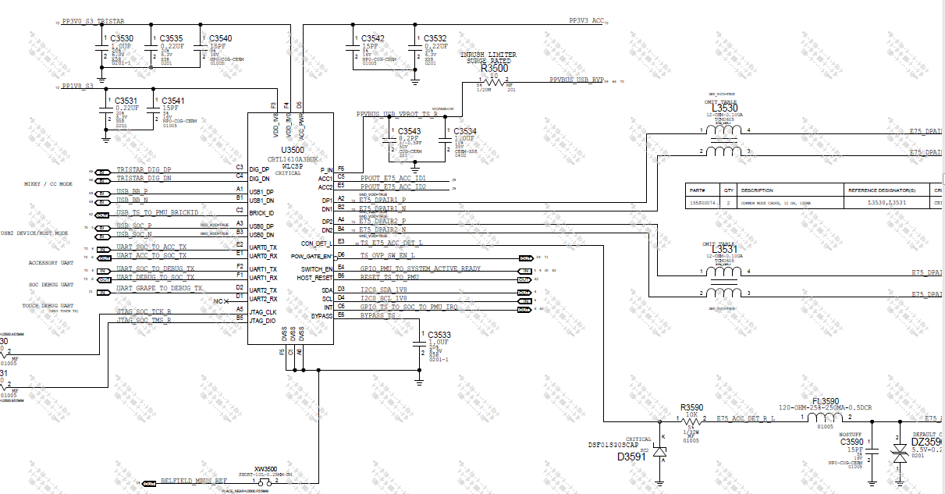

## 4.Board Info

-->Read Board Information (ID/Config/Version)

Board ID

测试方式:

通过Diags CMD: boardid读取MLB版本号

如图，PP1V8通过1k电阻连到GPIO端口,由于R0510、R0513、R0514为NOSTUFF,则相应GPIO端口为低电平信号0，其他则为高电平信号1，那么测试时通过GPIO 端口读取到电平信号为二进制00110，换成十六进制就是0x06，为J208，属于MLB_B

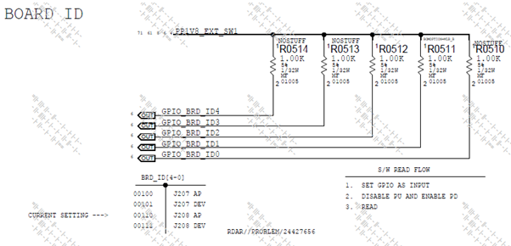

Boot Config

测试方式：

通过Diags CMD: bootcfg读取每个阶段MLB configs

测试原理类似Board ID

如图，根据原理图分析电平信号为二进制101，换算成十六进制为0x05。

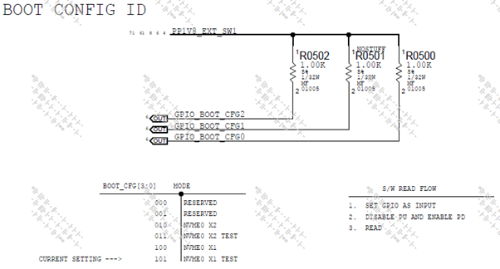

Board Revision

测试方式:

通过Diags CMD: boardrev读取MLB BRD_REV属于哪个阶段

如图，STUFFING 电阻 means 相应GPIO端口为低电平信号0，R0522、R0521为NOSTUFF,高电平1，则测试时读取到的信号为二进制0110，换成十六进制为0x06，则属于DVT 阶段。

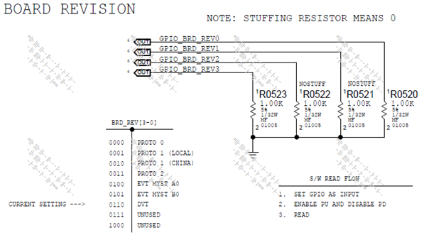

## 5.SoC Info

-->Read SOC Information，通过diags cmd 读取记录soc信息。

Chip id

DIE ID

FUSE ID

EC ID

测试方法： 用Diag命令读取。

2017/03/20 15:28:42.441 : [00195901:1013A93A] :-) chipid

2017/03/20 15:28:42.457 : Chip ID: 8011 Version: 4.0

2017/03/20 15:28:42.457 : Die ID: 00000101:1013A93A

2017/03/20 15:28:42.457 : Fuse ID: 82000000:00000206

2017/03/20 15:28:42.457 : ECID : 0x001959011013A93A

2017/03/20 15:28:42.473 : Raw ECID: 00195901:1013A93A

Get SoC Properites //记录SOC的一些信息

SoC_Production_Stage

IO-LEAKAGE-BIN-FUSE

CPU-SRAM-IO-LEAKAGE

GPU-SRAM-IO-LEAKAGE

VDD-LOW-IO-LEAKAGE

VDD-FIXED-IO-LEAKAGE

CPU-IO-LEAKAGE

SOC-IO-LEAKAGE

GPU-IO-LEAKAGE

DRAM-MEMORY-VENDOR

DRAM-MEMORY-SIZE

测试方法： 用Diag命令读取。命令:SOC -p

2017/03/20 15:28:42.473 : [00195901:1013A93A] :-) soc -p

2017/03/20 15:28:42.506 : io-leakage-bin-fuse: 458700

2017/03/20 15:28:42.506 : cpu-sram-io-leakage-bin-fuse: 5600

2017/03/20 15:28:42.521 : gpu-sram-io-leakage-bin-fuse: 11000

2017/03/20 15:28:42.521 : vdd-low-io-leakage-bin-fuse: 1600

2017/03/20 15:28:42.521 : vdd-fixed-io-leakage-bin-fuse: 82600

2017/03/20 15:28:42.521 : cpu-io-leakage-bin-fuse: 148400

2017/03/20 15:28:42.521 : vdd-var-soc-io-leakage-bin-fuse: 0

2017/03/20 15:28:42.537 : gpu-io-leakage-bin-fuse: 209500

2017/03/20 15:28:42.537 : binning-revision: 0

2017/03/20 15:28:42.537 : efi-memory-size: 0xFFFF8000

2017/03/20 15:28:42.537 : revision: B0

2017/03/20 15:28:42.537 : prod-id:0

2017/03/20 15:28:42.537 : secure-mode: 1

2017/03/20 15:28:42.537 : secure-storage: 0

2017/03/20 15:28:42.538 : package-id: 0

2017/03/20 15:28:42.538 : dram-memory-vendor: Hynix

2017/03/20 15:28:42.553 : dram-memory-type: SDRAM DDR4 S16

2017/03/20 15:28:42.553 : dram-memory-density: 512 MB

2017/03/20 15:28:42.553 : dram-memory-io-width: 16 bits

2017/03/20 15:28:42.553 : memctlr-cfg-channels: 4

2017/03/20 15:28:42.553 : memctlr-cfg-size: 4096 MB

Dump Raw Fuse Value //读取Nand的一些信息

CFG_FUSE0

CFG_FUSE1

CFG_FUSE2

CFG_FUSE3

CFG_FUSE4

CFG_FUSE5

CFG_FUSE6

CFG_FUSE7

CFG_FUSE8

CFG_FUSE9

CFG_FUSE10

CFG_FUSE11

CFG_FUSE12

CFG_FUSE13

CFG_FUSE14

CFG_FUSE15

测试方法： 用Diag命令读取：memrw --32 --count 16 0x2102bc000. 如下面log show :一共十六位,对应测项0到15

2017/03/20 15:28:42.555 : [00195901:1013A93A] :-) memrw --32 --count 16 0x2102bc000

2017/03/20 15:28:42.617 : 0x2102BC000: 0x00000206

2017/03/20 15:28:42.633 : 0x2102BC004: 0x82000000

2017/03/20 15:28:42.633 : 0x2102BC008: 0x43E7D0A1

2017/03/20 15:28:42.633 : 0x2102BC00C: 0x00000000

2017/03/20 15:28:42.633 : 0x2102BC010: 0x0481012F

2017/03/20 15:28:42.633 : 0x2102BC014: 0x49249245

2017/03/20 15:28:42.633 : 0x2102BC018: 0xD9A36A15

2017/03/20 15:28:42.633 : 0x2102BC01C: 0x71B21639

2017/03/20 15:28:42.633 : 0x2102BC020: 0x04C00392

2017/03/20 15:28:42.649 : 0x2102BC024: 0x0090D490

2017/03/20 15:28:42.649 : 0x2102BC028: 0x00000000

2017/03/20 15:28:42.649 : 0x2102BC02C: 0x50A00000

2017/03/20 15:28:42.649 : 0x2102BC030: 0x000000E0

2017/03/20 15:28:42.649 : 0x2102BC034: 0x00000000

2017/03/20 15:28:42.649 : 0x2102BC038: 0x00000000

2017/03/20 15:28:42.649 : 0x2102BC03C: 0x00000000

## 6.PMU Version Check

检查芯片(AUGUST/ AUTUMN/ Euphrates) 信息，确保产线没有用错物料。

芯片出厂前已经写入，FCT通过diag cmd来读取信息,脚本抓取相应字符.

不同案子，案子不同阶段所用命令不同，需要跟客户确认或者读Datasheet

PMU AUGUST OTP Revision

2017/03/20 15:28:42.729 : [00195901:1013A93A] :-) pmurw -r 0x0201

2017/03/20 15:28:42.745 : Read 1 bytes: 0x07

PMU AUGUST Platform ID

2017/03/20 15:28:42.745 : [00195901:1013A93A] :-) pmurw -r 0x0202

2017/03/20 15:28:42.761 : Read 1 bytes: 0x01

PMU AUGUST Device ID

2017/03/20 15:28:42.761 : [00195901:1013A93A] :-) pmurw -r 0x0204 5

2017/03/20 15:28:42.777 : Read 5 bytes: 0x0E 0xFD 0x80 0x20 0x00

PMU AUTUMN OTP Revision

2017/03/20 15:28:42.793 : [00195901:1013A93A] :-) reg read 0x0201

2017/03/20 15:28:42.809 : 0x201 => 0x04

PMU AUTUMN Platform ID

2017/03/20 15:28:42.809 : [00195901:1013A93A] :-) reg read 0x0202

2017/03/20 15:28:42.825 : 0x202 => 0x01

PMU AUTUMN Device ID

2017/03/20 15:28:42.825 : [00195901:1013A93A] :-) reg read 0x204

2017/03/20 15:28:42.841 : 0x204 => 0x0E

2017/03/20 15:28:42.841 : [00195901:1013A93A] :-) reg read 0x205

2017/03/20 15:28:42.857 : 0x205 => 0xCF

2017/03/20 15:28:42.857 : [00195901:1013A93A] :-) reg read 0x206

2017/03/20 15:28:42.873 : 0x206 => 0xB6

2017/03/20 15:28:42.873 : [00195901:1013A93A] :-) reg read 0x207

2017/03/20 15:28:42.889 : 0x207 => 0x3C

2017/03/20 15:28:42.889 : [00195901:1013A93A] :-) reg read 0x208

2017/03/20 15:28:42.905 : 0x208 => 0x00

2017/03/20 15:28:42.905 : [00195901:1013A93A] :-) i2c -z 2 -d 0 0x75 0x0001 1

2017/03/20 15:28:42.921 : Reading 1 bytes from register offset 0x01 into 0xF98D5598, buffer read:

2017/03/20 15:28:42.921 : Data: 0x04

Euphrates OTP Revision

2017/03/20 15:28:42.905 : [00195901:1013A93A] :-) i2c -z 2 -d 0 0x75 0x0001 1

2017/03/20 15:28:42.921 : Reading 1 bytes from register offset 0x01 into 0xF98D5598, buffer read:

2017/03/20 15:28:42.921 : Data: 0x04

Euphrates Platform ID

2017/03/20 15:28:42.921 : [00195901:1013A93A] :-) i2c -z 2 -d 0 0x75 0x0002 1

2017/03/20 15:28:42.953 : Reading 1 bytes from register offset 0x02 into 0xF98D5618, buffer read:

2017/03/20 15:28:42.953 : Data: 0x02

Euphrates Device ID

2017/03/20 15:28:42.953 : [00195901:1013A93A] :-) i2c -z 2 -d 0 0x75 0x0004 5

2017/03/20 15:28:42.985 : Reading 5 bytes from register offset 0x04 into 0xF98D5718, buffer read:

2017/03/20 15:28:42.985 : Data: 0x20 0x0E 0xC1 0xB9 0x87

## 7.USB Cable Check ???

-->设置vbus 为4.5v和5v,检查usb cable 是否detect.

测试步骤

Set VBUS=4.5V  //设置VBUS为4.5V

Set VBUS=5V //设置VBUS为5V

Cable Check

用diag command “charge –checkcable”读取Cable状态，返回值PASS就是Cable有连接

2017/03/02 09:07:40.511 : [00183551:08A0E63A] :-) charge --checkcable

2017/03/02 09:07:40.860 : PASS

## 8.RamDisk Mount

Load local Ramdisk into MLB DRAM,

RamDisk里面包含MLB的FW,测试用脚本等内容

在Mount Ramdisk时为了验证DX2的数据传输，将DX2设置成USB并连接治具,治具Uart直接连接到Tristar左边

测试步骤

Disconnect UART with Dx2

-->断开UART 和 Dx2连接,diags cmd: tristar -x "dx2 open"

Disconnect USB with Dx1

-->断开USB 和 Dx1连接,diags cmd: tristar -x "dx1 open"

Switch UART to left of Tristar

-->通过治具pogpin连到tristar左边的uart,作为信号传输线.这里没有连接Dx1到uart

Connect USB with Dx2

-->切换tristar USB到Dx2, diags cmd: tristar -x "dx2 usb0".

RAM Disk Mounted

-->通过diags cmd “ramdisk -m 0x3000000 -t 120” mounted RAM

Waiting for dmg file thru USB

Mounting RAM Disk

RAM Disk Mounted:PASS

Disconnect USB fixture with Dx2

CONN_DET OFF

CONN_DET ON

-->设置复位

Tristar 连接示意图

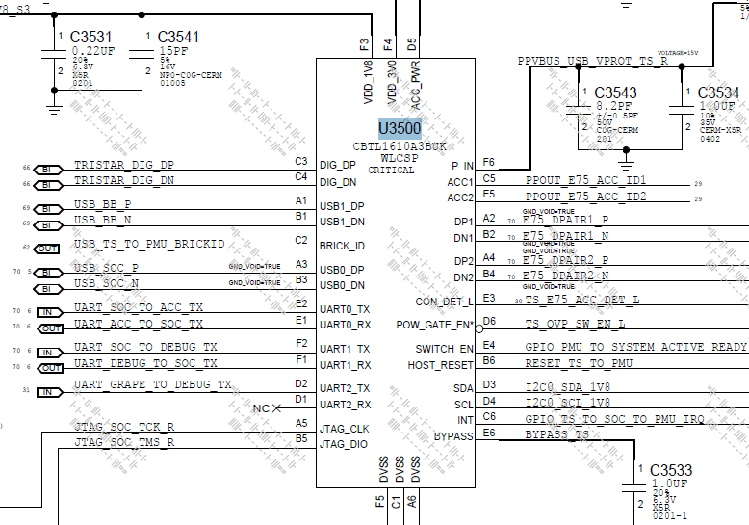

## 9 Hawking Test

FCT hawking的测试方法都是一样的，治具的Led以500Hz频率闪烁，主板连接的Strobe LED上面的感光sensor detect闪光频率，然后通过FFT计算出相应的数值。

**Hawking** **test** 類似于Headset microphone or Digital Mics：輸入waveform，然後ADC轉換，再對數字信號處理后,判斷結果。

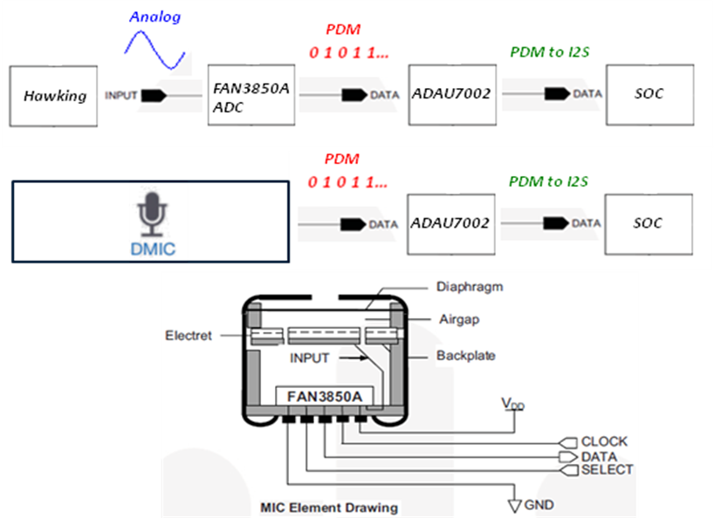

Hawking将detect的信号从IRIS_AVOUT 进入到U2600，然后通过U2600将模拟信号转换成数字信号，从HAWING_ADAU_SD出来，然后再到U2610,U2610将这种数字信号转换成PDM的一种信号，然后再将这个信号传输到SOC进行处理。

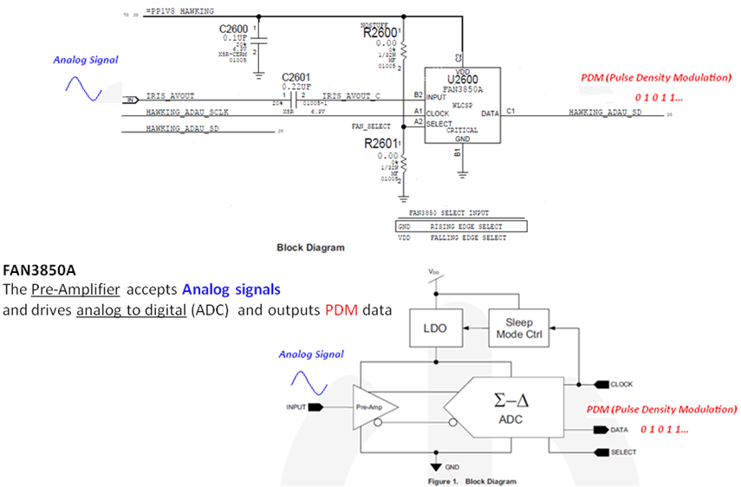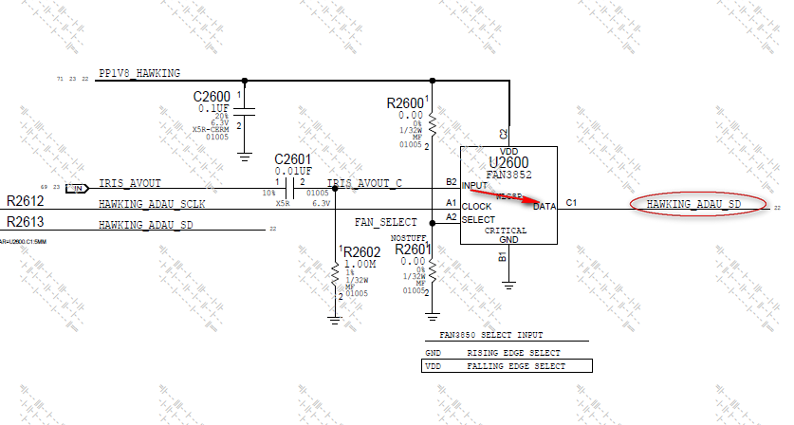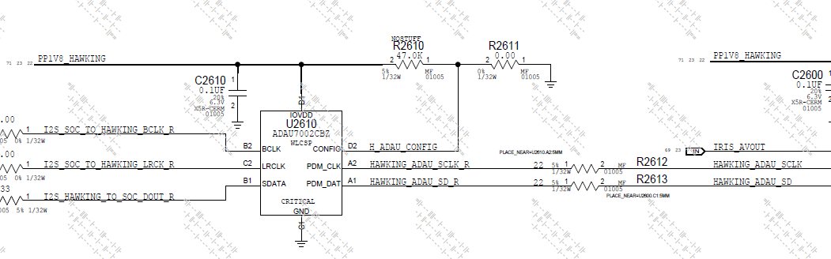

**测试Items(TL为例):**

Hawking Frequency Tone 1

Hawking DC Magnitude

Hawking Peak Magnitude Tone 1

Hawking Peak Power Tone 1

Hawking Noise Margin Tone 1

**测试log：**

audio -r

wait 50

processaudio --freebufs all

audioparam -b socmca -p ap-mca3 -s -n mclk-rate -v 12288000

recordaudio -b socmca -p ap-mca3 -r 48000 -d 32 --len 1000 -c 1

recordaudio -b socmca -p ap-mca3 -r 48000 -d 32 --len 1000 -c 1

DataFormat = 00000010

Configuring 'socmca' to record 48Khz, 32-bit, 1 channels of audio data for 1000mS...

Requesting new buffer...

Using buffer 'record0'

Recording audio...

Done!

OK

processaudio -p fft -o "--minHz 10 --maxHz 10000 --peakBinWidth 4 --numTones 7 --windowNorm true --sortOrder 1" -i record0

processaudio -p fft -o "--minHz 10 --maxHz 10000 --peakBinWidth 4 --numTones 7 --windowNorm true --sortOrder 1" -i record0

Number of samples does not equal power of 2 - truncating to 32768 samples...

Channel 0:

Using 32768 bins, Peak Bin= 341; Peak Magnitude=0.658332 FS; Frequency: 499.511718 +/- 2.929687 Hz (Tone 1)

Using 32768 bins, Peak Bin= 683; Peak Magnitude=0.348986 FS; Frequency: 1000.488281 +/- 2.929687 Hz (Tone 2)

Using 32768 bins, Peak Bin=1365; Peak Magnitude=0.154921 FS; Frequency: 1999.511718 +/- 2.929687 Hz (Tone 3)

Using 32768 bins, Peak Bin=1707; Peak Magnitude=0.145612 FS; Frequency: 2500.488281 +/- 2.929687 Hz (Tone 4)

Using 32768 bins, Peak Bin=2731; Peak Magnitude=0.090828 FS; Frequency: 4000.488281 +/- 2.929687 Hz (Tone 5)

Using 32768 bins, Peak Bin=2389; Peak Magnitude=0.078225 FS; Frequency: 3499.511718 +/- 2.929687 Hz (Tone 6)

Using 32768 bins, Peak Bin=3755; Peak Magnitude=0.067759 FS; Frequency: 5500.488281 +/- 2.929687 Hz (Tone 7)

**DC Magnitude=0.068295 FS**

**Signal Bins=9**

**SINAD=3.308999 dBFS**

**Peak Power: -3.631099 dBFS**

**Signal Power: -3.259173 dBFS**

**Noise Power: -17.872337 dBFS**

**Average Noise PSD: -53.159576 dBFS**

**Noise Margin: 49.528477 dBFS**

**SNR: 14.613164 dBFS**

**THD+N: -4.933784 dB**

## 10 Sensor Test

测试内容：FCT sensor test 主要是测试Accel,Gyro, Phosphorus三个sensor的version,conectivity,selftest以及通过取样计算出X/Y/Z三个方向的Average/std等。

**Sensor 连接框架图**

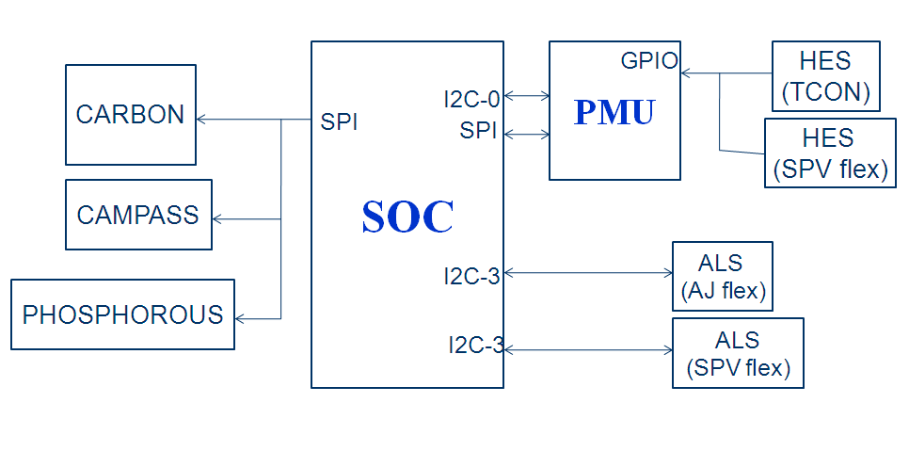

**Gyroscope & Accelerometer：**

加速度传感器用于基本姿态识别和环境感知,用来测量 x,y,z 三个轴上的加速力。加速力就是当物体在加速过程中作用在物体上的力。

MEMS 陀螺仪通常有两个方向的可移动电容板。径向的电容板加 振荡电压迫使物体作径向运动 (有点像加速度计中的自测试模式),横向的电容板测量由于横向科里奥利运动带来的电容变化(就像加速度计测量加速度)。因为科里奥利力正比于角速度,所以由电容的变化可以计算出角速度。

**Gyroscope & Accelerometer related block diagram**

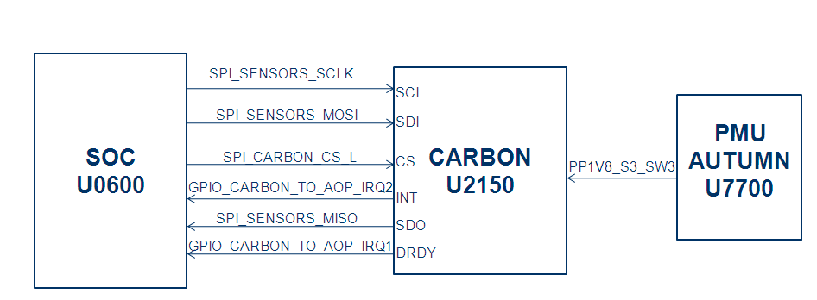

FCT station 通过command，来读取accell和gyro的vendor以及取样的数据。

**测试items:**

Accel Connectivity sensor -s accel –c

**测试log:** Executing connectivity test for 'accel'

GPIO 'CARBON_INT1_DRDY' = PASS

GPIO 'CARBON_INT2_INT' = PASS

test-result: passed

PASS

Capturing 500 samples from:

accel @ 100.00 Hz

command:sensor -s accel --set rate 100

Accel_ODR sensor -s accel --sample 500 --stats

Accel_Average_X 读取500ms的数据，计算出平均值，查看芯片是否工作正常

Accel_Average_Y

Accel_Average_Z

通过采样数据可以得到以下值（举例）：

accel:

# of samples captured: 500

# of bad samples (corrupted/lost): 0

calculated odr: 100.730804Hz

average: X = -0.008894, Y = 0.001871, Z = 1.016820, T = 25.426212

std-dev: X = 0.001057, Y = 0.001101, Z = 0.001310, T = 0.106187

rms: X = 0.008956, Y = 0.002171, Z = 1.016821, T = 25.426433

min: X = -0.012207, Y = -0.001464, Z = 1.012481, T = 25.168289

max: X = -0.005615, Y = 0.005615, Z = 1.021759, T = 25.755813

range: X = 0.006591, Y = 0.007080, Z = 0.009277, T = 0.587524

median: X = -0.009033, Y = 0.001953, Z = 1.016632, T = 25.462051

从此数据中就可以得到X/Y/Z Average.

Gyro的测试方法与accel相同，这里就不再重复。

**Phosphorus test**

PHOSPHORUS应用

由于导航仪市场较为混乱，产品质量良莠不齐，因此经常会出现导航仪瞎指挥的现状。如你在高架桥上时GPS却可能会指挥你转弯，但其实并没有转弯出口。这往往是由于GPS存在误差，不能够判断车子在高架桥上还是桥下所致。但如果再加上气压传感器，测量出所处的高度，就能够将误差降低到1米左右，随着精度提升导航也将变得更加精确。

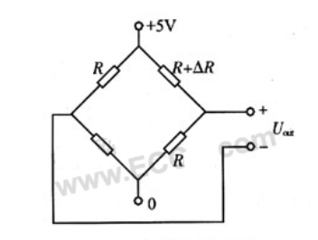

高精度气压传感器一般是利用MEMS技术在单晶硅片上加工出真空腔体和惠斯登电桥，惠斯登电桥桥臂两端的输出电压与施加的压力成正比，经过温度补偿和校准后具有体积小，精度高，响应速度快，不受温度变化影响的特点。输出方式一般为模拟电压输出和数字信号输出两种，其中数字信号输出方式由于和单片机连接方便，是市场上的主流

**PHOSPHORUS related block diagram**

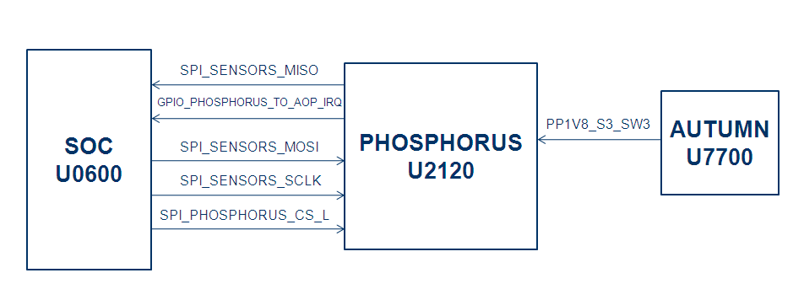

在FCT station,通过下Test CMD:

sensor -s pressure –init

解释：芯片初始化

sensor --sel pressure –contest

解释：芯片连接性测试

sensor -s pressure --sample 1000ms --stats 等，

解释：读取1000ms的数据，计算出当前气压的平均值，查看芯片是否工作正常

## 11 TDEV test

测试内容：TDEV主要是PMU通过NTC电阻去读取MLB的temperature.

NTC resistor: R8328,R8321, R8322 R8323, R8324, R8325, R8326,C8326

测试Items:

TCAL

TDEV1~TDEV8

测试log:

temperature --dev pmu

temperature --dev pmu

Device: pmu

TCAL

Instant: 52.06 deg C

TJINT

Instant: 28.07 deg C

TDEV1

Instant: 26.01 deg C

TDEV2

Instant: 24.20 deg C

TDEV3

Instant: 24.77 deg C

TDEV4

Instant: 23.89 deg C

TDEV5

Instant: 26.70 deg C

TDEV6

Instant: 25.88 deg C

TDEV7

Instant: 26.42 deg C

TDEV8

Instant: 27.40 deg C

THERMAL(0,1,3) Instant

THERMAL(0,1,3) Max

THERMAL(0,1,3) Min

THERMAL(0,1,3) Average

CCC_THERMAL(0~3) Instant

CCC_THERMAL(0~3) Max

CCC_THERMAL(0~3) Min

CCC_THERMAL(0~3) Average

测试log:

2017/03/02 15:28:14.257 : temperature --all

2017/03/02 15:28:16.766 : temperature --all

Device: soc

THERMAL0

Instant: 29.93 deg C

Max : 30.21 deg C

Min : 27.40 deg C

Average: 29.34 deg C

THERMAL1

Instant: 29.29 deg C

Max : 29.93 deg C

Min : 26.70 deg C

Average: 29.07 deg C

THERMAL2

Instant: 0.00 deg C

Max : 0.00 deg C

Min : 0.00 deg C

Average: 0.00 deg C

THERMAL3

Instant: 29.51 deg C

Max : 29.79 deg C

Min : 26.84 deg C

Average: 29.00 deg C

CCC_THERMAL0

Instant: 29.93 deg C

Max : 30.28 deg C

Min : 27.32 deg C

Average: 29.45 deg C

CCC_THERMAL1

Instant: 30.70 deg C

Max : 31.12 deg C

Min : 28.25 deg C

Average: 30.31 deg C

CCC_THERMAL2

Instant: 29.15 deg C

Max : 29.43 deg C

Min : 26.28 deg C

Average: 28.45 deg C

CCC_THERMAL3

Instant: 31.34 deg C

Max : 31.76 deg C

Min : 28.31 deg C

Average: 30.82 deg C

## 12.PDN Measurement

PDN:power deliver net

-->Measure Power on MLB from TP,通过diags cmd打开和关闭pmu chip 内部不同的BUCK,BOOST,LDO电路,实现电压的转换.治具通过TP量测每个power。

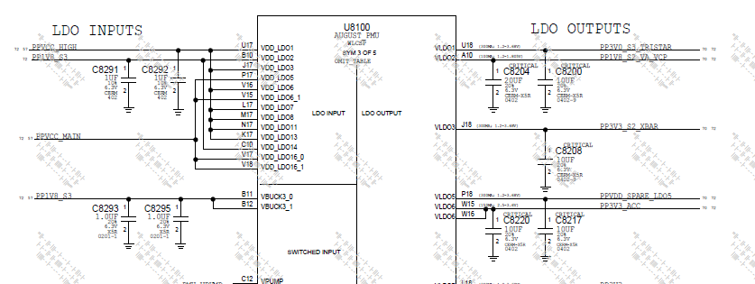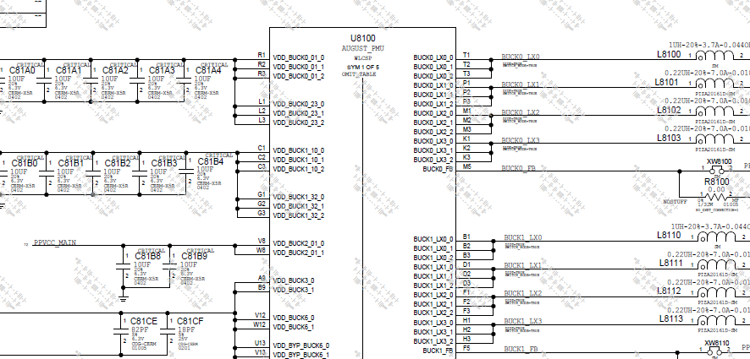

测试步骤:

PP0V775_S3_SOC_AOP_B0

-->soc -p get-perf-state

PPVDD_CPU_B0

PPVDD_CPU State Percentage

PPVDD_GPU_SRAM OFF

Turn on VDD_GPU

Turn on VDD_GPU_SRAM"

-->打开VDD_GPU diags cmd： pmuset --buck 1 –on，pmuset --buck 8 --vol 850， pmuset --buck 1 --vol 900

-->打开ldo6，diags cmd：pmuset --ldo 6 –on

-->设置pin18输出，diags cmd：pmugpio --pin 18 --output 1

-->设置pin120输出，diags cmd：socgpio --pin 120 --output 1

PPVDD_GPU

PPVDD_S1_FIXED_SOC_B0

PPVDD_GPU_SRAM

PP0V9_NAND

PP1V1_S3

Turn off VDD_GPU

-->关闭buck1，diags cmd：pmuset --buck 1 --off (VDD_GPU)

Turn off GPU_SRAM

-->关闭buck8，diags cmd：pmuset --buck 8 --off (VDD_GPU_SRAM)

PPVDD_CPU_SRAM_B0

PP0V9_NAND

PP1V1_S3

PP1V1_S1_EXT_SW

PP1V2_SOC_B0

PP1V8_ALWAYS

PP1V8_EXT_SW1

PP1V8_S2_VA_VCP

PP1V8_PHOS_FILT

PP1V8_S2_EXT_SW2

PP1V8_S3_SW3

PP1V8_CARBON_FILT

PP1V8_MAGNESIUM_FILT

PP1V8_S3

PP1V8_SW1

PP1V8_SW1_CAM

PP1V8_CAM_FRONT_CONN

PP1V8_CAM_REAR_CONN

PP1V8_GRAPE_EXT_SW

PP1V8_S3_MESA

PP3V0_S3_TRISTAR

PP3V3_S2

PP3V3_EXT_SW

PP3V3_GRAPE

-->打开ldo13，diags cmd：pmuset --ldo 13 --on (PP3V3_GRAPE)

PP3V3

PP3V3_ACC

PPVCC_MAIN_LCD_SW_CONN

PP3V05_S3_MESA

PPVCC_HIGH

PP1V19_CAM_REAR_CONN

-->打开ldo18，diags cmd：pmuset --ldo 18 --on

PP1V5_CAMERA

-->打开ldo9，diags cmd：pmuset --ldo 9 --on

PP2V9_PVDD_CAM_FRONT_FILT

-->打开buck9，diags cmd：pmuset --buck 9 --on

PP2V9_AVDD_CAM_FRONT_FILT

-->打开ldo21，diags cmd：pmuset --ldo 21 --on

PP2V85_AVDD_CAM_REAR_FILT

-->打开ldo17，diags cmd：pmuset --ldo 17 --on

-->选择打开寄存器，写入地址 diags cmd：reg select D2401，reg write 0x1901 0xB0"

PP1V19_FRONT_CAM

PP2V9_PVDD_CAM_REAR_FILT

-->打开buck9，diags cmd：pmuset --buck 9 --on

PP1V19_FRONT_CAM

PP3V0_UT_SVDD

PP3V0_ALS

PP1V8_HAWKING

-->打开ldo20，diags cmd：pmuset --ldo 20 --on (PP1V8_HAWKING）"

PP3V3_S2_XBAR

-->关闭ldo21，diags cmd：pmuset --ldo 17 --off, pmuset --ldo 21 --off

-->关闭buck9，diags cmd：pmuset --buck 9 --off

-->关闭ldo18，diags cmd：pmuset --ldo 18 --off

-->关闭ldo9，diags cmd：pmuset --ldo 9 --off

-->关闭ldo13，diags cmd：pmuset --ldo 13 --off

-->关闭ldo6，diags cmd：pmuset --ldo 6 --off

-->设置关闭pin18输出，diags cmd：pmugpio --pin 18 --output 0

-->设置关闭pin120输出，diags cmd socgpio --pin 120 --output 0

Turn_On Grape

-->打开grape，diags cmd：touch --on

Load Grape Firmware

-->load FW，diags cmd：touch --load_firmware

PP15V0_TOUCH_FILT

PP16V6_MESA

PP16V0_MESA

-->关闭grape，diags cmd：touch –off

## 13.Other Clocks

-->治具量测 AP and WLAN 的时钟频率

CLK_PMU_TO_AOP_32K

PMU_GPIO_CLK_32K_WLAN

## *******讲师: Evan************

## 14 Strobe LED test

1. Strobe LED test相关测试原理

Strobe LED function的测试，主要是通过外接一颗strobe灯，量测在cool和warm两种模式下的voltage和current.

在MLB上，Strobe LED的chip有两颗，U2900(Strobe1),U2950(Stobe2).

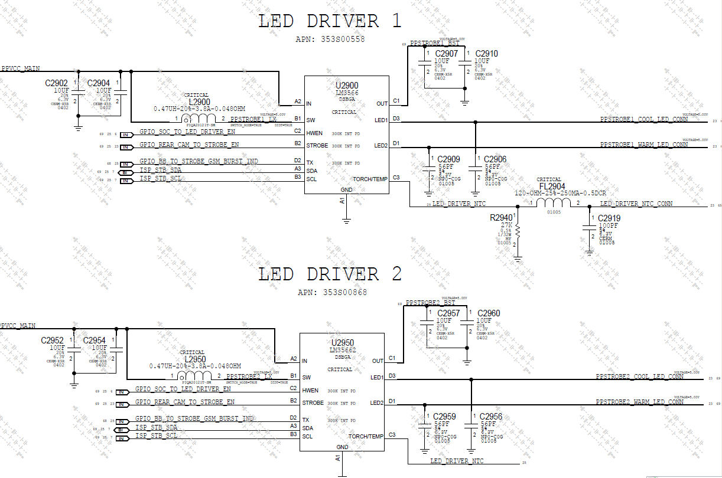

以下是在FCT工站Strobe相关测项：

Turn on Strobe_Device0

--> strobe --selectchip LM3566-0 --power on

STROBE_Device1_ID

--> 用Command读取ID camisp --i2cread 1 0x63 0x0C 1 1

strobe --selectchip LM3566-0 --selectstrobe led1 --set LedEnable on //Enable strobe device

camisp --i2cwrite 1 0x63 0x05 1 1 0xC6 //Set current to 100mA

strobe --selectchip LM3566-0 --selectstrobe led1 --mode Movie on

//LED1 is cool LED. Set Movie mode

LED_DRIVER_NTC_CONN_Cool1

PPSTROBE1_BST_Cool

VOLT_PPSTROBE1_COOL_LED_CONN

CURR_PPSTROBE1_COOL_LED_CONN

strobe --selectchip LM3566-0 --selectstrobe led1 --mode Movie off //Turn off LED

strobe --selectchip LM3566-0 --power off

Init Warm LED test

strobe --selectchip LM3566-0 --power on //Reset LM3566-0

strobe --selectchip LM3566-0 --selectstrobe led2 --set LedEnable on

camisp --i2cwrite 1 0x63 0x05 1 1 0xC6

strobe --selectchip LM3566-0 --selectstrobe led2 --mode Movie on

LED_DRIVE_NTC_CONN_Warm1

PPSTROBE1_BST_Warm

VOLT_PPSTROBE1_WARM_LED_CONN

CURR_PPSTROBE1_WARM_LED_CONN

Turn off Strobe_Device0

同理Strobe 2也是用相同的方法测试。

## 15 UV warn Test

测试意义：Read UV warn status between GPU ,CPU and PMU when under voltage

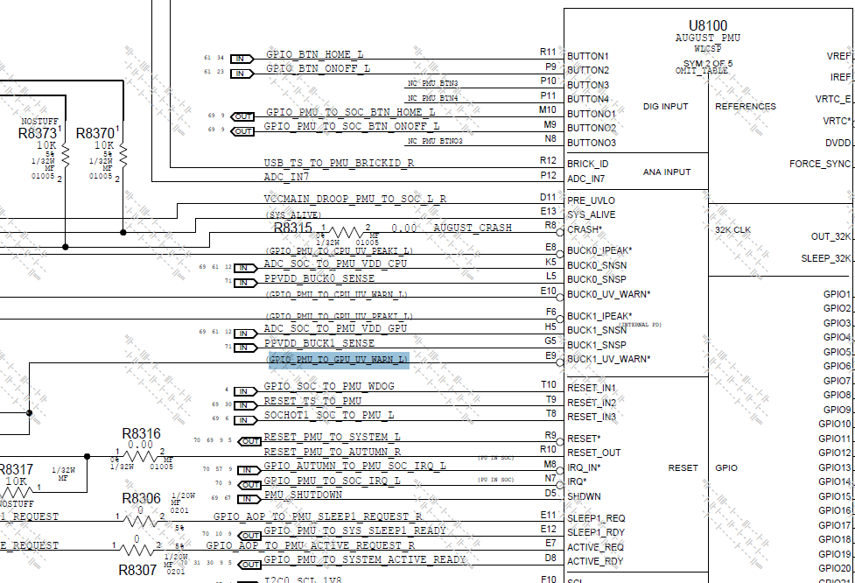

主要测试GPIO_PMU_TO_GPU_UV_WARN_L和GPIO_PMU_TO_CPU_UV_WARN_L这个两个pin能否从默认状态1，在低电压模式下变成0

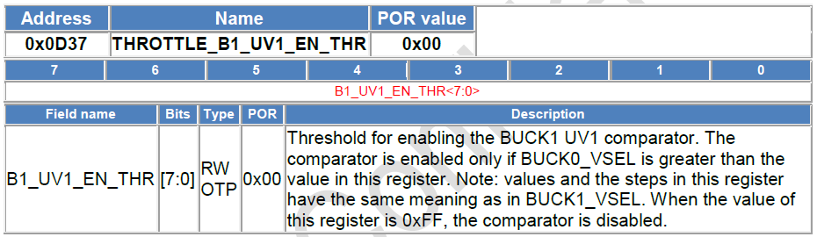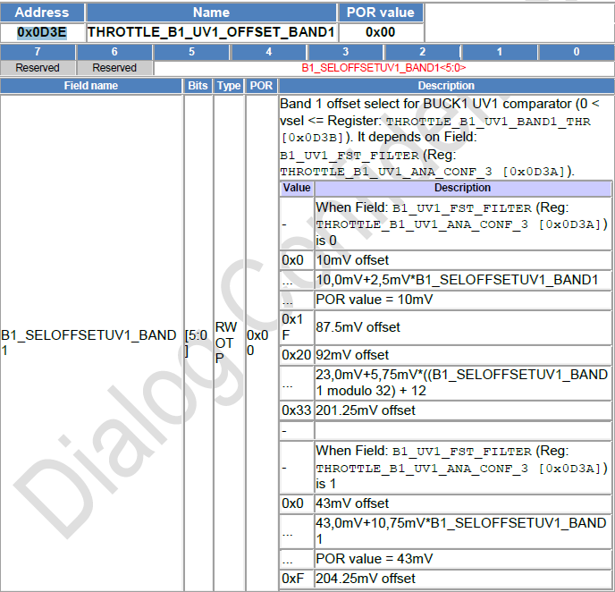

## 16 Tristar（U3500）

Tristar 是一個多路開關控制器，對USB,UART ,JTAG ,BRICK_ID等信號的切換，在FCT工站，enter diag,brick id 等相关测试都会与tristar相关。

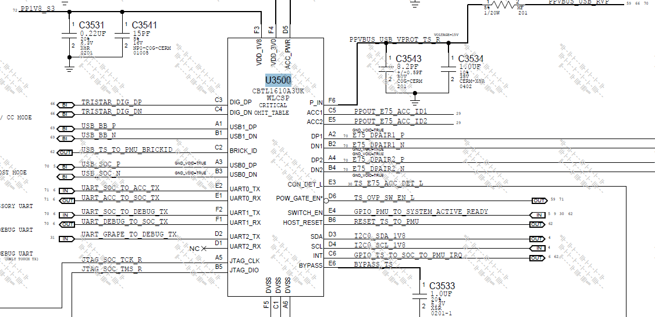

测试方法概述：

PPOUT_E75_ACC_ID1: 接Apple ID 用于Enter diag; 外部接分压电阻，用Brick ID读取ACC1的电压; 测试ACC1 output power.

PPOUT_E75_ACC_ID2: 当测试ACC1 load的时候接Apple ID; 外部接分压电阻，用Brick ID读取ACC2的电压; 测试ACC2 output power.

E75_DPAIR1_P/N: Enter diag 時作為USB 信號; Load ramdisk 時作為UART 信號; 外部接分压电阻，用Brick ID读取DP1 的电压;

E75_DPAIR2_P/N : Enter diag 時作為UART信號; 外部接分压电阻，用Brick ID读取DP2的电压.

UART_SOC_TO_ACC_TX

UART_ACC_TO_SOC_TX

在tristar测试中，通過cmd tristar -x "dx1 uart0" “tristar -w "0x1d 0x09"，loop back UART_SOC_TO_ACC_TX和UART_ACC_TO_SOC_TX，通過socgpio --pin 208 --output 1; socgpio --pin 209 --input;socgpio --pin 208 --output 0;socgpio --pin 209 --input來讀取這兩個pin的high/low

USB_SOC_P\N

在FCT enter diag 測試，把E75_DPAIR1_P\N 切到USB_SOC_P\N, 當做USB 信號接到fixture USB.把E75_DPAIR2_P\N 切到UART_SOC_TO_DEBUG_TX\UART_DEBUG_TO_SOC_TX做UART信號 接到fixture UART

UART_SOC_TO_DEBUG_TX\UART_DEBUG_TO_SOC_TX

在load Ramdisk 測試時，把E75_DPAIR1_P\N切到UART_SOC_TO_DEBUG_TX\UART_DEBUG_TO_SOC_TX當做UART信號，把USB 切到tristar的左邊.

USB_BB_P\N: USB_BB_P\N是baseband的通訊信號，在測試baseband power on 通過. USB_BB_P\N 和baseband 的IC 進行通訊

Tristar_DIG_DP\DN:在測試mikey bus,用cmd tristar -x “dx1 dig”Set up mikey signals on DPair1,然後在運行script.

在FCT 工站，关于tristar 的测试主要是通过发送command来check tristar vendor和GPIO/UART信号pin High/Low function是否正常。

测项如下：

VENDOR*

BASE_VER*

METAL_VER*

Con Detect Low

以上测项通过Command “tristar –p”读取

2017/03/02 09:09:29.851 : [00183551:08A0E63A] :-) tristar -p

2017/03/02 09:09:30.090 : >> properties

2017/03/02 09:09:30.090 : vendor = NXP

2017/03/02 09:09:30.090 : Base version = 0x1

2017/03/02 09:09:30.090 : Metal version = 0x2

2017/03/02 09:09:30.090 : Dx ID = 0x2

2017/03/02 09:09:30.090 : ACCx ID = 0x0

2017/03/02 09:09:30.146 : DX1 = OPEN

2017/03/02 09:09:30.146 : DX2 = OPEN-BRICKID

2017/03/02 09:09:30.146 : ACC2 = OPEN

2017/03/02 09:09:30.146 : ACC1 = OPEN

2017/03/02 09:09:30.146 : idSink = DISABLE

2017/03/02 09:09:30.146 : VDX = OFF

2017/03/02 09:09:30.148 : ID Connected = 0x1

2017/03/02 09:09:30.148 : ID Orientation = 0x0

2017/03/02 09:09:30.148 : Con Detect Low = 0x0

Host ID

用Diag Command “tristar -r 0x5d”读取

Tristar Rev

用Diag Command “tristar -r 0x0f”

PMU Interrupt test: 测试拉低拉高2种状态

PMU Tristar Interrupt Low

通过conmmand“tristar -r 0x0d”清除掉用Tristar Interrupt

然后用Command “pmurw -r 0x09C7 1”读取Tristar的状态。

GPIO Tristar Interrupt Low

用Command “socgpio --pin 218 –input”读取PMU GPIO的状态

PMU Tristar Interupt High

重新连接一次VBUS,然后用Command “pmurw -r 0x09C7 1”读取Tristar的中断状态

GPIO Tristar Interrupt High

用Command “socgpio --pin 218 –input”读取PMU GPIO的状态

Loopback UART0, connect TXD with RXD

tristar -x "dx1 uart0" tristar -w "0x1d 0x09"

UART2_TS_ACC_TXD/RXD High

socgpio --pin 208 --output 1;socgpio --pin 209 --input

UART2_TS_ACC_TXD/RXD Low

socgpio --pin 208 --output 0;socgpio --pin 209–input

Disconnect TXD with RXD

tristar -w "0x1d 0x08"

UART2_TS_ACC_TXD/RXD Continuity

socgpio --pin 208 --output 1;socgpio --pin 209 –input

Switch JTAG to DPair1

tristar -x "dx1 jtag"

TS_JTAG Continuity (DP)

TS_JTAG Continuity (DN)

治具量测电压

## 17 Brick ID Test

Brick ID 测试是将Brick ID connect ACC1/ACC2/DP1/DP2 test to detect external charge voltage。

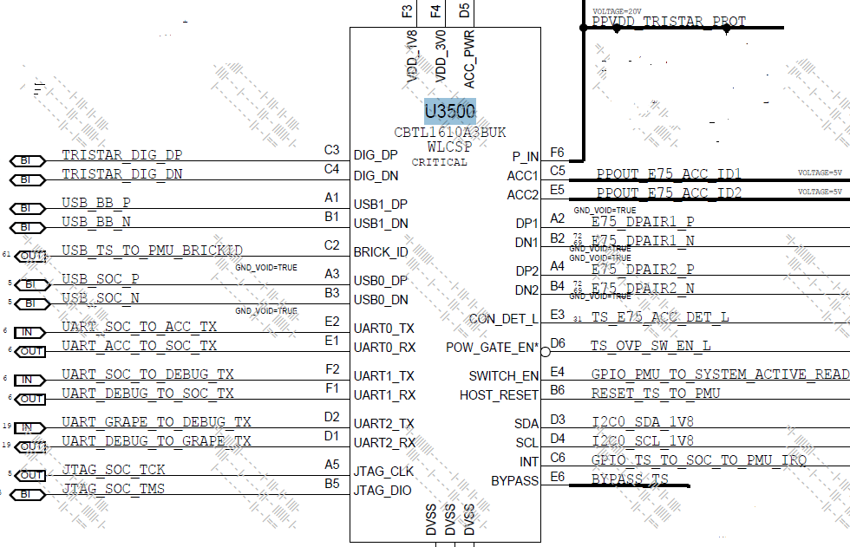

2.65V

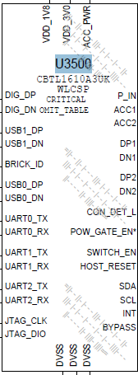

tristar -w "0x02 0x8c" // Connect Brick ID to ACC1

Read Brick ID Status ACC1 (on)

pmuadc --read brick_id

在测试之前，会先将AID connect to ACC2,再将Brick ID connect ACC1和2.65V的load然后通过command来读取brick id的电压。

Read Brick ID Status ACC2(on)

pmuadc --read brick_id

同理，在测之前，会通过command” tristar -w "0x02 0xc8" “将AID connect to ACC1, 再将Brick ID connect ACC2,然后通过command来读取brick id 的电压。

Read Brick ID Status (off)

测试之前先disconnect brick id load 和ACC2，然后读取brick id 的状态。

Read Brick ID Status Dx1 (on)

Read Brick ID Status DP1

Read Brick ID Status DN1

将brick id 连接DP1/DP1量测电压。

Read Brick ID Status DP2

Read Brick ID Status DN2

将DP2 disconnect, Switch UART to Left of Tristar，Connect Brick ID to DP2

将brick id 连接DP2/DP2量测电压.

## 18 Default GPIO States

测试内容：Check GPIO (Mneu key, Hold key….)States

测试items:

MenuKey=0 key // Read Default GPIO States

HoldKey=0

VolUP=0

VolDown=0

The default voltage of the button net (HOME_L, ONOFF_L) =1.8V. GPIO_BTN_VOL_DOWN_L and GPIO_BTN_VOL_UP_L = 0V

## 19 System Current

测试内容：Measure systerm current with WIFI/BT off

测试system current,是在state 0模式下测试的，并且会将VBUS断开。

System Current with WiFi/BT Off turn off wifi/BT量测系统电流

WiFi Power On

WiFi Firmware Load

WiFi Uart Test

Bluetooth Power On

Bluetooth Firmware Load

System Current with WiFi/BT On turn on wifi/BT量测系统电流

## 20 WiFi Signals

wifi signals测试内容：Load WIFI/BT FW to test function,check BB GPIO status。

WiFi Module Revision

wifi –properties

从diag中读取wifi module的vendor,module-revision, module-sn, firmware-filename等，

WiFi Host Wake Test

wifi --test_host_wake

// Driving "host wake" line high

// Driving "host wake" line low

WiFi Host Uart Test

wifi --test_uart

Bluetooth Self Test

bluetooth --test_self_test //读取local version

Bluetooth Host Wake Test

bluetooth --test_host_wake // Driving "host wake" line high

//Driving "host wake" line low

Bluetoothe Sleep Wake Test

bluetooth --test_sleep_wake //Driving "host wake" line low

以下测项是与BB相关的，只是测这些pin能否pull high/low

PCIE_SOC_TO_BB_RESET_H/L

socgpio --pin 12 --get,socgpio --pin 12 --output1,

socgpio --pin 12 –get, socgpio --pin 12 --output 0,

socgpio --pin 12 --get

PCIE_BB_TO_SOC_CLKREQ_H/L

socgpio --pin 15 --get,

socgpio --pin 15 --output1,

socgpio --pin 15 –get,

socgpio --pin 15 –output0,

socgpio --pin 15 –get //TL skip,can’t pull high,TX test.

GPIO_BB_TO_SOC_GPS_SYNC_H/L

socgpio --pin 20 --get,

socgpio --pin 20 --output1,

socgpio --pin 20 –get,

socgpio --pin 20 –output0,

socgpio --pin 20 –get

GPIO_BB_IPC_H/L

socgpio --pin 19 --get,

socgpio --pin 19 --output1,

socgpio --pin 19 –get,

socgpio --pin 19 --output 0,

socgpio --pin 19 --get

GPIO_SOC_TO_BB_COREDUMP_H/L

socgpio --pin 62 --get,

socgpio --pin 62 --output1,

socgpio --pin 62 –get,

socgpio --pin 62 --output 0,

socgpio --pin 62 –get

GPIO_SOC_TO_BB_MESA_ON_H/L

socgpio --pin 39 --get,

socgpio --pin 39 --output1,

socgpio --pin 39 –get,

socgpio --pin 39 --output 0,

socgpio --pin 39 –get

## 21 PMU Button test

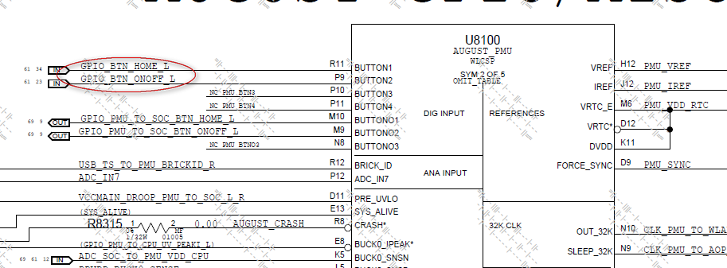

pmu button test 是通过治具发送command，看能否将GPIO_BTN_HOME_L和GPIO_BTN_ONOFF_L 这两个pin pull H/L，默认状态下是1.8V，当按下的时候变成0V。

## 22 Accessory Power Test

测试意义：

AAC power测试检测accessory线路及其帯负载能力。

测试方法：

ACC1和ACC2的方法类似，都是在LDO和Bypass两种模式下测试的.

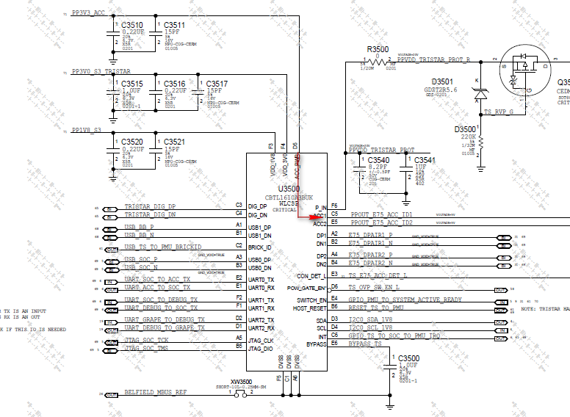

LDO模式如下图：

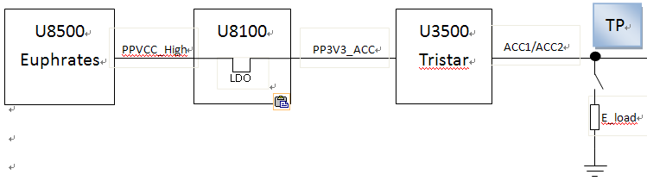

PPVCC_High经过PMU LDO降压到PP3V3，再经Tristar连接到ACC Power上。

Bypass模式如下图：

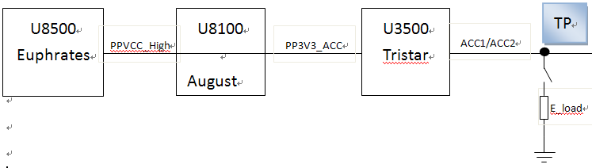

Bypass模式与LDO模式的区别在于: PPVCC_High经PMU bypass，未降压，同样经Tristar连接到ACC power上。

Accessory Power Test 测项：

accessory -p acc2，accessory -m normal

PP3V3_ACC_ACC2_100mA

VACC2 100mA Load

IACC2 100mA Load

这几项是在normal模式下，E_load断开情况下，治具量测TP点电压，电流.

accessory -m bypass

PP3V3_ACC_ACC2_500mA

VACC2 500mA Load

IACC2 500mA Load

这几项是在bypass模式下，E_load连接情况下，治具量测TP点电压，电流.

ACC1也是同理测试。

MAIN_ACC1_E-Load_Setting_High_Current

MAIN_ACC1_E-Load_Actual_High_Current

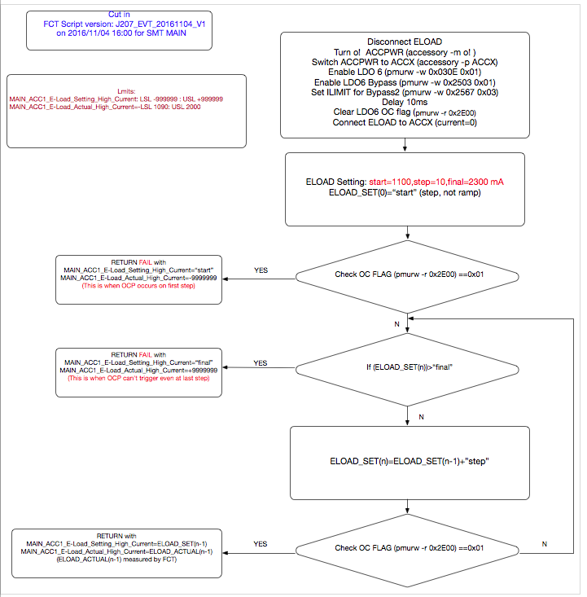

FCT fixture 通过控制 E-load board 逐步加大负载电流，Check OCP current。

Test method:

Setting: start=1.00A,step=0.010A,final=2.3A,target=0.2A

治具初始设置ELOAD current为1A, 然后以0.01A递增，每设置一次同时会量测一下实际值。当实际值小于200mA则视为OC并把前一次的实际值作为Eload_Current_Actual的值；当实际值大于200mA但小于2.3A,则以0.01A继续递增直到OC并把前一次的实际值作为Eload_Current_Actual的值；如果刚开始就OC, Eload_Current_2000mA_Actual的值return为-9999999；如果到2.3A还未OC则Eload_Current_2000mA_Actual的值return为9999999。

## 23 Orion test

测试意义：

Orion system is for external device support, such as keyboard and writing board

Orion会在两种模式下测试，一种是 Input(充电)模式，另一种是Output(放电)

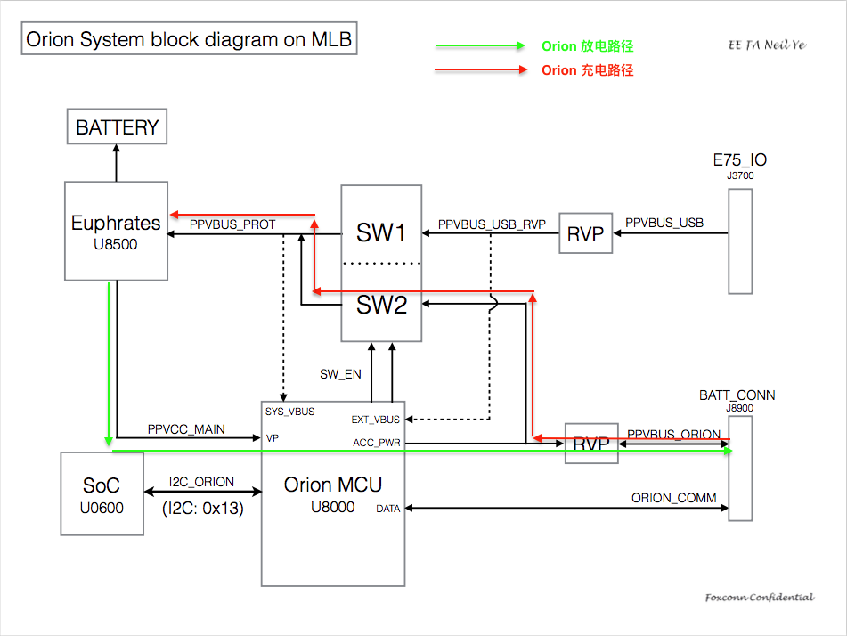

## 24 Orion Contact Contamination Test：

测试目的: 验证Orion外部设备的电压能否正常供给升到期望电压, 也验证Orion ADC模块正常工作与否

测试方法: 经由输出至Orion pin脚的恒定电流源以及治具设定的固定阻抗相乘,能够得到一期望电压值, 经由Orion ADC 读出该电压并比对.

Orion ADC Module与恒定电流源方块图如下.

在DATA Pin/ACC Power pin/ADC_CH1/ADC_CH2之间接入电阻， Mux选择哪个pin作为Power Pin,哪个Pin作为GND

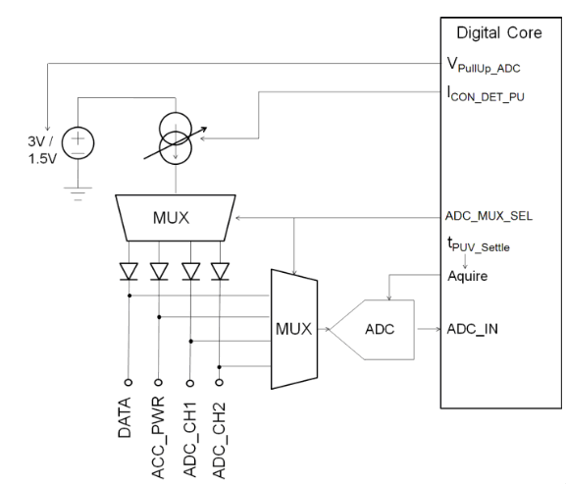

Orion ADC Voltage 4uA DATA_GND_150K 在DATA和GND之间加150k的电阻,

给4uA的电流，ADC去读取它们之间的电压

## 25 Oriong Input test

测试目的：检测通过ORION外部接口充电是否正常。

测试方法：通过设置输入电流，去量测orion及battery的实际电流。

测试items：

Check Status Input_Init

Check Status Input 通过读寄存器状态来check

Fixture set 5V到PPVBUS Orion

Fixture set battery =3.6V

Orion_to_Battery_OrionMeasurement 通过测试点PPVBUS_ORION量测电流

[INPUT]Read VBAT_TP 读BATT的电压

[INPUT]Read Orion Voltage 读外部给Orion供电，orion的电压

[INPUT]Read VBUS_E75 读下VBUS有没有电压，期望是没有的

Orion Input Communication (ORION_ACC_ID) 在input模式下，读取ID，通过读寄存器

command: i2c -d 1 0x13 0x74 8

//0x74: These registers (ID_RESP[0:7]) contain the AID slave

response to the default ID command

Orion_to_Battery_BatteryMeasurement charge --battlimit 3960，charge --force --set 1000

通过测试点PPBATT_VCC量测电流

Orion_to_Battery_OrionMeasurement_2300 charge --battlimit 3960，charge --force --set 2300

Orion_to_Battery_BatteryMeasurement_2300 通过测试点PPVBUS_ORION量测电流，

通过测试点PPBATT_VCC量测电流

## 26 Output Current test

测试目的：Check OCP current，PMU得到OC信号后会调整给负载的供电使输出功率降低。

测试方法：FCT fixture 通过控制 E-load board 逐步加大负载电流使Orion system进入over current protection status.

Output模式是在Input模式之后测得，所以测试之前，首先会将治具给的5V断开，接上Eload,然后通过command设置成Output模式。

与Input测试一样，Output模式下也会读取VBATT，VBUS，Orion voltage，Orion ACC ID.

[OUTPUT]Read VBAT_TP

[OUTPUT]Read VBUS_E75

Check Status Output

[OUTPUT]Read Orion Voltage

Orion OutPut Communication (ORION_ACC_ID) i2c -d 1 0x13 0x74 8

测完以上几项后就开始Orion Eload test，50mA/250mA/500mA/1000mA/2000mA

Test algorithms:

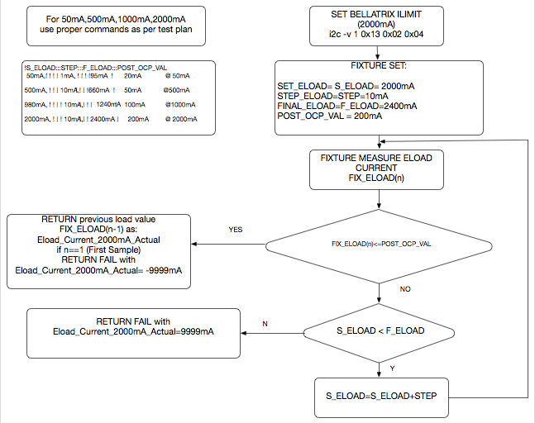

举例说明：

Test items：

Eload_Current_2000mA_Setting

Eload_Current_2000mA_Actual

Test method:

Setting: start=1.900A,step=0.010A,final=2.3A,target=0.2A

治具初始设置ELOAD current为1.9A, 然后以0.01A递增，每设置一次同时会量测一下实际值。当实际值小于200mA则视为OC并把前一次的实际值作为Eload_Current_2000mA_Actual的值；当实际值大于200mA但小于2.3A,则以0.01A继续递增直到OC并把前一次的实际值作为Eload_Current_2000mA_Actual的值；如果刚开始就OC, Eload_Current_2000mA_Actual的值return为-9999999；如果到2.3A还未OC则Eload_Current_2000mA_Actual的值return为9999999。

## 27 ORION ADC Measurement

测试内容：Measure temp power from ADC calculate

i2c -v 1 0x13 0x01 0x91 //进入isolate mode ????

ADC Temp i2c -v 1 0x13 0xA0 0x04 //读取Orion Temp

i2c -d 1 0x13 0xA5 1 //将读取的值的高八位写进A5中

i2c -d 1 0x13 0xA4 1 //将读取值的低八位写进A4中

ADC VP i2c -v 1 0x13 0xA0 0x00 //读取VP电压

i2c -d 1 0x13 0xA5 1

i2c -d 1 0x13 0xA4 1

ADC Accessory Power i2c -v 1 0x13 0xA0 0x01 //读取Accessory 电压

i2c -d 1 0x13 0xA5 1

i2c -d 1 0x13 0xA4 1

ADC External VBUS Power i2c -v 1 0x13 0xA0 0x02 //读取外部VBUS的电压

i2c -d 1 0x13 0xA5 1

i2c -d 1 0x13 0xA4 1

怎么计算的？

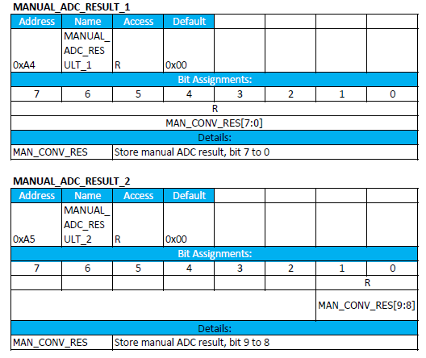

根据datasheet因为读取的是十六进制的，ADC A5只取八位的最后两位，A4取整个八位。

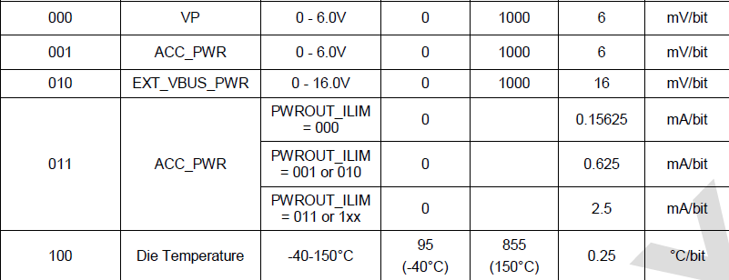

也就是A5二进制取最后两位+A4，再转换成十进制，再乘以LSB

举例说明： ADC VP

i2c -d 1 0x13 0xA5 1

Data: 0x02

i2c -d 1 0x13 0xA4 1

Data: 0x56

A5 0x02转换成二进制00000010

A4 0x56转换成二进制01010110

A5+A4=1001010110转换成十进制等于598

所以，算出值为598*6=3588

ADC Temp offset 0.25

ADC VP offset 6

ADC Accessory Power offset 6

ADC External VBUS Power offset 16

算法都是相同。

## 28 TDEV

测试内容：通过连接NTC电阻，来量测MLB的temperature.

## *****讲师 Chel*************************

## 29 Current Trim Test

Test Overview

These items are testing the battery charging current or USB current when set to different charge current，included 5V,9V,12V,14.8V USB voltage charge.

Test condition setting :

Use DC power supply to simulate the battery and USB power (cable power wire was cut off, USB power supply from power supply), and plug USB connector of the cable into B45 adaptor, connect 10K NTC resistor to MLB, then refer to the FCT test condition to set the voltage on power supply, check the charge current by reading the current value from the power supply.

Example: LV USB CURRENT CHARGE3960 USB 500

Set V_batt = 3.7V, V_usb = 5V, then send diag commands

:-)charge --batterylimit 3960

:-)charge --force --set 500

Then get the USB current from the power supply.

Related commpent:

Euphrates(U8500),PMU (U8100) or SOC(U0600)

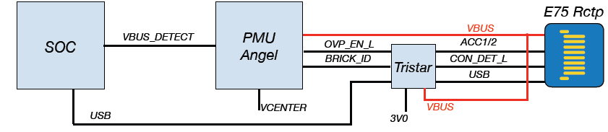

|  |
| --- |
| Connect NTC10K  Set VBUS = 5V  Reconnect USB power |
| V_batt = 3.65V |
| USB iLimit=500, batt iLlimit=3960  :-) charge --battlimit 3960  :-) charge --setma 500 --setmv 5000 --force |
| LV USB Current Charge 3960 USB 500 |
| LV_USB_CURRENT_500 |
| USB iLimit=480, batt iLlimit=3960 |
| LV USB Current Charge 3960 USB 480 |
| USB iLimit=100, batt iLlimit=3960 |
| LV USB Current Charge 3960 USB 100 |
| LV_USB_CURRENT_100 |
| USB iLimit=1000, batt iLlimit=3960 |
| LV USB Current Charge 3960 USB 1000 |
| LV_USB_CURRENT_1000 |
| USB iLimit=2100, batt iLimit 3960 |
| LV USB Current Charge 3960 USB 2100 |
| LV_USB_CURRENT_2100 |
| USB iLimit=2400, batt iLimit 3960 |
| LV USB Current Charge 3960 USB 2400 |
| LV_USB_CURRENT_2400 |
| LV_USB_CURRENT_CAL  v=string.format("0x%04X%04X",string_match(v,"(%d*)%.(%d*)"))  2417=9*16^2+7*16+1  6930=1*16^3+11*16^2+1*16+2 |
| VBUS_FIXTURE_CHARGE |
| PPVBUS_USB_EMI_5V |
| PPVBUS_USB_RVP_5V |
| USB iLimit=2400, batt iLimit 3270 |
| LV BATT Current Charge 3270 USB 2400 |
| USB iLimit=2400, batt iLimit 1960 |
| LV BATT Current Charge 1960 USB 2400 |
| USB iLimit=2400, batt iLimit 1630 |
| LV BATT Current Charge 1630 USB 2400 |
| V_batt = 3.9V, slow ramp to VBUS=9.0V |
| batt iLimit=6000mA |
| set to high voltage charge mode  :-) i2c -z 2 -v 0 0x75 0x0443 0x12 |
| USB iLimit=500 |
| 9V USB Current Charge 6000 USB 500 |
| 9V_USB_CURRENT_500 |
| USB iLimit=480 |
| 9V USB Current Charge 6000 USB 480 |
| 9V_USB_CURRENT_480 |
| USB iLimit=100 |
| 9V USB Current Charge 6000 USB 100 |
| 9V_USB_CURRENT_100 |
| USB iLimit=1000 |
| 9V USB Current Charge 6000 USB 1000 |
| 9V_USB_CURRENT_1000 |
| USB iLimit=1500 |
| 9V USB Current Charge 6000 USB 1500 |
| 9V_USB_CURRENT_1500 |
| USB iLimit=2000 |
| 9V USB Current Charge 6000 USB 2000 |
| 9V_USB_CURRENT_2000 |
| 9V_USB_CURRENT_CAL |
| USB iLimit=2000, batt iLimit 4090 |
| 9V BATT Current Charge 4090 USB 2000 |
| USB iLimit=2000, batt iLimit 3270 |
| 9V BATT Current Charge 3270 USB 2000 |
| USB iLimit=2000, batt iLimit 1630 |
| 9V BATT Current Charge 1630 USB 2000 |
| V_batt = 3.9V, slow ramp to VBUS=12.0V |
| batt iLimit=6000mA |
| USB iLimit=500 |
| 12V USB Current Charge 6000 USB 500 |
| 12V_USB_CURRENT_500 |
| USB iLimit=480 |
| 12V USB Current Charge 6000 USB 480 |
| 12V_USB_CURRENT_480 |
| USB iLimit=100 |
| 12V USB Current Charge 6000 USB 100 |
| 12V_USB_CURRENT_100 |
| USB iLimit=1000 |
| 12V USB Current Charge 6000 USB 1000 |
| 12V_USB_CURRENT_1000 |
| **USB iLimit=1500** |
| 12V USB Current Charge 6000 USB 1500 |
| 12V_USB_CURRENT_1500 |
| USB iLimit=2000 |
| 12V USB Current Charge 6000 USB 2000 |
| 12V_USB_CURRENT_2000 |
| 12V_USB_CURRENT_CAL |
| USB iLimit=2000, batt iLimit 4090 |
| 12V BATT Current Charge 4090 USB 2000 |
| batt iLimit 3270 |
| 12V BATT Current Charge 3270 USB 2000 |
| batt iLimit 1630 |
| 12V BATT Current Charge 1630 USB 2000 |
| V_batt = 3.9V, slow ramp to VBUS=14.8V |
| TO high voltage mode  :-) i2c -z 2 -v 0 0x75 0x0443 0x12 |
| batt iLimit=6000mA |
| USB iLimit=500 |
| HV USB Current Charge 6000 USB 500 |
| HV_USB_CURRENT_500 |
| USB iLimit=480 |
| HV USB Current Charge 6000 USB 480 |
| HV_USB_CURRENT_480 |
| USB iLimit=100 |
| HV USB Current Charge 6000 USB 100 |
| HV_USB_CURRENT_100 |
| USB iLimit=1000 |
| HV USB Current Charge 6000 USB 1000 |
| HV_USB_CURRENT_1000 |
| **USB iLimit=1500** |
| HV USB Current Charge 6000 USB 1500 |
| HV_USB_CURRENT_1500 |
| USB iLimit=2000 |
| HV USB Current Charge 6000 USB 2000 |
| HV_USB_CURRENT_2000 |
| HV_USB_CURRENT_CAL |
| USB_CURRENT_CAL |
| USB iLimit=2000, batt iLlimit=4090 |
| HV BATT Current Charge 4090 USB 2000 |
| USB iLimit=2000, batt iLlimit=3270 |
| HV BATT Current Charge 3270 USB 2000 |
| USB iLimit=2000, batt iLlimit=1630 |
| HV BATT Current Charge 1630 USB 2000 |

## 30 Pre-Charge Current

Test Overview

This item is testing the Pre-Charge Current.

Test condition setting:

Use DC power supply to simulate USB power(5V) and battery(2.8V), check the charge current by reading the current value from the power supply.

Related command:

|  |
| --- |
| charge --setma 1000 --setmv 5000 --force ; charge --battlimit 930 |
| Test Step  Connect NTC10K  USB iLimit=1000, (batt precharge limit at OTP value), battery limit = 930mA  :-) charge --setma 1000 --setmv 5000 --force  :-) charge --battlimit 930 |
| VBUS =5V, V_Batt = 2.8V |
| BATT Current Precharge OTP USB 1000 |
| Set VBATT to 3V |
| delay 0.1s |
| Set VBATT to 3.2V |
| delay 0.1s |
| PPVCC_MAIN VBAT 3.2V VBUS 5V NTC ON |
| PPVCC_HIGH VBAT 3.2V VBUS 5V NTC ON |
| Set VBATT to 3.4V |
| delay 0.1s |
| Set VBATT to 3.6V |
| delay 0.1s |
| PPVCC_MAIN VBAT 3.6V VBUS 5V NTC ON |
| PPVCC_HIGH VBAT 3.6V VBUS 5V NTC ON |
| Set VBATT to 3.9V |
| delay 0.1s |
| PPVCC_MAIN VBAT 3.9V VBUS 5V NTC ON |
| PPVCC_HIGH VBAT 3.9V VBUS 5V NTC ON |
| Slowly ramp up the voltage to 4.3V over 2 seconds |

## 31 Battery NTC Test

Test Overview

NTC function test is checking the battery temperature. Fixture will simulate 3 status of battery

Diag command is “i2c -z 2 -d 0 0x75 0x0320 1”(bit 7: 0 for normal, 1 for hot/cold)

1. Battery too hot, R(NTC)=3.3kΩ
2. Battery too cold, R(NTC)=33kΩ;
3. Battery works normal, no fault, R(NTC)=10kΩ

The related components:

J8900, C8922, U8100

Related log:

:-) i2c -z 2 -d 0 0x75 0x0320 1

Reading 1 bytes from register offset 0x320 into 0xF6F73698, buffer read:

Data: 0x02

Test Step

Vbatt=4.3V

Connect NTC10K

|  |
| --- |
| Read NTC Status (normal) |
| :-) i2c -z 2 -d 0 0x75 0x0320 1  connect 3.3K to NTC |
| delay 0.2s |
| Read TBAT  :-) pmuadc --sel euphrates --read tbat |
| Read NTC Status (too hot)  :-) i2c -z 2 -d 0 0x75 0x0320 1 |
| Connect 33K to NTC |
| delay 0.2s |
| Read NTC Status (too cold)  :-) i2c -z 2 -d 0 0x75 0x0320 1 |
| Disconnect NTC |
| Measure I_Batt without NTC |

## 32 PMU Float Voltage

Test Overview

This item is testing the PMU stop charge Current.

Test condition setting:

Use DC power supply to simulate USB power(5V) and battery(4.4V), check the charge current by reading the current value from the power supply.

Related cmd:

charge --set 2000 –force //Battery limit = 2000

charge --force --set 2000 //battiLimit 2000mA

|  |
| --- |
| pmuadc --sel euphrates --read vbat |
| Related log:  :-) pmuadc --sel euphrates --read vbat  PMU ADC test  expansion euphrates: vbat: 3879.7313 mV  Test Step  Connect NTC10K  Set VBATto 4.3v |
| VBAT |
| raise Vbatt to 4.3V, connect NTC Resistor (10k)  **//TX,TL always connect NTC 10K** |
| Charge battery limit 2000mA |
| Delay 0.5s |
| Charge USB limit 2000mA |
| Delay 1s |
| VBAT_S |
| BATT Stop Charge Current |
| **Raise Vbatt to 4.305** |
| Delay 0.5s |
| VBAT_S |
| BATT Stop Charge Current |
| **Raise Vbatt to 4.31** |
| Delay 0.5s |
| VBAT_S |
| BATT Stop Charge Current |
| **Raise Vbatt to 4.315** |
| Delay 0.5s |
| VBAT_S |
| BATT Stop Charge Current |
| **Raise Vbatt to 4.32** |
| Delay 0.5s |
| VBAT_S |
| BATT Stop Charge Current |
| **Raise Vbatt to 4.325** |
| Delay 0.5s |
| VBAT_S |
| BATT Stop Charge Current |
| **Raise Vbatt to 4.33** |
| Delay 0.5s |
| VBAT_S |
| BATT Stop Charge Current |
| **Raise Vbatt to 4.335** |
| Delay 0.5s |
| VBAT_S |
| BATT Stop Charge Current |
| **Raise Vbatt to 4.34** |
| Delay 0.5s |
| VBAT_S |
| BATT Stop Charge Current |
| **Raise Vbatt to 4.345** |
| Delay 0.5s |
| VBAT_S |
| BATT Stop Charge Current |
| **Raise Vbatt to 4.35** |
| Delay 0.5s |
| VBAT_S |
| BATT Stop Charge Current |
| **Raise Vbatt to 4.355** |
| Delay 0.5s |
| VBAT_S |
| BATT Stop Charge Current |
| **Raise Vbatt to 4.36** |
| Delay 0.5s |
| VBAT_S |
| BATT Stop Charge Current |
| **Raise Vbatt to 4.365** |
| Delay 0.5s |
| VBAT_S |
| BATT Stop Charge Current |
| **Raise Vbatt to 4.37** |
| Delay 0.5s |
| VBAT_S |
| BATT Stop Charge Current |
| **Raise Vbatt to 4.375** |
| Delay 0.5s |
| VBAT_S |
| BATT Stop Charge Current |
| **Raise Vbatt to 4.38** |
| Delay 0.5s |
| VBAT_S |
| BATT Stop Charge Current |
| VBAT_S |
| BATT Stop Charge Current |
| if curr <= 5 and curr >= -3 then  Send_Cmd("pmuadc --sel euphrates --read vbat");  Set VBATto 4.3v  **//TX,TL not set back vbat** |

Connect NCT_NONE

**//Test plan not have that**

## 33 USB Power Delivery

Test Overview

This item is testing the USB PD charge function.

Test condition setting:

Use DC power supply to simulate the battery and USB power (cable power wire was cut off, USB power supply from power supply), and plug USB connector of the cable into B45 adaptor, connect 10K NTC resistor to MLB, then refer to the FCT test condition to set the voltage on power supply, check the charge current by reading the current value from the power supply.

Related component: U8809/U8812/U3500.

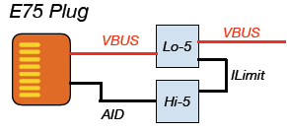

|  |  |
| --- | --- |
| Test Step  Disconnect USB power  USB_DECOUPLE_DISCONNECTED  Release CCG2 Reset  :-) socgpio --pin 97 –pullup  //TL skip this item,so it’s useless item. | |
| CC_MUX_TO_CC_Enable  :-) egpio --pick pmu2 --pin 3 --mode output  :-) wait 100  :-) egpio --pick pmu2 --pin 3 --write 0  //write 0 to cc,1 to mikey | |
| Enable SOC internal  :-) consolerouter --add --dest ramlog --src system.debug.debug  //Routing 'debug' (0x01000000): 'system' -> 'ramlog'  :-) consolerouter --add --dest ramlog --src system.debug.error  //Routing 'debug' (0x80000000): 'system' -> 'ramlog'  :-) consolerouter --add --dest ramlog --src ccg2.*  //Routing all prints: 'ccg2' -> 'ramlog'  :-) consolerouter --add --dest ramlog --src DiagShell  //Routing all prints: 'DiagShell' -> 'ramlog'  :-) ramlog --on 5  //Initializing ram logger to 5Mbytes  read version  :-) socgpio --pin 116 --output 1  //reset  :-) wait 100  :-) i2c -d 0 0x12 0x10 16  // Reading 16 bytes from register offset 0x10 | |
| Related log: :-) i2c -d 0 0x12 0x10 16  Reading 16 bytes from register offset 0x10 into 0xF6F73598, buffer read:  Data: 0xBB 0x02 0x00 0x10 0x69 0x61 0x05 0x00 0xCA 0x02 0x01 0x20 0x69 0x61 0x05 0x00 | |
| CCG2_Bootloader_Ver | |
| CCG2_APP_FW_Ver | |
|  | |
| Disconnect DX2 in tristar | |
| :-) tristar -x "dx2 open"  V_Batt_USB_DEL = 3.65V  // SetBattVolt 3.65V  Disconnect USB power  CONN_DET_L_TO_FLOAT  Switch debug UART to tristar left  P5V_TO_AID_DISCONNECT  ACCX_TO_AID_DISCONNECT  DP2_Disconnect  DP1_TO_USB_HUB_CONNECT | |
| Connect ACC1, ACC2, and USB_CC from the E75 to the MLB | |
| Connect PPVBUS_E75_USB_CONN to VBUS | |
| Connect CON_DET to GND | |
| Delay 1s  Connect NTC10K | |
| TBAT_GNDBOUNCE_LOW1 | |
| :-) pmuadc --sel euphrates --read tbat | |
| Enable Charge  :-) i2c -z 2 -v 0 0x75 0x0443 0x12  //set to high voltage charge mode  :-) consolerouter --add --src ccg2.* --dest ramlog  //Routing all prints: 'ccg2' -> 'ramlog'  :-) consolerouter --add --dest serial --src ccg2.*  //Routing all prints: 'ccg2' -> 'serial' | |
| Enable_PD_5V  :-) i2c -z 2 -v 0 0x75 0x01fd 0x42  :-) i2c -z 2 -d 0 0x75 0x01fd 1  // Read euphrates Status  Related log:  :-) i2c -z 2 -v 0 0x75 0x01fd 0x42  Set bytes: 0x42 Writing 1 bytes  -) i2c -z 2 -d 0 0x75 0x01fd 1  Reading 1 bytes from register offset 0x1FD into 0xF6F72918, buffer read:  Data: 0x00  Set Batt limit  :-) charge --battlimit 6000  Set USB limit  :-) charge --setmv 5000 --setma 2400 | |
| Set ramlog  ramlog --on 5 | |
| 5V USB PD Current Charge 6000 USB 2400 | |
| 5V BATT Current Charge USB PD 2400 | |
| 5V_USB_PD_Voltage_Report_VBUS_Before | |
| :-) pmuadc --sel euphrates --read vbus  Set vbat =3.9v | |
| DisConnect NTC10K Enable_PD_14.8V  :-) charge --battlimit 6000  :-) i2c -z 2 -v 0 0x75 0x0443 0x12  //set to high voltage charge mode  :-) charge --setmv 5000 --setma 2000  :-) charge --setmv 14800 --setma 500  REConnect NTC10K | |
| Enable Charge  :-) i2c -z 2 -v 0 0x75 0x0443 0x12  //set to high voltage charge mode | |
| USB iLimit=500, batt iLlimit=6000  :-) charge --battlimit 6000  :-) charge --setmv 14800 --setma 500  Debug HV USB PD PPVCC_MAIN  //ReadVolt PPVCC_MAIN  PMU_Version_Check  :-) i2c -z 2 -d 0 0x75 0x0040 1  :-) i2c -z 2 -d 0 0x75 0x0050 6  :-) i2c -z 2 -d 0 0x75 0x0060 7  Disconnect USB power  Set USB iLimit  :-) charge --setmv 14800 --setma 500  :-) charge --setmv 14800 --setma 1000  :-) charge --setmv 14800 --setma 2000 |
| HV USB PD Current USB 2000 Tjint_Before  tjint=tostring(string.match(dut_response,"euphrates%s*tjint%s*:%s*(%d*.%d*)")) | |
| HV USB PD Current USB 2000 Mid_die_Before  mid_die=tostring(string.match(dut_response,"euphrates%s*mid_die_temp%s*:%s*(%d*.%d*)")) | |
| HV USB PD Current Charge 6000 USB 2000 | |
| HV BATT Current Charge 6000 USB PD 2000 | |
| HV USB PD PD Charge 6000 USB 2000 VBUS_Fixture | |
| HV USB PD Current USB 2000 Tjint_After | |
| HV USB PD Current USB 2000 Mid_die_After | |
| Set USB ilimit  :-) charge --setmv 5000 --setma 2000  :-) charge --setmv 5000 --setma 250  CONN_DET_L_TO_FLOAT  CC_MUX_TO_MIKEY_Enable  :-) egpio --pick pmu2 --pin 3 --mode output  :-) wait 100  :-) egpio --pick pmu2 --pin 3 --write 1  ACC_PWR power off  :-) accessory --powerpin acc2 --powermode off  //turning off accessory power, setting switch to output power on acc2  VBUS_TO_MLB_DISCONNECT  ACC_ID_TO_MLB_DISCONNECT  ACC_PWR_TO_MLB_DISCONNECT  USB_CC_TO_MLB_DISCONNECT  DP2_TO_USBHUB_UART_CONNECT  P5V_TO_AID_CONNECT  SELECT_ACC1_TO_ACCX  ACCX_TO_AID_CONNECT  CONN_DET_L_TO_GND  DisConnect NTC10K_END  V_Batt_USB_DEL = 4.3V  Set VUSB=5V | |

For more information:

EZ-PD CCG2 provides USB Power Delivery port control solution for passive cables, active cables, and powered accessories.

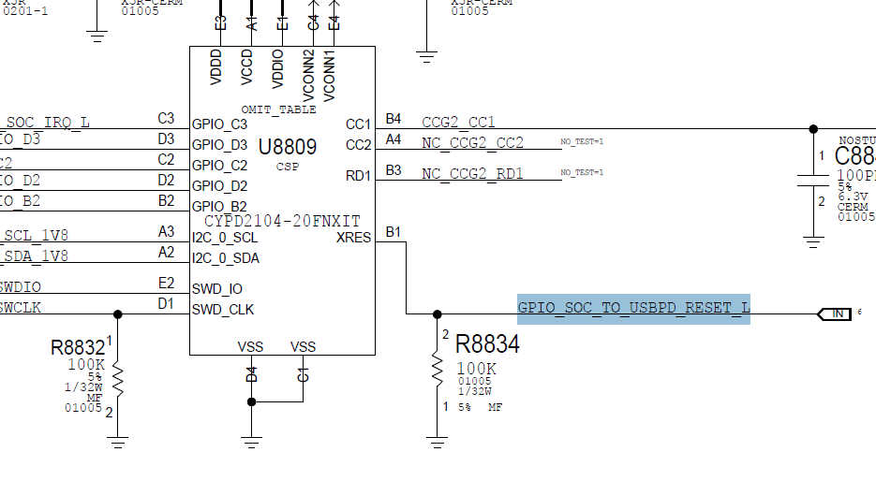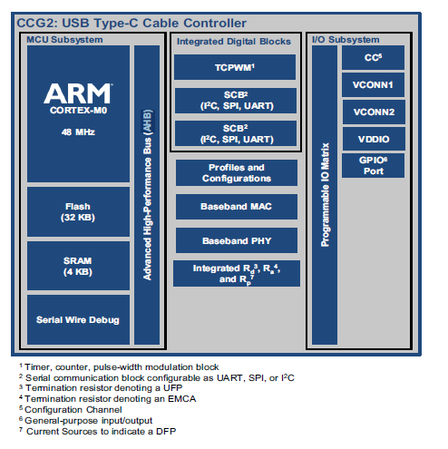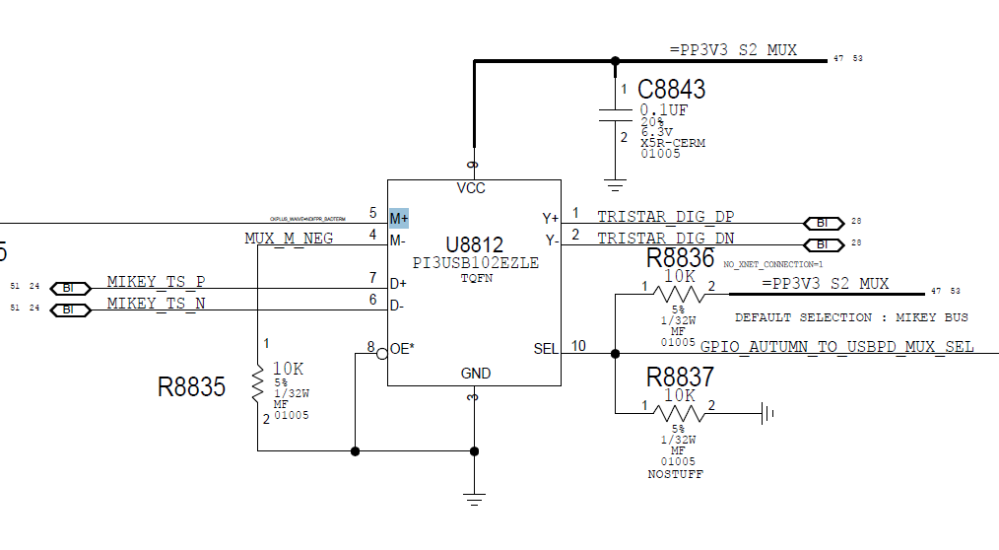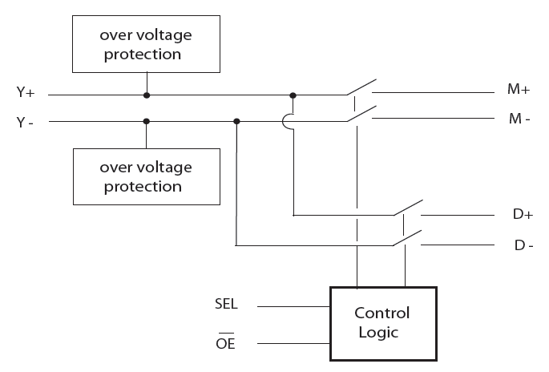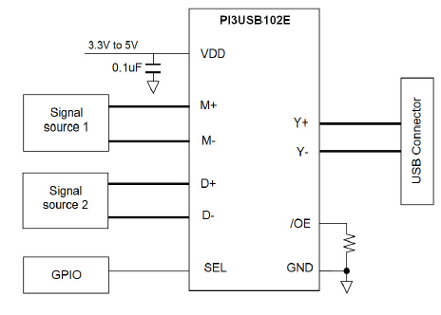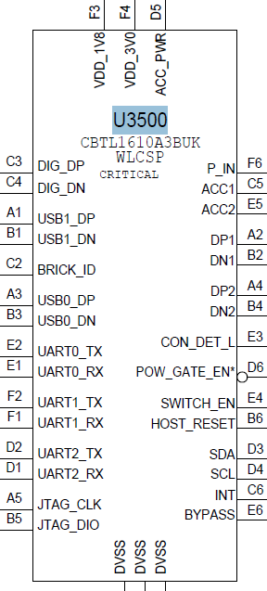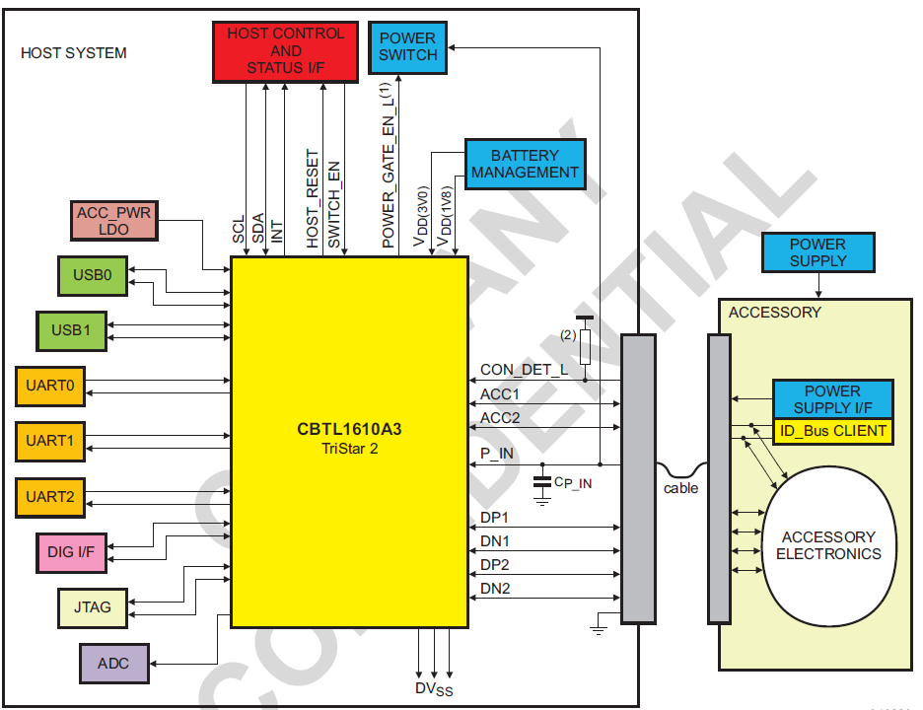

**Level sensitive signal for status of** accessory connection.

TriStar uses the following priority for determining the switch settings:

1. CON_DET_L or P_IN is debounced and valid (highest priority)

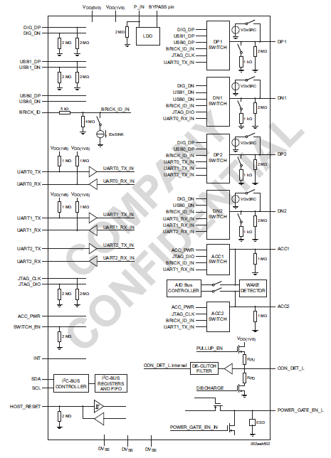

Related log:

-) pmuadc --sel euphrates --read all

PMU ADC test

Read all Channels

euphrates vsys_lo : 4000.6105 mV

euphrates ich_1a : 1000.0000 mA

euphrates tbat : 10432.2344 Ohm

euphrates vbat : 3880.9523 mV

euphrates ibus_in_lg : 2363.8583 mA

euphrates adc_in_p : 1113.9194 mV

euphrates adc_in_n : 1205.8608 mV

euphrates tjint : 52.3731 C

euphrates ibus_in_hg : 330.1587 mA

euphrates vbus : 14046.3980 mV

euphrates vcenter : 13963.3699 mV

euphrates vsys_hi : 4004.8840 mV

euphrates vcenter_temp1 : 58.9118 C

euphrates linchg_temp : 52.9566 C

euphrates chg_buck_temp : 57.8883 C

euphrates vcenter_temp0 : 57.9813 C

euphrates mid_die_temp : 52.0261 C

euphrates lv_ldo_temp : 50.5373 C

euphrates boost_temp : 52.3052 C

euphrates ich_6a : 6000.0000 mA

## 34 LED Brightness Test

Test Overview

LED Brightness Test is testing the voltage and current for backlight LED_A/B/C in different Brightness bank, LEDA/B/C_IO_1/2/3/4 are the LED strings for back light.

These test items contains the tests through diagcmd to set the LED back light in different mode.

The white LED driver circuit provides two different modes of operations. One continuous current mode (referred to as IDAC-MODE) using the 11-bit exponential-IDAC and one PWM controlled modes, where a combination of the exponential-IDAC and an overlaying PWM control is used to modulate the average LED output current.

Test step

|  |
| --- |
| Turn Off The LED  :-) bl -o  Enter test mode  :-) pmurw -w 0x7001 0x44  :-) pmurw -w 0x7002 0x61  :-) pmurw -w 0x7003 0x76  :-) pmurw -w 0x7004 0x65 |
| Set to idac mode  :-) pmurw -w 0x0B07 0x25  00100101 |
| Turn On LED  :-) bl -h  Set to IDAC mini  :-) pmurw -w 0x0B00 0x3F  :-) pmurw -w 0x0B01 0x02 |
| PPLED_BACK_REG_A IDAC_MIN |
| Current LEDIO1 IDAC_MIN_A |
| Current LEDIO2 IDAC_MIN_A |
| Current LEDIO3 IDAC_MIN_A |
| Current LEDIO4 IDAC_MIN_A |
| Current LEDIO5 IDAC_MIN_A |
| PPLED_BACK_REG_B IDAC_MIN |
| Current LEDIO1 IDAC_MIN_B |
| Current LEDIO2 IDAC_MIN_B |
| Current LEDIO3 IDAC_MIN_B |
| Current LEDIO4 IDAC_MIN_B |
| PPLED_BACK_REG_C IDAC_MIN |
| Current LEDIO1 IDAC_MIN_C |
| Current LEDIO2 IDAC_MIN_C |
| Current LEDIO3 IDAC_MIN_C |
| Current LEDIO4 IDAC_MIN_C |
| Set to IDAC MID  :-) pmurw -w 0x0B00 0x7F  :-) pmurw -w 0x0B01 0x06 |
|  |
| PPLED_BACK_REG_A IDAC_MID |
| Current LEDIO1 IDAC_MID_A |
| Current LEDIO2 IDAC_MID_A |
| Current LEDIO3 IDAC_MID_A |
| Current LEDIO4 IDAC_MID_A |
| Current LEDIO5 IDAC_MID_A |
| PPLED_BACK_REG_B IDAC_MID |
| Current LEDIO1 IDAC_MID_B |
| Current LEDIO2 IDAC_MID_B |
| Current LEDIO3 IDAC_MID_B |
| Current LEDIO4 IDAC_MID_B |
| PPLED_BACK_REG_C IDAC_MID |
| Current LEDIO1 IDAC_MID_C |
| Current LEDIO2 IDAC_MID_C |
| Current LEDIO3 IDAC_MID_C |
| Current LEDIO4 IDAC_MID_C |
| Set to IDAC Full  :-) pmurw -w 0x0B00 0xFF  :-) pmurw -w 0x0B01 0x07 |
| PPLED_BACK_REG_A IDAC_FULL |
| Current LEDIO1 IDAC_FULL_A |
| Current LEDIO2 IDAC_FULL_A |
| Current LEDIO3 IDAC_FULL_A |
| Current LEDIO4 IDAC_FULL_A |
| Current LEDIO5 IDAC_FULL_A |
| PPLED_BACK_REG_B IDAC_FULL |
| Current LEDIO1 IDAC_FULL_B |
| Current LEDIO2 IDAC_FULL_B |
| Current LEDIO3 IDAC_FULL_B |
| Current LEDIO4 IDAC_FULL_B |
| PPLED_BACK_REG_C IDAC_FULL |
| Current LEDIO1 IDAC_FULL_C |
| Current LEDIO2 IDAC_FULL_C |
| Current LEDIO3 IDAC_FULL_C |
| Current LEDIO4 IDAC_FULL_C |
| Turn Off The LED  :-) bl –o  Turn Off The LED  :-) bl –o  Set to PWM mode  :-) pmurw -w 0x0B07 0xA5  Turn On The LED  :-) bl –h |
| Set to PWM min  :-) pmurw -w 0x0B00 0x3F  :-) pmurw -w 0x0B01 0x02 |
| PPLED_BACK_REG_A PWM_MIN  Current LEDIO1 PWM_MIN_A  Current LEDIO2 PWM_MIN_A  Current LEDIO3 PWM_MIN_A  Current LEDIO4 PWM_MIN_A  Current LEDIO5 PWM_MIN_A  PPLED_BACK_REG_B PWM_MIN  Current LEDIO1 PWM_MIN_B  Current LEDIO2 PWM_MIN_B  Current LEDIO3 PWM_MIN_B  Current LEDIO4 PWM_MIN_B  PPLED_BACK_REG_C PWM_MIN  Current LEDIO1 PWM_MIN_C  Current LEDIO2 PWM_MIN_C  Current LEDIO3 PWM_MIN_C  Current LEDIO4 PWM_MIN_C |
| Set to PWM mid  :-) pmurw -w 0x0B00 0x7F  :-) pmurw -w 0x0B01 0x06 |
| PPLED_BACK_REG_A PWM_MID |
| Current LEDIO1 PWM_MID_A |
| Current LEDIO2 PWM_MID_A |
| Current LEDIO3 PWM_MID_A |
| Current LEDIO4 PWM_MID_A |
| Current LEDIO5 PWM_MID_A |
| PPLED_BACK_REG_B PWM_MID |
| Current LEDIO1 PWM_MID_B |
| Current LEDIO2 PWM_MID_B |
| Current LEDIO3 PWM_MID_B |
| Current LEDIO4 PWM_MID_B |
| PPLED_BACK_REG_C PWM_MID |
| Current LEDIO1 PWM_MID_C |
| Current LEDIO2 PWM_MID_C |
| Current LEDIO3 PWM_MID_C |
| Current LEDIO4 PWM_MID_C |
| Set to PWM Full  :-) pmurw -w 0x0B00 0xFF  :-) pmurw -w 0x0B01 0x07   |  | | --- | | PPLED_BACK_REG_A PWM_FULL | | Current LEDIO1 PWM_FULL_A | | Current LEDIO2 PWM_FULL_A | | Current LEDIO3 PWM_FULL_A | | Current LEDIO4 PWM_FULL_A | | Current LEDIO5 PWM_FULL_A | | PPLED_BACK_REG_B PWM_FULL | | Current LEDIO1 PWM_FULL_B | | Current LEDIO2 PWM_FULL_B | | Current LEDIO3 PWM_FULL_B | | Current LEDIO4 PWM_FULL_B | | PPLED_BACK_REG_C PWM_FULL | | Current LEDIO1 PWM_FULL_C | | Current LEDIO2 PWM_FULL_C | | Current LEDIO3 PWM_FULL_C | | Current LEDIO4 PWM_FULL_C | |
| Turn off LED  :-) bl -o |
| Exit test mode  For more information: |

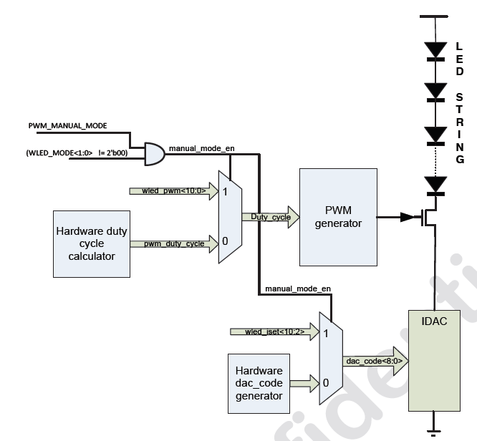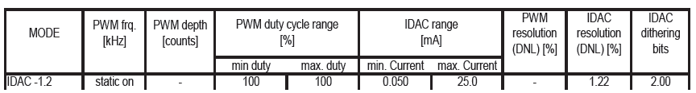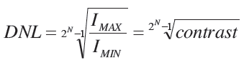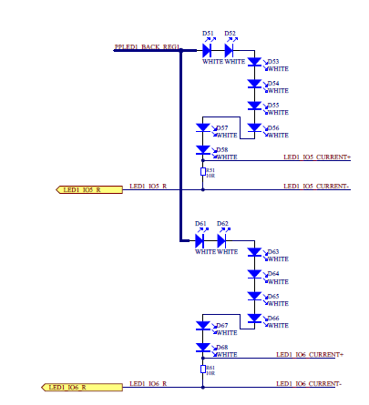

There are three boost converters WLED_BOOST_A, WLED_BOOST_B and WLED_BOOST_C each supplying six or eight (WLED_BOOST_A and WLED_BOOST_B) LED strings. Each string is composed of up to eight WLEDs.

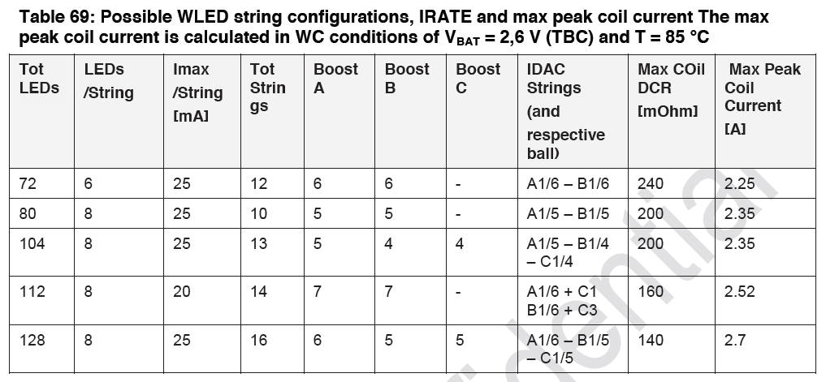

## *******讲师：Baron*******************

## 35 Audio General Test

CODEC Chip/Fab/Rev ID

Test Theory

Power on with battery and enter into Diag mode, then send diagcmd, the board would return some information about CODEC Chip.Laterly,detect headphone and mikeybus with diagcmd. The related cmd as follows:

:-) audio –reset

:-) audio --listblock /*CODEC Chip ID vendor*/

:-)audioreg -b clifden --read --addr 0x1001 1

:-)audioreg -b clifden --read --addr 0x1002 1

:-)audioreg -b clifden --read --addr 0x1003 1 //Codec Device ID

:-)audioreg -b clifden --read --addr 0x1004 1 // Codec Fab ID

:-)audioreg -b clifden --read --addr 0x1005 1 // Codec Rev ID

:-) mikey –detectheadphone

:-) mikey –detectopenmic

Test step:

|  |  |  |  |  |
| --- | --- | --- | --- | --- |
| **Codec Chip ID Vendor** | Cirrus |  | |  |
| :-) audio -r |  |  | |  |
| :-) audio --listblock |  |  | |  |
| audmux: |  |  | |  |
| clifden: |  |  | |  |
|  |  | Type: Codec | |  |
|  |  | Description: Cirrus Logic CS42L83 Codec | | |
|  |  | Power Enabled: true | |  |
| **Codec Chip ID Model** | CS42L83 |  | |  |
| **Codec Device ID** | 0x42 0xA8 0x3A | | |  |
| :-) audioreg -b clifden --read --addr 0x1001 1 | |  | |  |
|  | clifden: |  | |  |
|  |  | 0x1001 = 0x42 | |  |
|  | OK |  | |  |
| :-) audioreg -b clifden --read --addr 0x1002 1 | |  | |  |
|  | clifden: |  | |  |
|  |  | 0x1002 = 0xA8 | |  |
|  | OK |  | |  |
| :-) audioreg -b clifden --read --addr 0x1003 1 | |  | |  |
|  | clifden: |  | |  |
|  |  | 0x1003 = 0x3A | |  |
|  | OK |  | |  |
| **Codec Fab ID** | 0x00 |  | |  |
| :-) audioreg -b clifden --read --addr 0x1004 1 | |  | |  |
|  | clifden: |  | |  |
|  |  | 0x1004 = 0x00 | |  |
|  | OK |  | |  |
| **Codec Rev ID** | 0x0B |  | |  |
| :-) audioreg -b clifden --read --addr 0x1005 1 | |  | |  |
|  | clifden: |  | |  |
|  |  | 0x1005 = 0xB0 | |  |
|  | OK |  | |  |
| **HP_DET Open** | PASS |  | |  |
| :-) mikey --detectheadphone |  |  | |  |
| No Headphone |  |  | |  |
| **connect CONN_HP_HEADSET_DET to GND** | | | |  |
| **HP_DET Close** | PASS |  | |  |
| :-) mikey --detectheadphone |  |  | |  |
| Headphone detected! |  |  | |  |
| **close cmd** |  |  | |  |
| :-) routeaudio -b clifden -i hsin -o asp -r | |  | |  |
| Routing from clifden.hsin[1:0] --> clifden.asp[1:0] | |  | |  |
| OK |  |  | |  |
| **Mic Dectect Open** | PASS |  | |  |
| :-) mikey --detectopenmic |  |  | |  |
| Open MIC detected! |  |  | |  |
| **MIC_CONNECT_2K_LOAD** | |  | |  |
| **Mic Dectect Close** | PASS |  | |  |
| :-) mikey --detectopenmic |  |  | |  |
| Open MIC Not detected |  |  | |  |
| **FRQ_INF** | | |
| FCTSendCmd("FRQ_INF 0.54 500\r\n"); | | |
| **DMIC_MIC_SCLK** | | |
| FCTSendCmd("FRQ_INF 0.6 3000 500\r\n"); | | |
| FREQUENCY_SELECT(FRQ_DMIC_MIC_SCLK); | | |
| ReadFreq(); | | |

## 36 Headphone Mic Global/China Mode Loopback

Test Overview

These items are testing the external Mic function when insert Global or

China headphone.

Related components:

U3000, C3016/C3017, C3012, C3011, R3001, L3001~5

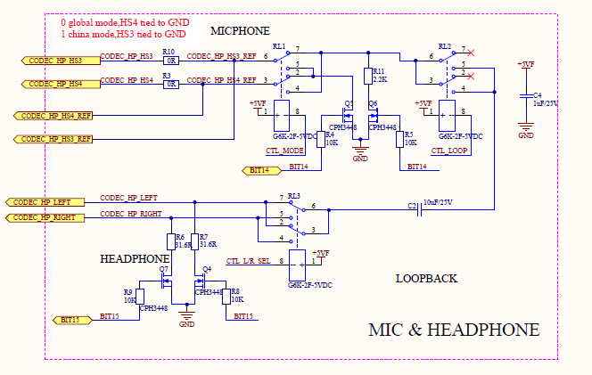

Test Step:

|  |  |  |
| --- | --- | --- |
| **HP_SPK_INPUT_LEFT** |  |  |
| **MIC_CHINA_MODE** |  |  |
| CODEC _HP_HS3&CODEC_HP_HS3_REF to GND |  |  |
| **MIC_CONNECT** |  |  |
| MIC_CONNECT_2K_LOAD |  |  |
| **HP_CONNECT_32R_LOAD_CONNECT** |  |  |
| Connect 32 Ohm between HP and GND |  |  |
| **MIC_GLOBAL_MODE** |  |  |
| CODEC _HP_HS4&CODEC_HP_HS4_REF to GND |  |  |
| **MIC_TO_HP_LOOPBACK** |  |  |
| connect HP_LEFT to HS3_REF |  |  |
| **MIC_GLOBAL_MODE** |  |  |
| CODEC _HP_HS4&CODEC_HP_HS4_REF to GND |  |  |
| **Reset Codec** |  |  |
| :-) audio -r |  |  |
| **Global HP Left Loopback@500mVRMS Frequency** | 1000.488281 |  |
| script: processaudio --freebufs all |  |  |
| //Delete all buffers in the system... |  |  |
| script: device -k HpSwitch -e set_global |  |  |
| script: routeaudio -b clifden -i asp -o hp -r |  |  |
| //Routing from clifden.asp[1:0] --> clifden.hp[1:0] |  |  |
| script: routeaudio -b clifden -i hsin -o asp -r |  |  |
| //Routing from clifden.hsin[1:0] --> clifden.asp[1:0] |  |  |
| script: setvol -b clifden -n mixerAdc -v mute |  |  |
| //Set 'mixerAdc' volume to mute |  |  |
| script: audioreg -b clifden -w -a 0x2303 -d 0x3F |  |  |
| //clifden:write 0x2303 = 0x3F |  |  |
| script: wait 100 |  |  |
| script: loopaudio -b socmca -p ap-mca4 -x ap-mca4 --len 1000 --bitdepth 24 --rate 48000 --channels 8 | |  |
| //Configuring 'socmca' to play/record 48Khz, 24-bit, 8 channels of padded audio data for 1000mS... | | |
| script: processaudio -p crop -i looprx0 -o "--start 5000" |  |  |
| //Using input buffer settings |  |  |
| Allocated output buffer 'process0'  for use with processor... | |  |
| script: processaudio -p fft -o "--normalize false" -i process0 |  |  |
| Channel 4: |  |  |
| Using 32768 bins, Peak Bin= 683; Peak Magnitude=1403736.101096; Frequency: 1000.488281 +/- 0.732421 Hz | | |
| DC Magnitude=44.843075 |  |  |
| Signal Bins=3 |  |  |
| SINAD=11.853594 dB |  |  |
| Peak Power:122.945709 dB |  |  |
| Signal Power: 123.046753 dB |  |  |
| Noise Power: 111.193158 dB |  |  |
| Average Noise PSD: 72.852132 dB |  |  |
| Noise Margin: 50.093577 dB |  |  |
| THD+N: -80.637055 dB |  |  |
| **Global HP Left Loopback@500mVRMS Peak Magnitude** | 122.9457145 | ?? |
| rex="Channel%s*4:.-Peak%s*Magnitude%s*=%s*([+-]?%d+%.?%d+).-Channel%s*5"  rex="Channel%s*0:.-Peak Magnitude=(%d*.%d*) | |  |
| **Global HP Left Loopback@500mVRMS THD+N** | -80.637055 |  |
| **Global HP Left Loopback@500mVRMS Positive dBFS** | -6.268864 |  |
| **Global HP Left Loopback@500mVRMS Negative dBFS** | -6.26934 |  |
| script: processaudio -p rms -i process0 |  |  |
| Channel 4: |  |  |
| Mean: -382.536046 |  |  |
| Mean of Square: 8328936117373.200195 |  |  |
| RMS (Root-Mean-Square): 2885989.625305 |  |  |
| Variance (Mean of Square - Mean Squared): 8328935971039.373046 | |  |
| Positive dBFS: -6.268864 |  |  |
| Negative dBFS: -6.269340 |  |  |
| **Reset Codec** |  |  |
| :-) audio -r |  |  |
| **Global HP Left Loopback@-10dB Frequency** | 1000.488281 |  |
| **Global HP Left Loopback@-10dB Peak Magnitude** | 112.9124756 |  |
| **Global HP Left Loopback@-10dB THD+N** | -73.104357 |  |
| **Global HP Left Loopback@-10dB Positive dBFS** | -16.287208 |  |
| **Global HP Left Loopback@-10dB Negative dBFS** | -16.289721 |  |
| **HP_SPK_INPUT_RIGHT** |  |  |
| **MIC_CHINA_MODE** |  |  |
| CODEC _HP_HS3&CODEC_HP_HS3_REF to GND |  |  |
| **MIC_GLOBAL_MODE** |  |  |
| CODEC _HP_HS4&CODEC_HP_HS4_REF to GND |  |  |
| **Reset Codec** |  |  |
| :-) audio -r |  |  |
| **Global HP Right Loopback@500mVRMS Frequency** | 1000.488281 |  |
| **Global HP Right Loopback@500mVRMS Peak Magnitude** | 122.9685564 |  |
| **Global HP Right Loopback@500mVRMS THD+N** | -80.824518 |  |
| **Global HP Right Loopback@500mVRMS Positive dBFS** | -6.235277 |  |
| **Global HP Right Loopback@500mVRMS Negative dBFS** | -6.235465 |  |
| **Reset Codec** |  |  |
| :-) audio -r |  |  |
| **CMD** |  |  |
| :-) audioreg -b clifden -w -a 0x2701 -d 0x1E |  |  |
| clifden:write |  |  |
|  | 0x2701 = 0x1E |  |
| OK |  |  |
| :-) i2c -m 2 0x48 0x1101 0x1 0x1 |  |  |
| Set bytes: | 0x1D | Writing 1 bytes |
| :-) i2c -m 2 0x48 0x1101 0x1 0x0 |  |  |
| Set bytes: | 0x1C | Writing 1 bytes |
|  | //radar:28770343 |  |
| **Global HP Right Loopback@-10dB Frequency** | 1000.488281 |  |
| **Global HP Right Loopback@-10dB Peak Magnitude** | 112.935181 |  |
| **Global HP Right Loopback@-10dB THD+N** | -73.131442 |  |
| **Global HP Right Loopback@-10dB Positive dBFS** | -16.276005 |  |
| **Global HP Right Loopback@-10dB Negative dBFS** | -16.276836 |  |
| **Global Mode Mic Bias** | 1.34644 |  |
| ReadVolt CODEC_HP_HS4 |  |  |
| **HP_SPK_INPUT_LEFT** |  |  |
| **MIC_GLOBAL_MODE** |  |  |
| CODEC _HP_HS4&CODEC_HP_HS4_REF to GND |  |  |
| **MIC_CONNECT** |  |  |
| MIC_CONNECT_2K_LOAD |  |  |
| **HP_CONNECT_32R_LOAD_CONNECT** |  |  |
| Connect 32 Ohm between HP and GND |  |  |
| **MIC_CHINA_MODE** |  |  |
| CODEC _HP_HS3&CODEC_HP_HS3_REF to GND |  |  |
| **MIC_TO_HP_LOOPBACK** |  |  |
| connect HP_LEFT to HS3_REF |  |  |
| **MIC_CHINA_MODE** |  |  |
| CODEC _HP_HS3&CODEC_HP_HS3_REF to GND |  |  |
| **Reset Codec** |  |  |
| :-) audio -r |  |  |
| **China HP Left Loopback@500mVRMS Frequency** | 1000.488281 |  |
| **China HP Left Loopback@500mVRMS Peak Magnitude** | 122.963702 |  |
| **China HP Left Loopback@500mVRMS THD+N** | -81.316101 |  |
| **China HP Left Loopback@500mVRMS Positive dBFS** | -6.250919 |  |
| **China HP Left Loopback@500mVRMS Negative dBFS** | -6.251802 |  |
| **China HP Left Loopback@-10dB Frequency** | 1000.488281 |  |
| **China HP Left Loopback@-10dB Peak Magnitude** | 112.9300683 |  |
| **China HP Left Loopback@-10dB THD+N** | -73.347176 |  |
| **China HP Left Loopback@-10dB Positive dBFS** | -16.2702 |  |
| **China HP Left Loopback@-10dB Negative dBFS** | -16.271509 |  |
| **China HP Right Loopback@500mVRMS Frequency** | 1000.488281 |  |
| **China HP Right Loopback@500mVRMS Peak Magnitude** | 122.9868051 |  |
| **China HP Right Loopback@500mVRMS THD+N** | -80.772376 |  |
| **China HP Right Loopback@500mVRMS Positive dBFS** | -6.227745 |  |
| **China HP Right Loopback@500mVRMS Negative dBFS** | -6.228753 |  |
| **China HP Right Loopback@-10dB Frequency** | 1000.488281 |  |
| **China HP Right Loopback@-10dB Peak Magnitude** | 112.9529403 |  |
| **China HP Right Loopback@-10dB THD+N** | -73.385197 |  |
| **China HP Right Loopback@-10dB Positive dBFS** | -16.245024 |  |
| **China Mode Mic Bias** | 1.34048 |  |
| **Turn Off Codec** |  |  |
| :-) audio --turnoff socmca |  |  |

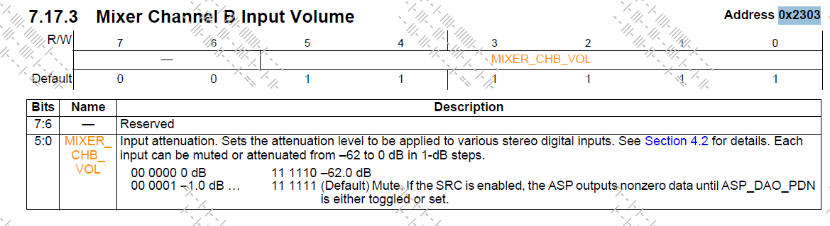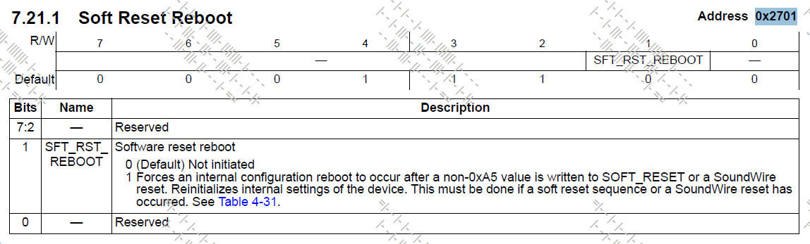

## 37 Speaker Amplifier Tests

Test Overview

These test items are testing the Left & Right speaker amplifier (U3250, U3200,U3301,U3302), including the device ID and function test.

Related components:

U3200, L3210, C3230, C3231, C3220, C3221 and C3223; U3250, L3260, C3280, C3281, C3270, C3271 and C3273,U3301,U3302.

|  |  |  |  |  |  |  |  |  |  |  |  |
| --- | --- | --- | --- | --- | --- | --- | --- | --- | --- | --- | --- |
| Test Step:  **Set Charge 0**  :-) charge --set 0 --force | | | |  |  | |  | |  | |  |
| **Switch Vboost** | | | |  |  | |  | |  | |  |
| **FRQ_INF** | | | |  |  | |  | |  | |  |
| FCTSendCmd（FRQ_INF 1 500 500\r\n） | | | |  |  | |  | |  | |  |
| **Reset Left Speaker Amp** | | | |  |  | |  | |  | |  |
| script: audio --reset | | | |  |  | |  | |  | |  |
| script: audioreg -r -b spkl1 -a 1ff -l 1 | | | |  |  | |  | |  | |  |
| spkl1: | | | |  |  | |  | |  | |  |
|  | | | | 0x1FF = 0x43 |  | |  | |  | |  |
| OK | | | |  |  | |  | |  | |  |
| script: setvol --block spkl1 -n amp-vol --value 0 | | | |  |  | |  | |  | |  |
| Set 'amp-vol' volume to +0 dB | | | |  |  | |  | |  | |  |
| OK | | | |  |  | |  | |  | |  |
| script: getvol --block spkl1 -n amp-vol | | | |  |  | |  | |  | |  |
| amp-vol = +0 dB | | | |  |  | |  | |  | |  |
| OK | | | |  |  | |  | |  | |  |
| script: routeaudio --route --block spkl1 --in spk-i2s --out spk-out | | | |  |  | |  | |  | |  |
| Routing from spkl1.spk-i2s[l] --> spkl1.spk-out[l] | | | |  |  | |  | |  | |  |
| OK | | | |  |  | |  | |  | |  |
| script: loopaudio -b socmca --txport ap-mca2 --rxport ap-mca2 --bitdepth 32 --rate 48000 --len 1500 --freq 2400 | | |  | | |  | |  | |
| Configuring 'socmca' to play/record 48Khz, 32-bit, 2 channels of packed audio data for 1500mS... | |  |  | | |  | |  | |
| script: wait 50 | | | |  |  | |  | |  | |  |
| **Read Revision ID (CN Left)** | | | | 0x1FF = 0x43 |  | |  | |  | |  |
| **HP_SPK_INPUT_LEFT** | | | |  |  | |  | |  | |  |
| **CN Left Speaker Idle Frequency** | | | | 646504.625 |  | |  | |  | |  |
| FREQUENCY_SELECT(FRQ_SPKR2_P_CLOCK) | | | |  |  | |  | |  | |  |
| ReadFreq(); | | | |  |  | |  | |  | |  |
|  | | | | //function ReadFreq will define vpp duty_cycle .. |  | |  | |  | |
| **CN Left Speaker Idle V Peak to Peak** | | | | 10.059 |  | |  | |  | |  |
| return vpp*3 | | | | ？？？ |  | |  | |  | |  |
| **CN Left Speaker Idle Duty Cycle** | | | | 0.504 |  | |  | |  | |  |
| return duty_cycle | | | |  |  | |  | |  | |  |
| **PPVBOOST_CN_L** | | | | 9.92066 |  | |  | |  | |  |
| ReadVolt PPVBOOST_L_CN | | | |  |  | |  | |  | |  |
| **Switch Vboost OFF** | | | |  |  | |  | |  | |  |
|  | | | |  |  | |  | |  | |  |
| **CN_Left_Speaker_Brownout_Voltage_Accuracy** | | | |  |  | |  | |  | |  |
|  |  | |  | |  | |  |
| **Enable BDE** | | | |  |  | |  | |  | |  |
| :-) audio -r | | | |  |  | |  | |  | |  |
| :-)audioparam -b spkl1 -s -n int-enable1 -v 2 | | | |  |  | |  | |  | |  |
| :-)audioreg -b spkl1 -w -a 0x0056 -d 0x40 | | | |  |  | |  | |  | |  |
| spkl1:write | | | |  |  | |  | |  | |  |
|  | | | | 0x56 = 0x40 |  | |  | |  | |  |
| :-)audioreg -b spkl1 -w -a 0x0010 -d 0x01 | | | |  |  | |  | |  | |  |
| spkl1:write | | | |  |  | |  | |  | |  |
|  | | | | 0x10 = 0x01 |  | |  | |  | |  |
| :-)routeaudio -b spkl1 -i spk-i2s -o spk-out -r | | | |  |  | |  | |  | |  |
| Routing from spkl1.spk-i2s[l] --> spkl1.spk-out[l] | | | |  |  | |  | |  | |  |
| **V_Batt_CN_Left = 4.1V** | | | | PASS |  | |  | |  | |  |
| SetBattVolt 4.1V | | | |  |  | |  | |  | |  |
| **V_Batt = 3.9V** | | | |  |  | |  | |  | |  |
| **V_Batt = 3.7V** | | | |  |  | |  | |  | |  |
| **V_Batt = 3..5V** | | | |  |  | |  | |  | |  |
| **V_Batt_CN_Left = 3.38V** | | | | PASS |  | |  | |  | |  |
| SetBattVolt 3.38V | | | |  |  | |  | |  | |  |
| **Read IRQ** | | | |  |  | |  | |  | |  |
| :-) audioreg -r -b spkl1 -a 0x0001 -l 9 | | | |  |  | |  | |  | |  |
| spkl1: | | | |  |  | |  | |  | |  |
|  | | | | 0x01 = 0x00 |  | |  | |  | |  |
|  | | | | 0x02 = 0x00 |  | |  | |  | |  |
|  | | | | 0x03 = 0x00 |  | |  | |  | |  |
|  | | | | 0x04 = 0x00 |  | |  | |  | |  |
|  | | | | 0x05 = 0x80 |  | |  | |  | |  |
|  | | | | 0x06 = 0x00 |  | |  | |  | |  |
|  | | | | 0x07 = 0x00 |  | |  | |  | |  |
|  | | | | 0x08 = 0x00 |  | |  | |  | |  |
|  | | | | 0x09 = 0x00 |  | |  | |  | |  |
| **Read IRQ registers 0x01 (CN Left)** | | | | 0x00 |  | |  | |  | |  |
| **Read IRQ registers 0x02 (CN Left)** | | | | 0x00 |  | |  | |  | |  |
| **Read IRQ registers 0x03 (CN Left)** | | | | 0x00 |  | |  | |  | |  |
| **Read IRQ registers 0x04 (CN Left)** | | | | 0x00 |  | |  | |  | |  |
| **Read IRQ registers 0x05 (CN Left)** | | | | 0x80 |  | |  | |  | |  |
| **Read IRQ registers 0x06 (CN Left)** | | | | 0x00 |  | |  | |  | |  |
| **Read IRQ registers 0x07 (CN Left)** | | | | 0x00 |  | |  | |  | |  |
| **Read IRQ registers 0x08 (CN Left)** | | | | 0x00 |  | |  | |  | |  |
| **Read IRQ registers 0x09 (CN Left)** | | | | 0x00 |  | |  | |  | |  |
| **Clear Interupt** | | | |  |  | |  | |  | |  |
| :-) audioparam -b spkl1 -s -n int-clear1 -v 2 | | | |  |  | |  | |  | |  |
| **Read SOC GPIO&Flag** | | | |  |  | |  | |  | |  |
| :-) socgpio --port 0 --pin 167 --get | | | |  |  | |  | |  | |  |
| SoC GPIO[0,167] = 1 | | | | //GPIO_SPKRAMP_TO_SOC_IRQ_L |  | |  | |  | |  |
| :-)audioreg -r -b spkl1 -a 0x0007 -l 1 | | | |  |  | |  | |  | |  |
| spkl1: | | | |  |  | |  | |  | |  |
|  | | | | 0x07 = 0x00 |  | |  | |  | |  |
| **Read VBAT_CN_L** | | | | 3.3730158 |  | |  | |  | |  |
| :-) pmuadc --sel euphrates --read vbat | | | |  |  | |  | |  | |  |
| PMU ADC test | | | |  |  | |  | |  | |  |
| expansion euphrates: vbat: 3373.0158 mV | | | |  |  | |  | |  | |  |
| **VPBR_CN_LEFT** | | | | 4C |  | |  | |  | |  |
| :-) audioreg -b spkl1 -w -a 0x0056 -d 0x45 | | | |  |  | |  | |  | |  |
| spkl1:write | | | |  |  | |  | |  | |  |
|  | | | | 0x56 = 0x45 |  | |  | |  | |  |
| :-) socgpio --port 0 --pin 167 --get | | | |  |  | |  | |  | |  |
| SoC GPIO[0,167] = 1 | | | |  |  | |  | |  | |  |
| :-)audioreg -r -b spkl1 -a 0x0007 -l 1 | | | |  |  | |  | |  | |  |
| spkl1: | | | |  |  | |  | |  | |  |
|  | | | | 0x07 = 0x00 |  | |  | |  | |  |
| . | | | |  |  | |  | |  | |  |
| . | | | |  |  | |  | |  | |  |
| . | | | |  |  | |  | |  | |  |
| :-) audioreg -b spkl1 -w -a 0x0056 -d 0x4C | | | |  |  | |  | |  | |  |
| spkl1:write | | | |  |  | |  | |  | |  |
|  | | | | 0x56 = 0x4C |  | |  | |  | |  |
| :-) socgpio --port 0 --pin 167 --get | | | |  |  | |  | |  | |  |
| SoC GPIO[0,167] = 0 | | | |  |  | |  | |  | |  |
| :-)audioreg -r -b spkl1 -a 0x0007 -l 1 | | | |  |  | |  | |  | |  |
| spkl1: | | | |  |  | |  | |  | |  |
|  | | | | 0x07 = 0x02 |  | |  | |  | |  |
| **VPBR_CN_LEFT INT** | | | | 76 |  | |  | |  | |  |
| 76=4*16+12 | | | |  |  | |  | |  | |  |
|  | | | |  |  | |  | |  | |  |
| **CN_Left_Speaker_Amplifier_Measurement** | | | |  |  | |  | |  | |  |
|  |  | |  | |  | |  |
| **Reset Codec** | | | |  |  | |  | |  | |  |
| :-) audio -r | | | |  |  | |  | |  | |  |
| **Set VBAT_CN_Left to 4.0V** | | | | PASS |  | |  | |  | |  |
| **HP_SPK_INPUT_LEFT** | | | |  |  | |  | |  | |  |
| **SPK1_CONNECT_4R_LOAD** | | | |  |  | |  | |  | |  |
| **HP_SPK_INPUT_LEFT** | | | |  |  | |  | |  | |  |
| **SPK2_CONNECT_4R_LOAD** | | | |  |  | |  | |  | |  |
| **CN&FH_L** | | | |  |  | |  | |  | |  |
| script: audio -r | | | |  |  | |  | |  | |  |
| script: processaudio --freebufs all | | | |  |  | |  | |  | |  |
| script: audioreg -b spkl2 -w -a 0x0082 -d 0x1C | | | |  |  | |  | |  | |  |
| spkl2:write | | | |  |  | |  | |  | |  |
|  | | | | 0x82 = 0x1C |  | |  | |  | |  |
| script: audioreg -b spkl2 -w -a 0x0083 -d 0x10 | | | |  |  | |  | |  | |  |
| spkl2:write | | | |  |  | |  | |  | |  |
|  | | | | 0x83 = 0x10 |  | |  | |  | |  |
| script: audioreg -b spkl2 -w -a 0x0084 -d 0x02 | | | |  |  | |  | |  | |  |
| spkl2:write | | | |  |  | |  | |  | |  |
|  | | | | 0x84 = 0x02 |  | |  | |  | |  |
| script: audioreg -b spkl2 -w -a 0x0085 -d 0x07 | | | |  |  | |  | |  | |  |
| spkl2:write | | | |  |  | |  | |  | |  |
|  | | | | 0x85 = 0x07 |  | |  | |  | |  |
| script: audioreg -b spkl2 -w -a 0x0086 -d 0x01 | | | |  |  | |  | |  | |  |
| spkl2:write | | | |  |  | |  | |  | |  |
|  | | | | 0x86 = 0x01 |  | |  | |  | |  |
| script: audioparam -b spkl2 -s -n ch-location -v 0 | | | |  |  | |  | |  | |  |
| script: audioparam --set --block spkl2 --param enable-mon --value true | |  |  | | |  | |  | |
| script: audioparam --set --block spkl2 --param ch-vmon --value 4 | | | |  |  | |  | |  | |  |
| script: audioparam --set --block spkl2 --param ch-imon --value 5 | | | |  |  | |  | |  | |  |
| script: routeaudio -b spkl2 -i spk-i2s -o spk-out -r | | | |  |  | |  | |  | |  |
| Routing from spkl2.spk-i2s[l] --> spkl2.spk-out[l] | | | |  |  | |  | |  | |  |
| script: audioparam -b spkl2 -n boost-voltage -g | | | |  |  | |  | |  | |  |
| block specific: | | | |  |  | |  | |  | |  |
|  | | | | spkl2: |  | |  | |  | |  |
|  | | | |  | boost-voltage = 6.477500 | | | | | |  |
| port specific: | | | |  |  | |  | |  | |  |
|  | | | | spkl2: |  | |  | |  | |  |
| script: audioparam -b spkl2 -n battery-voltage -g | | | |  |  | |  | |  | |  |
| block specific: | | | |  |  | |  | |  | |  |
|  | | | | spkl2: |  | |  | |  | |  |
|  | | | |  | battery-voltage = 3.975000 | | | | | |  |
| port specific: | | | |  |  | |  | |  | |  |
|  | | | | spkl2: |  | |  | |  | |  |
| script: audioparam -b spkl2 -n temperature -g | | | |  |  | |  | |  | |  |
| block specific: | | | |  |  | |  | |  | |  |
|  | | | | spkl2: |  | |  | |  | |  |
|  | | | |  | temperature = 27.320000 | | | | | |  |
| port specific: | | | |  |  | |  | |  | |  |
|  | | | | spkl2: |  | |  | |  | |  |
| script: audioreg -b spkl1 -w -a 0x0082 -d 0x1C | | | |  |  | |  | |  | |  |
| spkl1:write | | | |  |  | |  | |  | |  |
|  | | | | 0x82 = 0x1C |  | |  | |  | |  |
| script: audioreg -b spkl1 -w -a 0x0083 -d 0x10 | | | |  |  | |  | |  | |  |
| spkl1:write | | | |  |  | |  | |  | |  |
|  | | | | 0x83 = 0x10 |  | |  | |  | |  |
| script: audioreg -b spkl1 -w -a 0x0084 -d 0x02 | | | |  |  | |  | |  | |  |
| spkl1:write | | | |  |  | |  | |  | |  |
|  | | | | 0x84 = 0x02 |  | |  | |  | |  |
| script: audioreg -b spkl1 -w -a 0x0085 -d 0x07 | | | |  |  | |  | |  | |  |
|  | | | |  |  | |  | |  | |  |
| spkl1:write | | | |  |  | |  | |  | |  |
|  | | | | 0x85 = 0x07 |  | |  | |  | |  |
| script: audioreg -b spkl1 -w -a 0x0086 -d 0x01 | | | |  |  | |  | |  | |  |
| spkl1:write | | | |  |  | |  | |  | |  |
|  | | | | 0x86 = 0x01 |  | |  | |  | |  |
| script: audioparam -b spkl1 -s -n ch-location -v 0 | | | |  |  | |  | |  | |  |
| script: audioparam --set --block spkl1 --param enable-mon --value true | |  |  | | |  | |  | |
| script: audioparam --set --block spkl1 --param ch-vmon --value 0 | | | |  |  | |  | |  | |  |
| script: audioparam --set --block spkl1 --param ch-imon --value 1 | | | |  |  | |  | |  | |  |
| script: routeaudio -b spkl1 -i spk-i2s -o spk-out -r | | | |  |  | |  | |  | |  |
| Routing from spkl1.spk-i2s[l] --> spkl1.spk-out[l] | | | |  |  | |  | |  | |  |
| script: audioparam -b spkl1 -n boost-voltage -g | | | |  |  | |  | |  | |  |
| block specific: | | | |  |  | |  | |  | |  |
|  | | | | spkl1: |  | |  | |  | |  |
|  | | | |  | boost-voltage = 6.485000 | | | | | |  |
| port specific: | | | |  |  | |  | |  | |  |
|  | | | | spkl1: |  | |  | |  | |  |
| script: audioparam -b spkl1 -n battery-voltage -g | | | |  |  | |  | |  | |  |
| block specific: | | | |  |  | |  | |  | |  |
|  | | | | spkl1: |  | |  | |  | |  |
|  | | | |  | battery-voltage = 3.975000 | | | | | |  |
| port specific: | | | |  |  | |  | |  | |  |
|  | | | | spkl1: |  | |  | |  | |  |
| script: audioparam -b spkl1 -n temperature -g | | | |  |  | |  | |  | |  |
| block specific: | | | |  |  | |  | |  | |  |
|  | | | | spkl1: |  | |  | |  | |  |
|  | | | |  | temperature = 24.759999 | | | | | |  |
| port specific: | | | |  |  | |  | |  | |  |
|  | | | | spkl1: |  | |  | |  | |  |
| script: audioparam -b socmca -p ap-mca2 -s -n master-lrclk-enable -v false | |  |  | | |  | |  | |
| script: loopaudio -b socmca --txport ap-mca2 --rxport ap-mca2 --bitdepth 32 --rate 48000 --len 1500 --freq 2400 -c 8 | | |  | | |  | |  | |
| Configuring 'socmca' to play/record 48Khz, 32-bit, 8 channels of packed audio data for 1500mS... | |  |  | | |  | |  | |
| script: processaudio -p crop -i looprx0 -o "--start 7000" | | | |  |  | |  | |  | |  |
| Using input buffer settings | | | |  |  | |  | |  | |  |
| Allocated output buffer 'process0' for use with processor... | | | |  |  | |  | |  | |  |
| script: processaudio -p fft -i process0 -o "--normalize false --peakBinWidth 3" | |  |  | | |  | |  | |
| **CN&FH_LF** | | | |  |  | |  | |  | |  |
| CNL_VMON_F_CH0 | | | |  |  | |  | |  | |  |
| Channel 0: | | | |  |  | |  | |  | |  |
| Using 32768 bins, Peak Bin=1638; Peak Magnitude=92836882.592126; Frequency: 2399.414062 +/- 2.197265 Hz | | |  | | |  | |  | |
| DC Magnitude=1604641.754352 | | | |  |  | |  | |  | |  |
| Signal Bins=7 | | | |  |  | |  | |  | |  |
| SINAD=35.747954 dB | | | |  |  | |  | |  | |  |
| Peak Power: 159.354410 dB | | | |  |  | |  | |  | |  |
| Signal Power: 159.891561 dB | | | |  |  | |  | |  | |  |
| Noise Power: 124.143607 dB | | | |  |  | |  | |  | |  |
| Average Noise PSD: 85.803853 dB | | | |  |  | |  | |  | |  |
| Noise Margin: 73.550557 dB | | | |  |  | |  | |  | |  |
| THD+N: -59.889398 dB | | | |  |  | |  | |  | |  |
| CNL_IMON_F_CH1 | | | |  |  | |  | |  | |  |
| Channel 1: | | | |  |  | |  | |  | |  |
| Using 32768 bins, Peak Bin=1638; Peak Magnitude=72637288.999294; Frequency: 2399.414062 +/- 2.197265 Hz | | |  | | |  | |  | |
| DC Magnitude=8662682.519354 | | | |  |  | |  | |  | |  |
| Signal Bins=7 | | | |  |  | |  | |  | |  |
| SINAD=18.979420 dB | | | |  |  | |  | |  | |  |
| Peak Power: 157.223192 dB | | | |  |  | |  | |  | |  |
| Signal Power: 157.760381 dB | | | |  |  | |  | |  | |  |
| Noise Power: 138.780960 dB | | | |  |  | |  | |  | |  |
| Average Noise PSD: 100.441206 dB | | | |  |  | |  | |  | |  |
| Noise Margin: 56.781985 dB | | | |  |  | |  | |  | |  |
| THD+N: -50.837664 dB | | | |  |  | |  | |  | |  |
| FHL_VMON_F_CH4 | | | |  |  | |  | |  | |  |
| Channel 4: | | | |  |  | |  | |  | |  |
| Using 32768 bins, Peak Bin=1638; Peak Magnitude=93018916.012596; Frequency: 2399.414062 +/- 2.197265 Hz | | |  | | |  | |  | |
| DC Magnitude=2658192.490108 | | | |  |  | |  | |  | |  |
| Signal Bins=7 | | | |  |  | |  | |  | |  |
| SINAD=31.379386 dB | | | |  |  | |  | |  | |  |
| Peak Power: 159.371425 dB | | | |  |  | |  | |  | |  |
| Signal Power: 159.908555 dB | | | |  |  | |  | |  | |  |
| Noise Power: 128.529168 dB | | | |  |  | |  | |  | |  |
| Average Noise PSD: 90.189415 dB | | | |  |  | |  | |  | |  |
| Noise Margin: 69.182010 dB | | | |  |  | |  | |  | |  |
| THD+N: -60.064030 dB | | | |  |  | |  | |  | |  |
| FHL_IMON_F_CH5 | | | |  |  | |  | |  | |  |
| Channel 5: | | | |  |  | |  | |  | |  |
| Using 32768 bins, Peak Bin=1638; Peak Magnitude=75734519.149647; Frequency: 2399.414062 +/- 2.197265 Hz | | |  | | |  | |  | |
| DC Magnitude=2787392.719102 | | | |  |  | |  | |  | |  |
| Signal Bins=7 | | | |  |  | |  | |  | |  |
| SINAD=29.166866 dB | | | |  |  | |  | |  | |  |
| Peak Power: 157.585877 dB | | | |  |  | |  | |  | |  |
| Signal Power: 158.123025 dB | | | |  |  | |  | |  | |  |
| Noise Power: 128.956158 dB | | | |  |  | |  | |  | |  |
| Average Noise PSD: 90.616404 dB | | | |  |  | |  | |  | |  |
| Noise Margin: 66.969472 dB | | | |  |  | |  | |  | |  |
| THD+N: -50.742228 dB | | | |  |  | |  | |  | |  |
| **Get DUT_STRING_L** | | | |  |  | |  | |  | |  |
| script: processaudio -p rms -i process0 | | | |  |  | |  | |  | |  |
| **Get VMON&IMON_CN_L** | | | |  |  | |  | |  | |  |
| CNL_VMON_RMS_CH0 | | | |  |  | |  | |  | |  |
| Channel 0: | | | |  |  | |  | |  | |  |
| Mean: -4060916.058584 | | | |  |  | |  | |  | |  |
| Mean of Square: 37827613896447784.000000 | | | |  |  | |  | |  | |  |
| RMS (Root-Mean-Square): 194493223.266127 | | | |  |  | |  | |  | |  |
| Variance (Mean of Square - Mean Squared): 37811122857212912.000000 | |  |  | | |  | |  | |
| Positive dBFS: -17.933398 | | | |  |  | |  | |  | |  |
| Negative dBFS: -17.674037 | | | |  |  | |  | |  | |  |
| CNL_IMON_RMS_CH1 | | | |  |  | |  | |  | |  |
| Channel 1: | | | |  |  | |  | |  | |  |
| Mean: 21504351.877907 | | | |  |  | |  | |  | |  |
| Mean of Square: 23616526959552352.000000 | | | |  |  | |  | |  | |  |
| RMS (Root-Mean-Square): 153676696.214983 | | | |  |  | |  | |  | |  |
| Variance (Mean of Square - Mean Squared): 23154089809863480.000000 | |  |  | | |  | |  | |
| Positive dBFS: -18.944964 | | | |  |  | |  | |  | |  |
| Negative dBFS: -20.677279 | | | |  |  | |  | |  | |  |
| CNL_VMON_dBFS_P_CH0 | | | |  |  | |  | |  | |  |
| Channel 0: | | | |  |  | |  | |  | |  |
| Mean: -4060916.058584 | | | |  |  | |  | |  | |  |
| Mean of Square: 37827613896447784.000000 | | | |  |  | |  | |  | |  |
| RMS (Root-Mean-Square): 194493223.266127 | | | |  |  | |  | |  | |  |
| Variance (Mean of Square - Mean Squared): 37811122857212912.000000 | |  |  | | |  | |  | |
| Positive dBFS: -17.933398 | | | |  |  | |  | |  | |  |
| Negative dBFS: -17.674037 | | | |  |  | |  | |  | |  |
| CNL_VMON_dBFS_N_CH0 | | | |  |  | |  | |  | |  |
| Channel 0: | | | |  |  | |  | |  | |  |
| Mean: -4060916.058584 | | | |  |  | |  | |  | |  |
| Mean of Square: 37827613896447784.000000 | | | |  |  | |  | |  | |  |
| RMS (Root-Mean-Square): 194493223.266127 | | | |  |  | |  | |  | |  |
| Variance (Mean of Square - Mean Squared): 37811122857212912.000000 | |  |  | | |  | |  | |
| Positive dBFS: -17.933398 | | | |  |  | |  | |  | |  |
| Negative dBFS: -17.674037 | | | |  |  | |  | |  | |  |
| CNL_IMON_dBFS_P_CH1 | | | |  |  | |  | |  | |  |
| Channel 1: | | | |  |  | |  | |  | |  |
| Mean: 21504351.877907 | | | |  |  | |  | |  | |  |
| Mean of Square: 23616526959552352.000000 | | | |  |  | |  | |  | |  |
| RMS (Root-Mean-Square): 153676696.214983 | | | |  |  | |  | |  | |  |
| Variance (Mean of Square - Mean Squared): 23154089809863480.000000 | |  |  | | |  | |  | |
| Positive dBFS: -18.944964 | | | |  |  | |  | |  | |  |
| Negative dBFS: -20.677279 | | | |  |  | |  | |  | |  |
| CNL_IMON_dBFS_N_CH1 | | | |  |  | |  | |  | |  |
| Channel 1: | | | |  |  | |  | |  | |  |
| Mean: 21504351.877907 | | | |  |  | |  | |  | |  |
| Mean of Square: 23616526959552352.000000 | | | |  |  | |  | |  | |  |
| RMS (Root-Mean-Square): 153676696.214983 | | | |  |  | |  | |  | |  |
| Variance (Mean of Square - Mean Squared): 23154089809863480.000000 | |  |  | | |  | |  | |
| Positive dBFS: -18.944964 | | | |  |  | |  | |  | |  |
| Negative dBFS: -20.677279 | | | |  |  | |  | |  | |  |
| **Get VMON&IMON_FH_L** | | | |  |  | |  | |  | |  |
| FHL_VMON_RMS_CH4 | | | |  |  | |  | |  | |  |
| Channel 4: | | | |  |  | |  | |  | |  |
| Mean: 6555706.226215 | | | |  |  | |  | |  | |  |
| Mean of Square: 38002568969665072.000000 | | | |  |  | |  | |  | |  |
| RMS (Root-Mean-Square): 194942476.052975 | | | |  |  | |  | |  | |  |
| Variance (Mean of Square - Mean Squared): 37959591685540632.000000 | |  |  | | |  | |  | |
| Positive dBFS: -17.613409 | | | |  |  | |  | |  | |  |
| Negative dBFS: -18.032162 | | | |  |  | |  | |  | |  |
| FHL_IMON_RMS_CH5 | | | |  |  | |  | |  | |  |
| Channel 5: | | | |  |  | |  | |  | |  |
| Mean: -7005713.707323 | | | |  |  | |  | |  | |  |
| Mean of Square: 25209540567915716.000000 | | | |  |  | |  | |  | |  |
| RMS (Root-Mean-Square): 158775125.784600 | | | |  |  | |  | |  | |  |
| Variance (Mean of Square - Mean Squared): 25160460543366740.000000 | |  |  | | |  | |  | |
| Positive dBFS: -19.826271 | | | |  |  | |  | |  | |  |
| Negative dBFS: -19.267808 | | | |  |  | |  | |  | |  |
| FHL_VMON_dBFS_P_CH4 | | | |  |  | |  | |  | |  |
| Channel 4: | | | |  |  | |  | |  | |  |
| Mean: 6555706.226215 | | | |  |  | |  | |  | |  |
| Mean of Square: 38002568969665072.000000 | | | |  |  | |  | |  | |  |
| RMS (Root-Mean-Square): 194942476.052975 | | | |  |  | |  | |  | |  |
| Variance (Mean of Square - Mean Squared): 37959591685540632.000000 | |  |  | | |  | |  | |
| Positive dBFS: -17.613409 | | | |  |  | |  | |  | |  |
| Negative dBFS: -18.032162 | | | |  |  | |  | |  | |  |
| FHL_VMON_dBFS_N_CH4 | | | |  |  | |  | |  | |  |
| Channel 4: | | | |  |  | |  | |  | |  |
| Mean: 6555706.226215 | | | |  |  | |  | |  | |  |
| Mean of Square: 38002568969665072.000000 | | | |  |  | |  | |  | |  |
| RMS (Root-Mean-Square): 194942476.052975 | | | |  |  | |  | |  | |  |
| Variance (Mean of Square - Mean Squared): 37959591685540632.000000 | |  |  | | |  | |  | |
| Positive dBFS: -17.613409 | | | |  |  | |  | |  | |  |
| Negative dBFS: -18.032162 | | | |  |  | |  | |  | |  |
| FHL_IMON_dBFS_P_CH5 | | | |  |  | |  | |  | |  |
| Channel 5: | | | |  |  | |  | |  | |  |
| Mean: -7005713.707323 | | | |  |  | |  | |  | |  |
| Mean of Square: 25209540567915716.000000 | | | |  |  | |  | |  | |  |
| RMS (Root-Mean-Square): 158775125.784600 | | | |  |  | |  | |  | |  |
| Variance (Mean of Square - Mean Squared): 25160460543366740.000000 | |  |  | | |  | |  | |
| Positive dBFS: -19.826271 | | | |  |  | |  | |  | |  |
| Negative dBFS: -19.267808 | | | |  |  | |  | |  | |  |
| FHL_IMON_dBFS_N_CH5 | | | |  |  | |  | |  | |  |
| Channel 5: | | | |  |  | |  | |  | |  |
| Mean: -7005713.707323 | | | |  |  | |  | |  | |  |
| Mean of Square: 25209540567915716.000000 | | | |  |  | |  | |  | |  |
| RMS (Root-Mean-Square): 158775125.784600 | | | |  |  | |  | |  | |  |
| Variance (Mean of Square - Mean Squared): 25160460543366740.000000 | |  |  | | |  | |  | |
| Positive dBFS: -19.826271 | | | |  |  | |  | |  | |  |
| Negative dBFS: -19.267808 | | | |  |  | |  | |  | |  |
| script: audioreg -r -b spkl1 -a 0x0004 -l 3 | | | |  |  | |  | |  | |  |
| spkl1: | | | |  |  | |  | |  | |  |
|  | | | | 0x04 = 0x00 |  | |  | |  | |  |
|  | | | | 0x05 = 0xD8 |  | |  | |  | |  |
|  | | | | 0x06 = 0x00 |  | |  | |  | |  |
| script: audioreg -r -b spkl2 -a 0x0004 -l 3 | | | |  |  | |  | |  | |  |
| spkl2: | | | |  |  | |  | |  | |  |
|  | | | | 0x04 = 0x00 |  | |  | |  | |  |
|  | | | | 0x05 = 0xD8 |  | |  | |  | |  |
|  | | | | 0x06 = 0x00 |  | |  | |  | |  |
| script: processaudio --freebufs all | | | |  |  | |  | |  | |  |
| Delete all buffers in the system... | | | |  |  | |  | |  | |  |
| script: setvol -b spkl2 -n amp-vol -v -5 | | | |  |  | |  | |  | |  |
| Set 'amp-vol' volume to -5 dB | | | |  |  | |  | |  | |  |
| script: setvol -b spkl2 -n spk-pcm-gain -v 15 | | | |  |  | |  | |  | |  |
| Set 'spk-pcm-gain' volume to +15 dB | | | |  |  | |  | |  | |  |
| script: setvol -b spkl1 -n amp-vol -v -5 | | | |  |  | |  | |  | |  |
| Set 'amp-vol' volume to -5 dB | | | |  |  | |  | |  | |  |
| script: setvol -b spkl1 -n spk-pcm-gain -v 15 | | | |  |  | |  | |  | |  |
| Set 'spk-pcm-gain' volume to +15 dB | | | |  |  | |  | |  | |  |
| script: audioparam -b socmca -p ap-mca2 -s -n master-lrclk-enable -v false | |  |  | | |  | |  | |
| script: loopaudio -b socmca --txport ap-mca2 --rxport ap-mca2 --bitdepth 32 --rate 48000 --len 50 --freq 2400 -c 8 | | |  | | |  | |  | |
| Configuring 'socmca' to play/record 48Khz, 32-bit, 8 channels of packed audio data for 50mS... | |  |  | | |  | |  | |
| script: audioparam -b socmca -p ap-mca2 -s -n master-bclk-enable -v true | |  |  | | |  | |  | |
| script: audioparam -b socmca -p ap-mca2 -s -n master-lrclk-enable -v true | |  |  | | |  | |  | |
| script: wait 50 | | | |  |  | |  | |  | |  |
| script: audioparam -b spkl2 -n boost-voltage -g | | | |  |  | |  | |  | |  |
| block specific: | | | |  |  | |  | |  | |  |
|  | | | | spkl2: |  | |  | |  | |  |
|  | | | |  | boost-voltage = 9.977500 | | | | | |  |
| port specific: | | | |  |  | |  | |  | |  |
|  | | | | spkl2: |  | |  | |  | |  |
| script: audioparam -b spkl1 -n boost-voltage -g | | | |  |  | |  | |  | |  |
| block specific: | | | |  |  | |  | |  | |  |
|  | | | | spkl1: |  | |  | |  | |  |
|  | | | |  | boost-voltage = 9.937500 | | | | | |  |
| port specific: | | | |  |  | |  | |  | |  |
|  | | | | spkl1: |  | |  | |  | |  |
| script: audio --turnoff spkl1 | | | |  |  | |  | |  | |  |
| Turning-off power to spkl1... | | | |  |  | |  | |  | |  |
| script: audio --turnoff spkl2 | | | |  |  | |  | |  | |  |
| Turning-off power to spkl2... | | | |  |  | |  | |  | |  |
| script: audio --turnoff socmca | | | |  |  | |  | |  | |  |
| Turning-off power to socmca... | | | |  |  | |  | |  | |  |
| **HP_SPK_INPUT_RIGHT** | | | |  |  | |  | |  | |  |
| **SPK1_CONNECT_4R_LOAD** | | | |  |  | |  | |  | |  |
| **HP_SPK_INPUT_RIGHT** | | | |  |  | |  | |  | |  |
| **SPK2_CONNECT_4R_LOAD** | | | |  |  | |  | |  | |  |
| **CN&FH_R** | | | |  |  | |  | |  | |  |
| script: audio -r | | | |  |  | |  | |  | |  |
| script: processaudio --freebufs all | | | |  |  | |  | |  | |  |
| Delete all buffers in the system... | | | |  |  | |  | |  | |  |
| script: audioreg -b spkr2 -w -a 0x0082 -d 0x1C | | | |  |  | |  | |  | |  |
| spkr2:write | | | |  |  | |  | |  | |  |
|  | | | | 0x82 = 0x1C |  | |  | |  | |  |
| script: audioreg -b spkr2 -w -a 0x0083 -d 0x10 | | | |  |  | |  | |  | |  |
| spkr2:write | | | |  |  | |  | |  | |  |
|  | | | | 0x83 = 0x10 |  | |  | |  | |  |
| script: audioreg -b spkr2 -w -a 0x0084 -d 0x02 | | | |  |  | |  | |  | |  |
| spkr2:write | | | |  |  | |  | |  | |  |
|  | | | | 0x84 = 0x02 |  | |  | |  | |  |
| script: audioreg -b spkr2 -w -a 0x0085 -d 0x07 | | | |  |  | |  | |  | |  |
| spkr2:write | | | |  |  | |  | |  | |  |
|  | | | | 0x85 = 0x07 |  | |  | |  | |  |
| script: audioreg -b spkr2 -w -a 0x0086 -d 0x01 | | | |  |  | |  | |  | |  |
| spkr2:write | | | |  |  | |  | |  | |  |
|  | | | | 0x86 = 0x01 |  | |  | |  | |  |
| script: audioparam -b spkr2 -s -n ch-location -v 0 | | | |  |  | |  | |  | |  |
| script: audioparam --set --block spkr2 --param enable-mon --value true | |  |  | | |  | |  | |
| script: audioparam --set --block spkr2 --param ch-vmon --value 6 | | | |  |  | |  | |  | |  |
| script: audioparam --set --block spkr2 --param ch-imon --value 7 | | | |  |  | |  | |  | |  |
| script: routeaudio -b spkr2 -i spk-i2s -o spk-out -r | | | |  |  | |  | |  | |  |
| Routing from spkr2.spk-i2s[l] --> spkr2.spk-out[l] | | | |  |  | |  | |  | |  |
| script: audioparam -b spkr2 -n boost-voltage -g | | | |  |  | |  | |  | |  |
| block specific: | | | |  |  | |  | |  | |  |
|  | | | | spkr2: |  | |  | |  | |  |
|  | | | |  | boost-voltage = 6.500000 | | | | | |  |
| port specific: | | | |  |  | |  | |  | |  |
|  | | | | spkr2: |  | |  | |  | |  |
| script: audioparam -b spkr2 -n battery-voltage -g | | | |  |  | |  | |  | |  |
| block specific: | | | |  |  | |  | |  | |  |
|  | | | | spkr2: |  | |  | |  | |  |
|  | | | |  | battery-voltage = 3.981250 | | | | | |  |
| port specific: | | | |  |  | |  | |  | |  |
|  | | | | spkr2: |  | |  | |  | |  |
| script: audioparam -b spkr2 -n temperature -g | | | |  |  | |  | |  | |  |
| block specific: | | | |  |  | |  | |  | |  |
|  | | | | spkr2: |  | |  | |  | |  |
|  | | | |  | temperature = 26.935999 | | | | | |  |
| port specific: | | | |  |  | |  | |  | |  |
|  | | | | spkr2: |  | |  | |  | |  |
| script: audioreg -b spkr1 -w -a 0x0082 -d 0x1C | | | |  |  | |  | |  | |  |
| spkr1:write | | | |  |  | |  | |  | |  |
|  | | | | 0x82 = 0x1C |  | |  | |  | |  |
| script: audioreg -b spkr1 -w -a 0x0083 -d 0x10 | | | |  |  | |  | |  | |  |
| spkr1:write | | | |  |  | |  | |  | |  |
|  | | | | 0x83 = 0x10 |  | |  | |  | |  |
| script: audioreg -b spkr1 -w -a 0x0084 -d 0x02 | | | |  |  | |  | |  | |  |
| spkr1:write | | | |  |  | |  | |  | |  |
|  | | | | 0x84 = 0x02 |  | |  | |  | |  |
| script: audioreg -b spkr1 -w -a 0x0085 -d 0x07 | | | |  |  | |  | |  | |  |
| spkr1:write | | | |  |  | |  | |  | |  |
|  | | | | 0x85 = 0x07 |  | |  | |  | |  |
| script: audioreg -b spkr1 -w -a 0x0086 -d 0x01 | | | |  |  | |  | |  | |  |
| spkr1:write | | | |  |  | |  | |  | |  |
|  | | | | 0x86 = 0x01 |  | |  | |  | |  |
| script: audioparam -b spkr1 -s -n ch-location -v 0 | | | |  |  | |  | |  | |  |
| script: audioparam --set --block spkr1 --param enable-mon --value true | |  |  | | |  | |  | |
| script: audioparam --set --block spkr1 --param ch-vmon --value 2 | | | |  |  | |  | |  | |  |
| script: audioparam --set --block spkr1 --param ch-imon --value 3 | | | |  |  | |  | |  | |  |
| script: routeaudio -b spkr1 -i spk-i2s -o spk-out -r | | | |  |  | |  | |  | |  |
| Routing from spkr1.spk-i2s[l] --> spkr1.spk-out[l] | | | |  |  | |  | |  | |  |
| script: audioparam -b spkr1 -n boost-voltage -g | | | |  |  | |  | |  | |  |
| block specific: | | | |  |  | |  | |  | |  |
|  | | | | spkr1: |  | |  | |  | |  |
|  | | | |  | boost-voltage = 6.474999 | | | | | |  |
| port specific: | | | |  |  | |  | |  | |  |
|  | | | | spkr1: |  | |  | |  | |  |
| script: audioparam -b spkr1 -n battery-voltage -g | | | |  |  | |  | |  | |  |
| block specific: | | | |  |  | |  | |  | |  |
|  | | | | spkr1: |  | |  | |  | |  |
|  | | | |  | battery-voltage = 3.975000 | | | | | |  |
| port specific: | | | |  |  | |  | |  | |  |
|  | | | | spkr1: |  | |  | |  | |  |
| script: audioparam -b spkr1 -n temperature -g | | | |  |  | |  | |  | |  |
| block specific: | | | |  |  | |  | |  | |  |
|  | | | | spkr1: |  | |  | |  | |  |
|  | | | |  | temperature = 25.143999 | | | | | |  |
| port specific: | | | |  |  | |  | |  | |  |
|  | | | | spkr1: |  | |  | |  | |  |
|  | | | |  |  | |  | |  | |  |
| script: audioparam -b socmca -p ap-mca2 -s -n master-lrclk-enable -v false | |  |  | | |  | |  | |
| script: loopaudio -b socmca --txport ap-mca2 --rxport ap-mca2 --bitdepth 32 --rate 48000 --len 1500 --freq 2400 -c 8 | | |  | | |  | |  | |
| Configuring 'socmca' to play/record 48Khz, 32-bit, 8 channels of packed audio data for 1500mS... | |  |  | | |  | |  | |
| script: processaudio -p crop -i looprx0 -o "--start 7000" | | | |  |  | |  | |  | |  |
| Using input buffer settings | | | |  |  | |  | |  | |  |
| Allocated output buffer 'process0' for use with processor... | | | |  |  | |  | |  | |  |
| script: processaudio -p fft -i process0 -o "--normalize false --peakBinWidth 3" | |  |  | | |  | |  | |
| **CN&FH_RF** | | | |  |  | |  | |  | |  |
| CNR_VMON_F_CH2 | | | |  |  | |  | |  | |  |
| Channel 2: | | | |  |  | |  | |  | |  |
| Using 32768 bins, Peak Bin=1638; Peak Magnitude=93066953.996472; Frequency: 2399.414062 +/- 2.197265 Hz | | |  | | |  | |  | |
| DC Magnitude=5426132.648696 | | | |  |  | |  | |  | |  |
| Signal Bins=7 | | | |  |  | |  | |  | |  |
| SINAD=25.202473 dB | | | |  |  | |  | |  | |  |
| Peak Power: 159.375910 dB | | | |  |  | |  | |  | |  |
| Signal Power: 159.912991 dB | | | |  |  | |  | |  | |  |
| Noise Power: 134.710518 dB | | | |  |  | |  | |  | |  |
| Average Noise PSD: 96.370764 dB | | | |  |  | |  | |  | |  |
| Noise Margin: 63.005145 dB | | | |  |  | |  | |  | |  |
| THD+N: -59.421555 dB | | | |  |  | |  | |  | |  |
| CNR_IMON_F_CH3 | | | |  |  | |  | |  | |  |
| Channel 3: | | | |  |  | |  | |  | |  |
| Using 32768 bins, Peak Bin=1638; Peak Magnitude=73905000.414754; Frequency: 2399.414062 +/- 2.197265 Hz | | |  | | |  | |  | |
| DC Magnitude=2955111.732812 | | | |  |  | |  | |  | |  |
| Signal Bins=7 | | | |  |  | |  | |  | |  |
| SINAD=28.447193 dB | | | |  |  | |  | |  | |  |
| Peak Power: 157.373476 dB | | | |  |  | |  | |  | |  |
| Signal Power: 157.910591 dB | | | |  |  | |  | |  | |  |
| Noise Power: 129.463398 dB | | | |  |  | |  | |  | |  |
| Average Noise PSD: 91.123644 dB | | | |  |  | |  | |  | |  |
| Noise Margin: 66.249832 dB | | | |  |  | |  | |  | |  |
| THD+N: -50.601596 dB | | | |  |  | |  | |  | |  |
| FHR_VMON_F_CH6 | | | |  |  | |  | |  | |  |
| Channel 6: | | | |  |  | |  | |  | |  |
| Using 32768 bins, Peak Bin=1638; Peak Magnitude=93323380.589923; Frequency: 2399.414062 +/- 2.197265 Hz | | |  | | |  | |  | |
| DC Magnitude=638165.173964 | | | |  |  | |  | |  | |  |
| Signal Bins=7 | | | |  |  | |  | |  | |  |
| SINAD=43.599876 dB | | | |  |  | |  | |  | |  |
| Peak Power: 159.399809 dB | | | |  |  | |  | |  | |  |
| Signal Power: 159.936999 dB | | | |  |  | |  | |  | |  |
| Noise Power: 116.337123 dB | | | |  |  | |  | |  | |  |
| Average Noise PSD: 77.997369 dB | | | |  |  | |  | |  | |  |
| Noise Margin: 81.402439 dB | | | |  |  | |  | |  | |  |
| THD+N: -59.152985 dB | | | |  |  | |  | |  | |  |
| FHR_IMON_F_CH7 | | | |  |  | |  | |  | |  |
| Channel 7: | | | |  |  | |  | |  | |  |
| Using 32768 bins, Peak Bin=1638; Peak Magnitude=75332158.542306; Frequency: 2399.414062 +/- 2.197265 Hz | | |  | | |  | |  | |
| DC Magnitude=2150564.065318 | | | |  |  | |  | |  | |  |
| Signal Bins=7 | | | |  |  | |  | |  | |  |
| SINAD=31.324210 dB | | | |  |  | |  | |  | |  |
| Peak Power: 157.539608 dB | | | |  |  | |  | |  | |  |
| Signal Power: 158.076769 dB | | | |  |  | |  | |  | |  |
| Noise Power: 126.752558 dB | | | |  |  | |  | |  | |  |
| Average Noise PSD: 88.412804 dB | | | |  |  | |  | |  | |  |
| Noise Margin: 69.126803 dB | | | |  |  | |  | |  | |  |
| THD+N: -50.530431 dB | | | |  |  | |  | |  | |  |
| **Get DUT_STRING_R** | | | |  |  | |  | |  | |  |
| script: processaudio -p rms -i process0 | | | |  |  | |  | |  | |  |
| **Get VMON&IMON_CN_R** | | | |  |  | |  | |  | |  |
| CNR_VMON_RMS_CH2 | | | |  |  | |  | |  | |  |
| Channel 2: | | | |  |  | |  | |  | |  |
| Mean: -13592353.933784 | | | |  |  | |  | |  | |  |
| Mean of Square: 38187375562732576.000000 | | | |  |  | |  | |  | |  |
| RMS (Root-Mean-Square): 195415904.068048 | | | |  |  | |  | |  | |  |
| Variance (Mean of Square - Mean Squared): 38002623477271304.000000 | |  |  | | |  | |  | |
| Positive dBFS: -18.174923 | | | |  |  | |  | |  | |  |
| Negative dBFS: -17.310624 | | | |  |  | |  | |  | |  |
| CNR_IMON_RMS_CH3 | | | |  |  | |  | |  | |  |
| Channel 3: | | | |  |  | |  | |  | |  |
| Mean: -7444674.843569 | | | |  |  | |  | |  | |  |
| Mean of Square: 24016895446205392.000000 | | | |  |  | |  | |  | |  |
| RMS (Root-Mean-Square): 154973854.072889 | | | |  |  | |  | |  | |  |
| Variance (Mean of Square - Mean Squared): 23961472262678920.000000 | |  |  | | |  | |  | |
| Positive dBFS: -20.026016 | | | |  |  | |  | |  | |  |
| Negative dBFS: -19.440055 | | | |  |  | |  | |  | |  |
| CNR_VMON_dBFS_P_CH2 | | | |  |  | |  | |  | |  |
| Channel 2: | | | |  |  | |  | |  | |  |
| Mean: -13592353.933784 | | | |  |  | |  | |  | |  |
| Mean of Square: 38187375562732576.000000 | | | |  |  | |  | |  | |  |
| RMS (Root-Mean-Square): 195415904.068048 | | | |  |  | |  | |  | |  |
| Variance (Mean of Square - Mean Squared): 38002623477271304.000000 | |  |  | | |  | |  | |
| Positive dBFS: -18.174923 | | | |  |  | |  | |  | |  |
| Negative dBFS: -17.310624 | | | |  |  | |  | |  | |  |
| CNR_VMON_dBFS_N_CH2 | | | |  |  | |  | |  | |  |
| Channel 2: | | | |  |  | |  | |  | |  |
| Mean: -13592353.933784 | | | |  |  | |  | |  | |  |
| Mean of Square: 38187375562732576.000000 | | | |  |  | |  | |  | |  |
| RMS (Root-Mean-Square): 195415904.068048 | | | |  |  | |  | |  | |  |
| Variance (Mean of Square - Mean Squared): 38002623477271304.000000 | |  |  | | |  | |  | |
| Positive dBFS: -18.174923 | | | |  |  | |  | |  | |  |
| Negative dBFS: -17.310624 | | | |  |  | |  | |  | |  |
| CNR_IMON_dBFS_P_CH3 | | | |  |  | |  | |  | |  |
| Channel 3: | | | |  |  | |  | |  | |  |
| Mean: -7444674.843569 | | | |  |  | |  | |  | |  |
| Mean of Square: 24016895446205392.000000 | | | |  |  | |  | |  | |  |
| RMS (Root-Mean-Square): 154973854.072889 | | | |  |  | |  | |  | |  |
| Variance (Mean of Square - Mean Squared): 23961472262678920.000000 | |  |  | | |  | |  | |
| Positive dBFS: -20.026016 | | | |  |  | |  | |  | |  |
| Negative dBFS: -19.440055 | | | |  |  | |  | |  | |  |
| CNR_IMON_dBFS_N_CH3 | | | |  |  | |  | |  | |  |
| Channel 3: | | | |  |  | |  | |  | |  |
| Mean: -7444674.843569 | | | |  |  | |  | |  | |  |
| Mean of Square: 24016895446205392.000000 | | | |  |  | |  | |  | |  |
| RMS (Root-Mean-Square): 154973854.072889 | | | |  |  | |  | |  | |  |
| Variance (Mean of Square - Mean Squared): 23961472262678920.000000 | |  |  | | |  | |  | |
| Positive dBFS: -20.026016 | | | |  |  | |  | |  | |  |
| Negative dBFS: -19.440055 | | | |  |  | |  | |  | |  |
| **Get VMON&IMON_FH_R** | | | |  |  | |  | |  | |  |
| FHR_VMON_RMS_CH6 | | | |  |  | |  | |  | |  |
| Channel 6: | | | |  |  | |  | |  | |  |
| Mean: 1550983.041969 | | | |  |  | |  | |  | |  |
| Mean of Square: 38209804845082184.000000 | | | |  |  | |  | |  | |  |
| RMS (Root-Mean-Square): 195473284.223400 | | | |  |  | |  | |  | |  |
| Variance (Mean of Square - Mean Squared): 38207399296685704.000000 | |  |  | | |  | |  | |
| Positive dBFS: -17.808926 | | | |  |  | |  | |  | |  |
| Negative dBFS: -17.906277 | | | |  |  | |  | |  | |  |
| FHR_IMON_RMS_CH7 | | | |  |  | |  | |  | |  |
| Channel 7: | | | |  |  | |  | |  | |  |
| Mean: 5266789.549292 | | | |  |  | |  | |  | |  |
| Mean of Square: 24920803014405748.000000 | | | |  |  | |  | |  | |  |
| RMS (Root-Mean-Square): 157863241.492140 | | | |  |  | |  | |  | |  |
| Variance (Mean of Square - Mean Squared): 24893063942249212.000000 | |  |  | | |  | |  | |
| Positive dBFS: -19.368280 | | | |  |  | |  | |  | |  |
| Negative dBFS: -19.774461 | | | |  |  | |  | |  | |  |
| FHR_VMON_dBFS_P_CH6 | | | |  |  | |  | |  | |  |
| Channel 6: | | | |  |  | |  | |  | |  |
| Mean: 1550983.041969 | | | |  |  | |  | |  | |  |
| Mean of Square: 38209804845082184.000000 | | | |  |  | |  | |  | |  |
| RMS (Root-Mean-Square): 195473284.223400 | | | |  |  | |  | |  | |  |
| Variance (Mean of Square - Mean Squared): 38207399296685704.000000 | |  |  | | |  | |  | |
| Positive dBFS: -17.808926 | | | |  |  | |  | |  | |  |
| Negative dBFS: -17.906277 | | | |  |  | |  | |  | |  |
| FHR_VMON_dBFS_N_CH6 | | | |  |  | |  | |  | |  |
| Channel 6: | | | |  |  | |  | |  | |  |
| Mean: 1550983.041969 | | | |  |  | |  | |  | |  |
| Mean of Square: 38209804845082184.000000 | | | |  |  | |  | |  | |  |
| RMS (Root-Mean-Square): 195473284.223400 | | | |  |  | |  | |  | |  |
| Variance (Mean of Square - Mean Squared): 38207399296685704.000000 | |  |  | | |  | |  | |
| Positive dBFS: -17.808926 | | | |  |  | |  | |  | |  |
| Negative dBFS: -17.906277 | | | |  |  | |  | |  | |  |
| FHR_IMON_dBFS_P_CH7 | | | |  |  | |  | |  | |  |
| Channel 7: | | | |  |  | |  | |  | |  |
| Mean: 5266789.549292 | | | |  |  | |  | |  | |  |
| Mean of Square: 24920803014405748.000000 | | | |  |  | |  | |  | |  |
| RMS (Root-Mean-Square): 157863241.492140 | | | |  |  | |  | |  | |  |
| Variance (Mean of Square - Mean Squared): 24893063942249212.000000 | |  |  | | |  | |  | |
| Positive dBFS: -19.368280 | | | |  |  | |  | |  | |  |
| Negative dBFS: -19.774461 | | | |  |  | |  | |  | |  |
| FHR_IMON_dBFS_N_CH7 | | | |  |  | |  | |  | |  |
| Channel 7: | | | |  |  | |  | |  | |  |
| Mean: 5266789.549292 | | | |  |  | |  | |  | |  |
| Mean of Square: 24920803014405748.000000 | | | |  |  | |  | |  | |  |
| RMS (Root-Mean-Square): 157863241.492140 | | | |  |  | |  | |  | |  |
| Variance (Mean of Square - Mean Squared): 24893063942249212.000000 | |  |  | | |  | |  | |
| Positive dBFS: -19.368280 | | | |  |  | |  | |  | |  |
| Negative dBFS: -19.774461 | | | |  |  | |  | |  | |  |
| script: audioreg -r -b spkr1 -a 0x0004 -l 3 | | | |  |  | |  | |  | |  |
| spkr1: | | | |  |  | |  | |  | |  |
|  | | | | 0x04 = 0x00 |  | |  | |  | |  |
|  | | | | 0x05 = 0xD8 |  | |  | |  | |  |
|  | | | | 0x06 = 0x00 |  | |  | |  | |  |
| script: audioreg -r -b spkr2 -a 0x0004 -l 3 | | | |  |  | |  | |  | |  |
| spkr2: | | | |  |  | |  | |  | |  |
|  | | | | 0x04 = 0x00 |  | |  | |  | |  |
|  | | | | 0x05 = 0xD8 |  | |  | |  | |  |
|  | | | | 0x06 = 0x00 |  | |  | |  | |  |
| script: setvol -b spkr2 -n amp-vol -v -5 | | | |  |  | |  | |  | |  |
| Set 'amp-vol' volume to -5 dB | | | |  |  | |  | |  | |  |
| script: setvol -b spkr2 -n spk-pcm-gain -v 15 | | | |  |  | |  | |  | |  |
| Set 'spk-pcm-gain' volume to +15 dB | | | |  |  | |  | |  | |  |
| script: setvol -b spkr1 -n amp-vol -v -5 | | | |  |  | |  | |  | |  |
| Set 'amp-vol' volume to -5 dB | | | |  |  | |  | |  | |  |
| script: setvol -b spkr1 -n spk-pcm-gain -v 15 | | | |  |  | |  | |  | |  |
| Set 'spk-pcm-gain' volume to +15 dB | | | |  |  | |  | |  | |  |
| script: audioparam -b socmca -p ap-mca2 -s -n master-lrclk-enable -v false | |  |  | | |  | |  | |
| script: loopaudio -b socmca --txport ap-mca2 --rxport ap-mca2 --bitdepth 32 --rate 48000 --len 50 --freq 2400 -c 8 | | |  | | |  | |  | |
| Configuring 'socmca' to play/record 48Khz, 32-bit, 8 channels of packed audio data for 50mS... | |  |  | | |  | |  | |
| script: audioparam -b socmca -p ap-mca2 -s -n master-bclk-enable -v true | |  |  | | |  | |  | |
| script: audioparam -b socmca -p ap-mca2 -s -n master-lrclk-enable -v true | |  |  | | |  | |  | |
| script: wait 50 | | | |  |  | |  | |  | |  |
| script: audioparam -b spkr2 -n boost-voltage -g | | | |  |  | |  | |  | |  |
| block specific: | | | |  |  | |  | |  | |  |
|  | | | | spkr2: |  | |  | |  | |  |
|  | | | |  | boost-voltage = 9.962500 | | | | | |  |
| port specific: | | | |  |  | |  | |  | |  |
|  | | | | spkr2: |  | |  | |  | |  |
| script: audioparam -b spkr1 -n boost-voltage -g | | | |  |  | |  | |  | |  |
| block specific: | | | |  |  | |  | |  | |  |
|  | | | | spkr1: |  | |  | |  | |  |
|  | | | |  | boost-voltage = 9.950000 | | | | | |  |
| port specific: | | | |  |  | |  | |  | |  |
|  | | | | spkr1: |  | |  | |  | |  |
| script: audio --turnoff spkr1 | | | |  |  | |  | |  | |  |
| Turning-off power to spkr1... | | | |  |  | |  | |  | |  |
| script: audio --turnoff spkr2 | | | |  |  | |  | |  | |  |
| Turning-off power to spkr2... | | | |  |  | |  | |  | |  |
| script: audio --turnoff socmca | | | |  |  | |  | |  | |  |
| Turning-off power to socmca.. | | | |  |  | |  | |  | |  |
| **CN_Load_Disconnect** | | | |  |  | |  | |  | |  |
| SPK1_CONNECT_4R_LOAD_DIS | | | |  |  | |  | |  | |  |
| **FH_Load_Disconnect** | | | |  |  | |  | |  | |  |
| **Just send blank** | | | |  |  | |  | |  | |  |
| :-) | | | |  |  | |  | |  | |  |
| **VMON_RMS_CN_Left** | | | | 0.996247612 |  | |  | |  | |  |
| ret=11*CNL_VMON_RMS_CH0/(2^31-1) | | | |  |  | |  | |  | |  |
| 0.996247612 | | | |  |  | |  | |  | |  |
| **IMON_RMS_CN_Left** | | | | 214.6838647 |  | |  | |  | |  |
| ret=3*CNL_IMON_RMS_CH1/(2^31-1) | | | |  |  | |  | |  | |  |
| return ret*1000 | | | |  |  | |  | |  | |  |
| 0.214683865 | | | |  |  | |  | |  | |  |
| **VMON_PP_CN_Left** | | | | 2.833252022 |  | |  | |  | |  |
| ret=11*(10^(CNL_VMON_dBFS_P_CH0/20)+10^(CNL_VMON_dBFS_N_CH0/20)) | |  |  | | |  | |  | |
| 2.833252022 | | | |  |  | |  | |  | |  |
| **IMON_PP_CN_Left** | | | | 616.2414946 |  | |  | |  | |  |
| ret=3*(10^(CNL_IMON_dBFS_P_CH1/20)+10^(CNL_IMON_dBFS_N_CH1/20)) | |  |  | | |  | |  | |
| return ret*1000 | | | |  |  | |  | |  | |  |
| 0.616241495 | | | |  |  | |  | |  | |  |
| **CN_Left_VMON_Frequency** | | | | 2399.414062 |  | |  | |  | |  |
| return tonumber(CNL_VMON_F_CH0) | | | |  |  | |  | |  | |  |
| **CN_Left_IMON_Frequency** | | | | 2399.414062 |  | |  | |  | |  |
| return tonumber(CNL_IMON_F_CH1) | | | |  |  | |  | |  | |  |
| **CN_Left_VMON_FFT PeakMagnitude** | | | | 0.475535965 |  | |  | |  | |  |
| Channel 0: | | | |  |  | |  | |  | |  |
| Using 32768 bins, Peak Bin=1638; Peak Magnitude=92836882.592126; Frequency: 2399.414062 +/- 2.197265 Hz | | |  | | |  | |  | |
| DC Magnitude=1604641.754352 | | | |  |  | |  | |  | |  |
| Signal Bins=7 | | | |  |  | |  | |  | |  |
| SINAD=35.747954 dB | | | |  |  | |  | |  | |  |
| Peak Power: 159.354410 dB | | | |  |  | |  | |  | |  |
| Signal Power: 159.891561 dB | | | |  |  | |  | |  | |  |
| Noise Power: 124.143607 dB | | | |  |  | |  | |  | |  |
| Average Noise PSD: 85.803853 dB | | | |  |  | |  | |  | |  |
| Noise Margin: 73.550557 dB | | | |  |  | |  | |  | |  |
| THD+N: -59.889398 dB | | | |  |  | |  | |  | |  |
| ret=11*PeakM/(2^31-1) | | | |  |  | |  | |  | |  |
| 0.475535965 | | | |  |  | |  | |  | |  |
| **CN_Left_IMON_FFT PeakMagnitude** | | | | 0.101473121 |  | |  | |  | |  |
| Channel 1: | | | |  |  | |  | |  | |  |
| Using 32768 bins, Peak Bin=1638; Peak Magnitude=72637288.999294; Frequency: 2399.414062 +/- 2.197265 Hz | | |  | | |  | |  | |
| DC Magnitude=8662682.519354 | | | |  |  | |  | |  | |  |
| Signal Bins=7 | | | |  |  | |  | |  | |  |
| SINAD=18.979420 dB | | | |  |  | |  | |  | |  |
| Peak Power: 157.223192 dB | | | |  |  | |  | |  | |  |
| Signal Power: 157.760381 dB | | | |  |  | |  | |  | |  |
| Noise Power: 138.780960 dB | | | |  |  | |  | |  | |  |
| Average Noise PSD: 100.441206 dB | | | |  |  | |  | |  | |  |
| Noise Margin: 56.781985 dB | | | |  |  | |  | |  | |  |
| THD+N: -50.837664 dB | | | |  |  | |  | |  | |  |
| ret=3*PeakM/(2^31-1) | | | |  |  | |  | |  | |  |
| 0.101473121 | | | |  |  | |  | |  | |  |
| **CN Left boost-voltage** | | | | 6.485 |  | |  | |  | |  |
| script: audioparam -b spkl1 -n boost-voltage -g | | | |  |  | |  | |  | |  |
| block specific: | | | |  |  | |  | |  | |  |
| spkl1: | | | |  |  | |  | |  | |  |
|  | | | | boost-voltage = 6.485000 | boost-voltage = 6.485000 | | | | | |  |
| **CN Left boost-voltage_Track** | | | | 9.9375 |  | |  | |  | |  |
| script: wait 50 | | | |  |  | |  | |  | |  |
| script: audioparam -b spkl1 -n boost-voltage -g | | | |  |  | |  | |  | |  |
| block specific: | | | | spkl1: |  | |  | |  | |  |
|  | | | | boost-voltage = 9.937500 | boost-voltage = 9.937500 | | | | | |  |
| **CN Left battery-voltage** | | | | 3.975 |  | |  | |  | |  |
| script: audioparam -b spkl1 -n battery-voltage -g | | | |  |  | |  | |  | |  |
| block specific: | | | | spkl1: |  | |  | |  | |  |
|  | | | | battery-voltage = 3.975000 | battery-voltage = 3.975000 | | | | | |  |
| **CN Left temperature** | | | | 24.759999 |  | |  | |  | |  |
| script: audioparam -b spkl1 -n temperature -g | | | |  |  | |  | |  | |  |
| block specific: | | | | spkl1: |  | |  | |  | |  |
|  | | | | temperature = 24.759999 | temperature = 24.759999 | | | | | |  |
| **Rdc_CN_Left_FCT** | | | | 4.640533251 |  | |  | |  | |  |
| return tonumber(Temp_Table.Tem1)/tonumber(Temp_Table.Tem2) | | | |  |  | |  | |  | |  |
| Rdc_CN_Left_FCT=VMON_RMS_CN_Left*1000/IMON_RMS_CN_Left | |  |  | | |  | |  | |
| 4.640533251 | | | |  |  | |  | |  | |  |
| **THDN_VMON_CN_Left** | | | | -59.889398 |  | |  | |  | |  |
| Channel 0: | | | |  |  | |  | |  | |  |
| Using 32768 bins, Peak Bin=1638; Peak Magnitude=92836882.592126; Frequency: 2399.414062 +/- 2.197265 Hz | | |  | | |  | |  | |
| DC Magnitude=1604641.754352 | | | |  |  | |  | |  | |  |
| Signal Bins=7 | | | |  |  | |  | |  | |  |
| SINAD=35.747954 dB | | | |  |  | |  | |  | |  |
| Peak Power: 159.354410 dB | | | |  |  | |  | |  | |  |
| Signal Power: 159.891561 dB | | | |  |  | |  | |  | |  |
| Noise Power: 124.143607 dB | | | |  |  | |  | |  | |  |
| Average Noise PSD: 85.803853 dB | | | |  |  | |  | |  | |  |
| Noise Margin: 73.550557 dB | | | |  |  | |  | |  | |  |
| THD+N: -59.889398 dB | | | |  |  | |  | |  | |  |
| **THDN_IMON_CN_Left** | | | | -50.837664 |  | |  | |  | |  |
| Channel 1: | | | |  |  | |  | |  | |  |
| Using 32768 bins, Peak Bin=1638; Peak Magnitude=72637288.999294; Frequency: 2399.414062 +/- 2.197265 Hz | | |  | | |  | |  | |
| DC Magnitude=8662682.519354 |  |  |  | | |  | |  | |
| Signal Bins=7 |  |  |  | | |  | |  | |
| SINAD=18.979420 dB |  |  |  | | |  | |  | |
| Peak Power: 157.223192 dB |  |  |  | | |  | |  | |
| Signal Power: 157.760381 dB |  |  |  | | |  | |  | |
| Noise Power: 138.780960 dB |  |  |  | | |  | |  | |
| Average Noise PSD: 100.441206 dB |  |  |  | | |  | |  | |
| Noise Margin: 56.781985 dB |  |  |  | | |  | |  | |
| THD+N: -50.837664 dB |  |  |  | | |  | |  | |
| **Read Revision ID (CN Right)** | 0x1FF = 0x43 |  |  | | |  | |  | |
| **CN Right Speaker Idle Frequency** | 646504.625 |  |  | | |  | |  | |
| **CN Right Speaker Idle V Peak to Peak** | 10.071 |  |  | | |  | |  | |
| **CN Right Speaker Idle Duty Cycle** | 0.504 |  |  | | |  | |  | |
| **PPVBOOST_CN_R** | 9.92126 |  |  | | |  | |  | |
| **V_Batt_CN_Right = 4.1V** | PASS |  |  | | |  | |  | |
| **V_Batt_CN_Right = 3.38V** | PASS |  |  | | |  | |  | |
| **Read IRQ registers 0x01 (CN Right)** | 0x00 |  |  | | |  | |  | |
| **Read IRQ registers 0x02 (CN Right)** | 0x00 |  |  | | |  | |  | |
| **Read IRQ registers 0x03 (CN Right)** | 0x00 |  |  | | |  | |  | |
| **Read IRQ registers 0x04 (CN Right)** | 0x00 |  |  | | |  | |  | |
| **Read IRQ registers 0x05 (CN Right)** | 0x80 |  |  | | |  | |  | |
| **Read IRQ registers 0x06 (CN Right)** | 0x00 |  |  | | |  | |  | |
| **Read IRQ registers 0x07 (CN Right)** | 0x00 |  |  | | |  | |  | |
| **Read IRQ registers 0x08 (CN Right)** | 0x00 |  |  | | |  | |  | |
| **Read IRQ registers 0x09 (CN Right)** | 0x00 |  |  | | |  | |  | |
| **Read VBAT_CN_R** | 3.3687423 |  |  | | |  | |  | |
| **VPBR_CN_RIGHT** | 4B |  |  | | |  | |  | |
| **VPBR_CN_RIGHT INT** | 75 |  |  | | |  | |  | |
| **Set VBAT_CN_Right to 4.0V** | PASS |  |  | | |  | |  | |
| **VMON_RMS_CN_Right** | 1.000973836 |  |  | | |  | |  | |
| **IMON_RMS_CN_Right** | 216.4959733 |  |  | | |  | |  | |
| **VMON_PP_CN_Right** | 2.856414987 |  |  | | |  | |  | |
| **IMON_PP_CN_Right** | 619.0795938 |  |  | | |  | |  | |
| **CN_Right_VMON_Frequency** | 2399.414062 |  |  | | |  | |  | |
| **CN_Right_IMON_Frequency** | 2399.414062 |  |  | | |  | |  | |
| **CN_Right_VMON_FFT PeakMagnitude** | 0.476714454 |  |  | | |  | |  | |
| **CN_Right_IMON_FFT PeakMagnitude** | 0.103244093 |  |  | | |  | |  | |
| **CN Right boost-voltage** | 6.474999 |  |  | | |  | |  | |
| **CN Right boost-voltage_Track** | 9.95 |  |  | | |  | |  | |
| **CN Right battery-voltage** | 3.975 |  |  | | |  | |  | |
| **CN Right temperature** | 25.143999 |  |  | | |  | |  | |
| **Rdc_CN_Right_FCT** | 4.623521728 |  |  | | |  | |  | |
| **THDN_VMON_CN_Right** | -59.421555 |  |  | | |  | |  | |
| **THDN_IMON_CN_Right** | -50.601596 |  |  | | |  | |  | |
| **Read Revision ID (FH Left)** | 0x1FF = 0x43 |  |  | | |  | |  | |
| **FH Left Speaker Idle Frequency** | 646504.625 |  |  | | |  | |  | |
| **FH Left Speaker Idle V Peak to Peak** | 10.059 |  |  | | |  | |  | |
| **FH Left Speaker Idle Duty Cycle** | 0.512 |  |  | | |  | |  | |
| **PPVBOOST_FH_L** | 9.92966 |  |  | | |  | |  | |
| **V_Batt_FH_Left = 4.1V** | PASS |  |  | | |  | |  | |
| **V_Batt_FH_Left = 3.38V** | PASS |  |  | | |  | |  | |
| **Read IRQ registers 0x01 (FH Left)** | 0x00 |  |  | | |  | |  | |
| **Read IRQ registers 0x02 (FH Left)** | 0x00 |  |  | | |  | |  | |
| **Read IRQ registers 0x03 (FH Left)** | 0x00 |  |  | | |  | |  | |
| **Read IRQ registers 0x04 (FH Left)** | 0x00 |  |  | | |  | |  | |
| **Read IRQ registers 0x05 (FH Left)** | 0x80 |  |  | | |  | |  | |
| **Read IRQ registers 0x06 (FH Left)** | 0x00 |  |  | | |  | |  | |
| **Read IRQ registers 0x07 (FH Left)** | 0x00 |  |  | | |  | |  | |
| **Read IRQ registers 0x08 (FH Left)** | 0x00 |  |  | | |  | |  | |
| **Read IRQ registers 0x09 (FH Left)** | 0x00 |  |  | | |  | |  | |
| **Read VBAT_FH_L** | 3.3724053 |  |  | | |  | |  | |
| **VPBR_FH_LEFT** | 4B |  |  | | |  | |  | |
| **VPBR_FH_LEFT INT** | 75 |  |  | | |  | |  | |
| **Set VBAT_FH_Left to 4.0V** | PASS |  |  | | |  | |  | |
| **VMON_RMS_FH_Left** | 0.998548808 |  |  | | |  | |  | |
| **IMON_RMS_FH_Left** | 221.8062885 |  |  | | |  | |  | |
| **VMON_PP_FH_Left** | 2.827545297 |  |  | | |  | |  | |
| **IMON_PP_FH_Left** | 632.4462955 |  |  | | |  | |  | |
| **FH_Left_VMON_Frequency** | 2399.414062 |  |  | | |  | |  | |
| **FH_Left_IMON_Frequency** | 2399.414062 |  |  | | |  | |  | |
| **FH_Left_VMON_FFT PeakMagnitude** | 0.47646839 |  |  | | |  | |  | |
| **FH_Left_IMON_FFT PeakMagnitude** | 0.105799901 |  |  | | |  | |  | |
| **FH Left boost-voltage** | 6.4775 |  |  | | |  | |  | |
| **FH Left boost-voltage_Track** | 9.9775 |  |  | | |  | |  | |
| **FH Left battery-voltage** | 3.975 |  |  | | |  | |  | |
| **FH Left temperature** | 27.32 |  |  | | |  | |  | |
| **Rdc_FH_Left_FCT** | 4.501895844 |  |  | | |  | |  | |
| **THDN_VMON_FH_Left** | -60.06403 |  |  | | |  | |  | |
| **THDN_IMON_FH_Left** | -50.742228 |  |  | | |  | |  | |
| **Read Revision ID (FH Right)** | 0x1FF = 0x43 |  |  | | |  | |  | |
| **FH Right Speaker Idle Frequency** | 646503.5 |  |  | | |  | |  | |
| **FH Right Speaker Idle V Peak to Peak** | 10.053 |  |  | | |  | |  | |
| **FH Right Speaker Idle Duty Cycle** | 0.512 |  |  | | |  | |  | |
| **PPVBOOST_FH_R** | 9.92614 |  |  | | |  | |  | |
| **V_Batt_FH_Right = 4.1V** | PASS |  |  | | |  | |  | |
| **V_Batt_FH_Right = 3.38V** | PASS |  |  | | |  | |  | |
| **Read IRQ registers 0x01 (FH Right)** | 0x00 |  |  | | |  | |  | |
| **Read IRQ registers 0x02 (FH Right)** | 0x00 |  |  | | |  | |  | |
| **Read IRQ registers 0x03 (FH Right)** | 0x00 |  |  | | |  | |  | |
| **Read IRQ registers 0x04 (FH Right)** | 0x00 |  |  | | |  | |  | |
| **Read IRQ registers 0x05 (FH Right)** | 0x80 |  |  | | |  | |  | |
| **Read IRQ registers 0x06 (FH Right)** | 0x00 |  |  | | |  | |  | |
| **Read IRQ registers 0x07 (FH Right)** | 0x00 |  |  | | |  | |  | |
| **Read IRQ registers 0x08 (FH Right)** | 0x00 |  |  | | |  | |  | |
| **Read IRQ registers 0x09 (FH Right)** | 0x00 |  |  | | |  | |  | |
| **Read VBAT_FH_R** | 3.3748473 |  |  | | |  | |  | |
| **VPBR_FH_RIGHT** | 4C |  |  | | |  | |  | |
| **VPBR_FH_RIGHT INT** | 76 |  |  | | |  | |  | |
| **Set VBAT_FH_Right to 4.0V** | PASS |  |  | | |  | |  | |
| **VMON_RMS_FH_Right** | 1.001267753 |  |  | | |  | |  | |
| **IMON_RMS_FH_Right** | 220.5324009 |  |  | | |  | |  | |
| **VMON_PP_FH_Right** | 2.815460412 |  |  | | |  | |  | |
| **IMON_PP_FH_Right** | 630.5237203 |  |  | | |  | |  | |
| **FH_Right_VMON_Frequency** | 2399.414062 |  |  | | |  | |  | |
| **FH_Right_IMON_Frequency** | 2399.414062 |  |  | | |  | |  | |
| **FH_Right_VMON_FFT PeakMagnitude** | 0.478027941 |  |  | | |  | |  | |
| **FH_Right_IMON_FFT PeakMagnitude** | 0.10523781 |  |  | | |  | |  | |
| **FH Right boost-voltage** | 6.5 |  |  | | |  | |  | |
| **FH Right boost-voltage_Track** | 9.9625 |  |  | | |  | |  | |
| **FH Right battery-voltage** | 3.98125 |  |  | | |  | |  | |
| **FH Right temperature** | 26.935999 |  |  | | |  | |  | |
| **Rdc_FH_Right_FCT** | 4.540229687 |  |  | | |  | |  | |
| **THDN_VMON_FH_Right** | -59.152985 |  |  | | |  | |  | |
| **THDN_IMON_FH_Right** | -50.530431 |  |  | | |  | |  | |

**\*\*\*\*\*\*\*\*\*\*\*\*\*\*\*\*\*\*\*\*Belong to Baron\*\*\*\*\*\*\*\*\*\*\*\*\*\*\*\*\*\*\***

## 38 Audio General Test

**Audio chip information and headphone detect**

HP 接口有5个Pins:1.GND 2.HP_Right 3.HP_Det 4. HP_Left 5.MIC

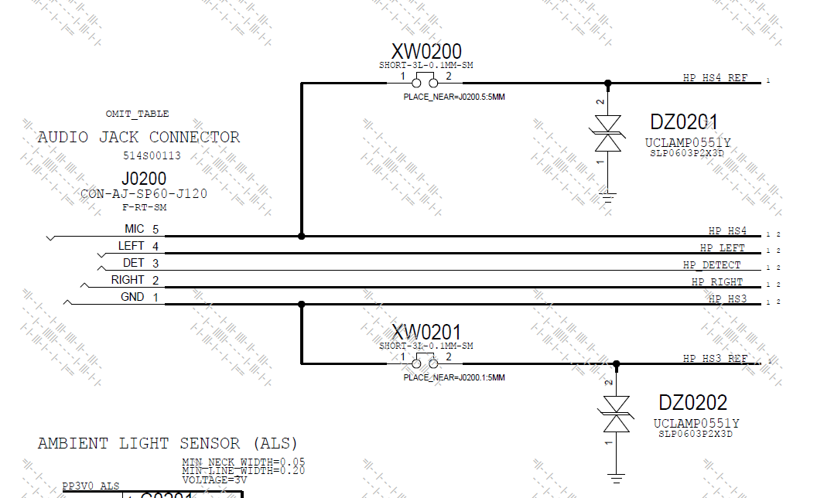

GND 和MIC根据Global HP&China HP不同可以互换位置。在Audio codec端通过设置实现Global 和 China的互换。

Left & Right是HP输出的左右通道

HP_Det用于检查是否有耳机插入

测试步骤:

Codec Chip ID Vendor

Codec Chip ID Model

-->audio --listblock

2017/03/20 15:21:05.995 : audmux:

2017/03/20 15:21:05.995 : Type: SOC HW Module

2017/03/20 15:21:05.995 : Description: Mca Audio Mux

2017/03/20 15:21:05.995 : Power Enabled: true

2017/03/20 15:21:05.995 : belfield:

2017/03/20 15:21:05.995 : Type: Codec

2017/03/20 15:21:05.995 : Description: Belfied MikeyBus Host

2017/03/20 15:21:06.011 : Power Enabled: true

2017/03/20 15:21:06.011 : clifden:

2017/03/20 15:21:06.011 : Type: Codec

2017/03/20 15:21:06.011 : Description: Cirrus Logic CS42L83 Codec

Codec Device ID 0x42 0xA8 0x3A

-->audioreg -b clifden --read --addr 0x1001 1,

clifden: 0x1001 = 0x42

-->audioreg -b clifden --read --addr 0x1002 1,

clifden: 0x1002 = 0xA8

-->audioreg -b clifden --read --addr 0x1003 1,

clifden: 0x1003 = 0x3A

Codec Fab ID

-->audioreg -b clifden --read --addr 0x1004 1

clifden:0x1004 = 0x00 tsmc ??

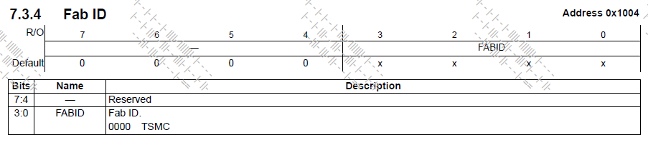

Codec Rev ID

-->audioreg -b clifden --read --addr 0x1005 1

clifden:0x1005 = 0xB0

HP_DET Open

-->未插入耳机是侦测HP是否有HP接入:mikey –detectheadphone

connect CONN_HP_HEADSET_DET to GND

HP_DET Close

-->插入耳机再次侦测HP,如果有detect结果会show Headphone detected : mikey –detectheadphone

Mikey Dectect Open

-->侦测MIC是否被拉低,检测是global还是china 耳机 :mikey –detectopenmic,

MIC_CONNECT

Connect 2.2K Ohm to GND with codec_HP_HS3 and codec_HP_HS4

1. HP_HS3通过2.2k Ohm到地,因为加分压电阻电平信号被拉低一点. HP_HS4直接接地.耳机为globle mode
2. HP_HS4通过2.2k Ohm到地, ,因为加分压电阻电平信号被拉低一点. HP_HS3直接接地.耳机为china mode

Mikey Dectect Close

-->再次侦测MIC: mikey –detectopenmic, 如果没有detect结果会show Open MIC Not detected

## 39.Headphone Mic Global Mode Loopback

主板通过HP Left或Right输出一段音频信号，通过MIC接收信号，接收的信号存储在SOC Buffer里面，diag读取Buffer的数据进行fft运算得到需要的数据包括，THDN, Power,dbfs等

有四组HP : global left/right,china left/right,下面以Globle mode left HP 为例

Codec_HP_Left & Codec_HP_Right通过Pogo pin接入主板的HP_Left & HP_Right

Codec_HP_HS3 & Codec_HP_HS4 通过Pogo pin接入主板的MIC & GND

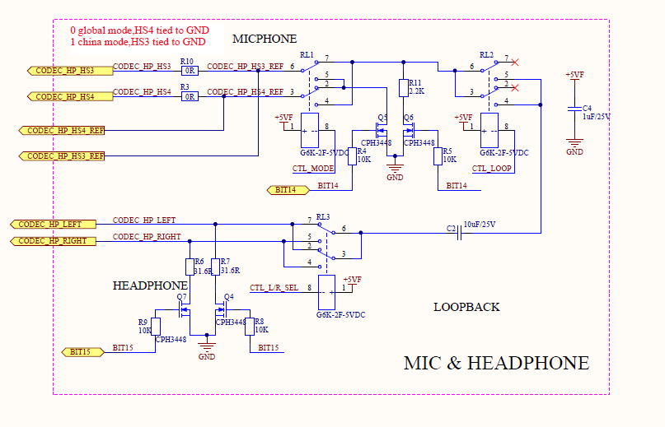

**MLB原理图**

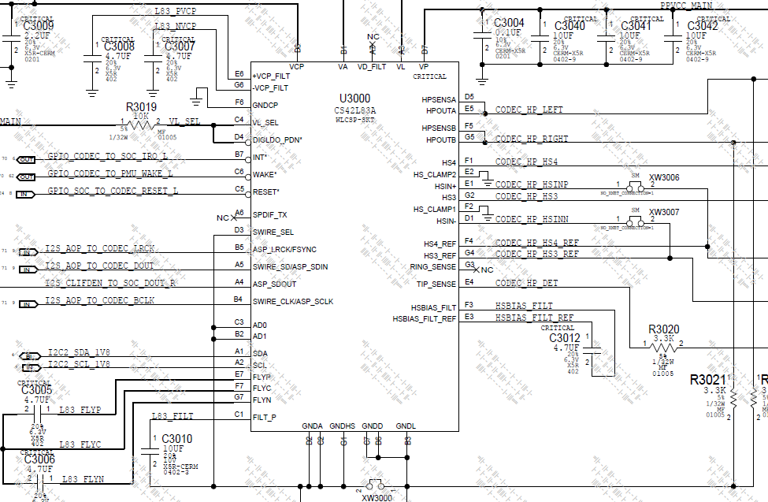

processaudio --freebuffers all

-->清空buffer里面的信息

routeaudio -b clifden -i asp -o hp –r ⇨

-->设置路径，音频从ASP进入，从HP输出 ,

-->asp -audio serial port

-->aop面向方面的程序设计（Aspect-Oriented Programming

routeaudio -b clifden -i hsin -o asp –r

-->设置路径，音频从MIC进入，从ASP输出到SOC

device -k HpSwitch -e set_global

-->设置global HP

setvol -b clifden -n mixerAdc -v mute

-->设置mixer Adc input value

audioreg -b clifden -w -a 0x2303 -d 0x3F

-->把0x3F写入到地址0x2303,关闭right HP

loopaudio -b socmca -p ap-mca4 -x ap-mca4 --len 1000 --bitdepth 24 --rate 48000 --channels

-->设置loop audio 信号 24字节48khz时长1s

processaudio -p fft -o ""--normalize false"" -i looprx0⇨

-->进行FFT运算得到THDN等数值

processaudio -p crop -i looprx0 -o "--start 5000""

-->进行rms运算等得到dbfs等测值

Log show:

2016/04/29 15:05:04.470 : Channel 4:

2016/04/29 15:05:04.470 : Using 32768 bins, Peak Bin= 683; Peak Magnitude=1269129.016009; Frequency: 1000.488281 +/- 0.732421 Hz

2016/04/29 15:05:04.520 : DC Magnitude=43.292259

2016/04/29 15:05:04.520 : Signal Bins=3

2016/04/29 15:05:04.520 : SINAD=11.854372 dB

2016/04/29 15:05:04.520 : Peak Power: 122.070115 dB

2016/04/29 15:05:04.520 : Signal Power: 122.171648 dB

2016/04/29 15:05:04.520 : Noise Power: 110.317275 dB

2016/04/29 15:05:04.520 : Average Noise PSD: 71.976249 dB

2016/04/29 15:05:04.537 : Noise Margin: 50.093866 dB

2016/04/29 15:05:04.537 : THD+N: -79.645490 dB

2016/04/29 15:05:05.014 : Channel 4:

2016/04/29 15:05:05.014 : Mean: -384.579562

2016/04/29 15:05:05.028 : Mean of Square: 6575610145418.605468

2016/04/29 15:05:05.028 : RMS (Root-Mean-Square): 2564295.253167

2016/04/29 15:05:05.028 : Variance (Mean of Square - Mean Squared): 6575609997517.166015

2016/04/29 15:05:05.028 : Positive dBFS: -7.076198

2016/04/29 15:05:05.028 : Negative dBFS: -6.879685

Global Mode HP Left Loopback@500mV RMS Frequency

**VRMS：**有效电压值（电压驻波比

Global Mode HP Left Loopback@500mVRMS Peak Magnitude

Global Mode HP Left Loopback@500mVRMS THD+N

**THD+N**：total harmonic distortion+noise 总谐波失真

Global Mode HP Left Loopback@500mVRMS Positive dbFS

dBFS: Decibel Full Scale—滿量程分貝.

Global Mode HP Left Loopback@500mVRMS Negative dbFS

## 40.CN Left Speaker Amplifier Tests

**Read CN Left speaker information,frequency,peak power and vboost voltage**

MLB 上面有4个speaker: CN LEFT / CN RIGHT / FH LEFT / FH RIGHT

CN: chin ,FH: forehead,这里只以CN LEFT speaker(U3302)为例.

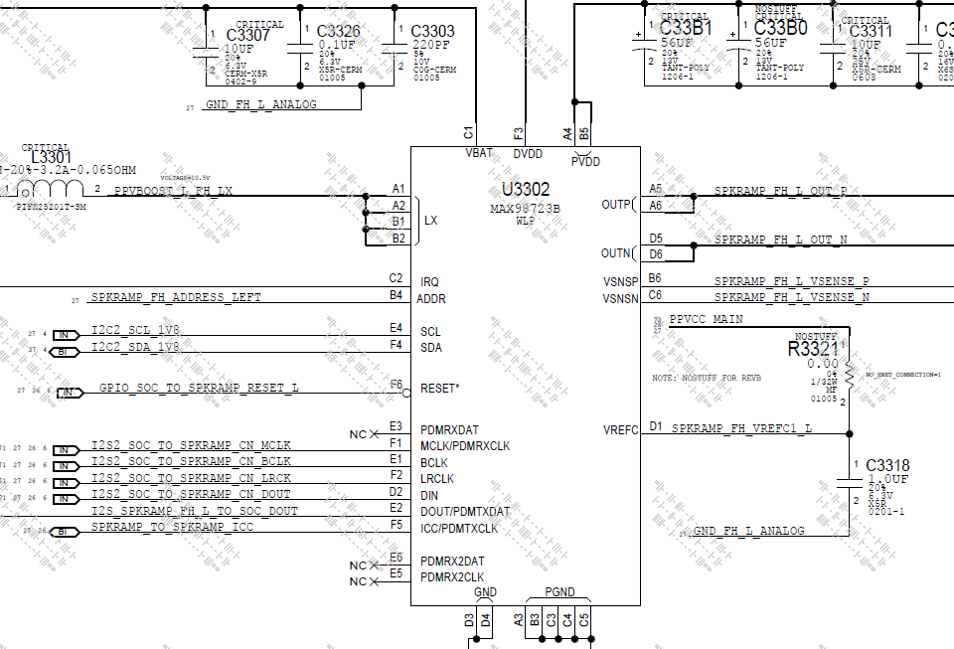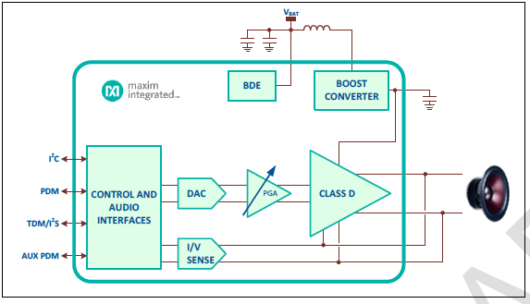

Read Revision ID (CN Left)

-->读speaker芯片版本号

audioreg -r -b spkl1 -a 1ff -l 1

spkl1:0x1FF = 0x43

Connect HP_SPK_INPUT_LEFT

Enable Boost and class DG and keep in idle state

--setvol --block spkl1 -n amp-vol --value 0

Set 音波为0 dB

--getvol --block spkl1 -n amp-vol

amp-vol = 0 dB

--routeaudio --route --block spkl1 --in spk-i2s --out spk-out

设置Routing from spkl1.spk-i2s[i] --> spkl1.spk-out[o]

--loopaudio -b socmca --txport ap-mca2 --rxport ap-mca2 --bitdepth 32 --rate 48000 --len 1500 --freq 2400"

配置音频信号play/record 48Khz, 32-bit, fre 2400 data for 1.5S时长

Measure OUTP and OUTN

CN Left Speaker Idle Frequency ???

CN Left Speaker Idle V Peak to Peak

CN Left Speaker Idle Duty Cycle(占空比)

PPVBOOST_CN_L

## 41.CN Left Speaker Brownout Voltage Accuracy

读取Speaker 中断寄存器里写入的值.

Brownout Detection Engine (BDE) can be programmed to initiate various current limiting, signal limiting and clip functions, based on battery voltage status. Threshold, hysteresis, and attack and release rates are programmable.

Read IRQ registers 0x01 (CN Left)

Read IRQ registers 0x02 (CN Left)

Read IRQ registers 0x03 (CN Left)

Read IRQ registers 0x04 (CN Left)

Read IRQ registers 0x05 (CN Left)

Read IRQ registers 0x06 (CN Left)

Read IRQ registers 0x07 (CN Left)

Read IRQ registers 0x08 (CN Left)

Read IRQ registers 0x09 (CN Left)

Set VBAT4.3V to 3.38V (slowly ramping down to 3.38V by 0.2V interval)

Enable BDE

audio -r;

audioparam -b spkl1 -s -n int-enable1 -v 2;

audioreg -b spkl1 -w -a 0x0056 -d 0x40;

0x56 = 0x40

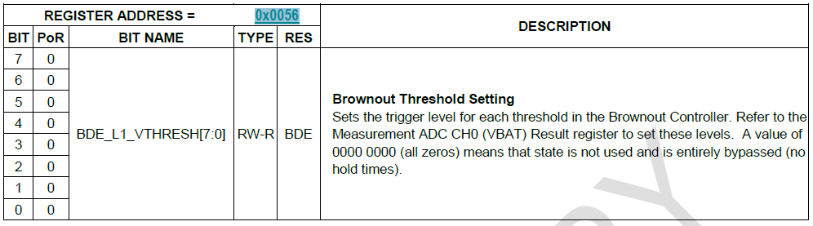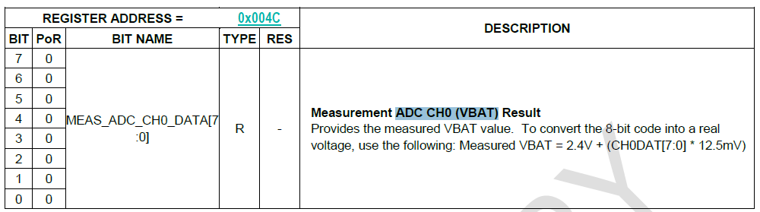

audioreg -b spkl1 -w -a 0x0010 -d 0x01;

0x10 = 0x01

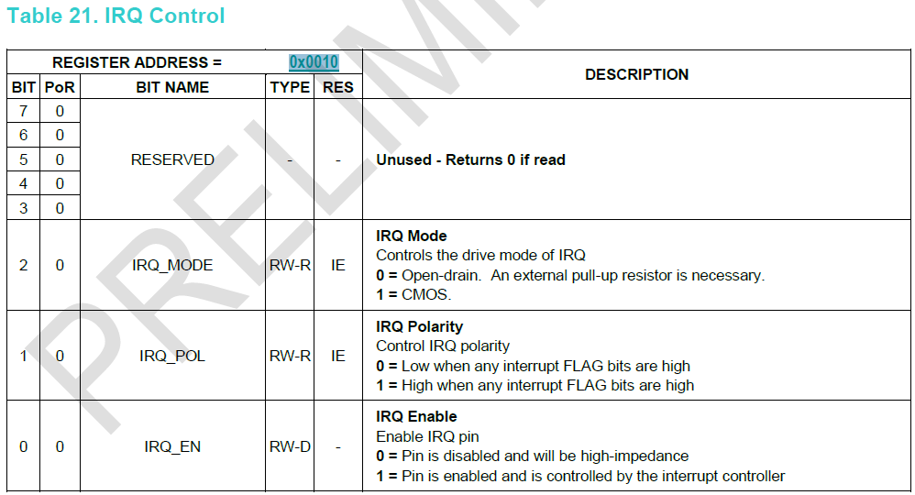

routeaudio -b spkl1 -i spk-i2s -o spk-out -

Routing from spkl1.spk-i2s[l] --> spkl1.spk-out[l]

audioreg -r -b spkl1 -a 0x0001 -l 9

0x01 = 0x00

0x02 = 0x00

0x03 = 0x00

0x04 = 0x00

0x05 = 0xC0

0x06 = 0x00

0x07 = 0x00

0x08 = 0x00

0x09 = 0x00

Read VBAT_CN_L

:-) pmuadc --sel euphrates --read vbat

expansion euphrates: vbat: 3386.4468 mV

VPBR_CN_LEFT

--> If Flag 0x07 reads 0x02 and IRQ (socgpio --port 0 --pin 167) is pulled low, then stop test and record BDE_L1_VTHRESH(0x0056) value to VPBR_CN_LEFT

-->If Flag 0x07 reads 0x00 and IRQ is pulled high, then increase BDE_L1_VTHRESH from 45, 46, 47, 48, 49, 4A…….

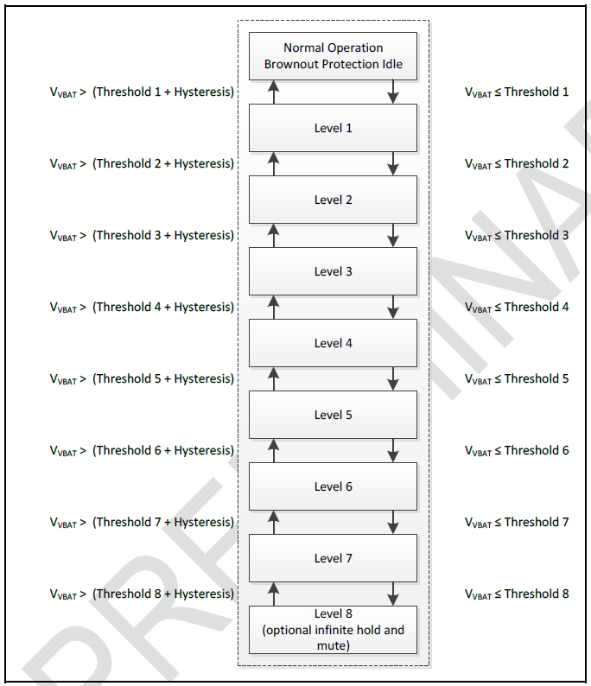

Log show:

2017/03/20 15:21:56.296 : [00117584:30A3A93A] :-) audioreg -b spkl1 -w -a 0x0056 -d 0x45

2017/03/20 15:21:56.312 : spkl1:write

2017/03/20 15:21:56.312 : 0x56 = 0x45

2017/03/20 15:21:56.312 : OK

2017/03/20 15:21:56.312 : [00117584:30A3A93A] :-) socgpio --port 0 --pin 167 --get;audioreg -r -b spkl1 -a 0x0007 -l 1

2017/03/20 15:21:56.392 : SoC GPIO[0,167] = 1

2017/03/20 15:21:56.392 : OK

2017/03/20 15:21:56.408 : spkl1:

2017/03/20 15:21:56.408 : 0x07 = 0x00

2017/03/20 15:21:56.408 : OK

………….

2017/03/20 15:21:57.160 : [00117584:30A3A93A] :-) audioreg -b spkl1 -w -a 0x0056 -d 0x4d

2017/03/20 15:21:57.176 : spkl1:write

2017/03/20 15:21:57.176 : 0x56 = 0x4D

2017/03/20 15:21:57.176 : OK

2017/03/20 15:21:57.176 : [00117584:30A3A93A] :-) socgpio --port 0 --pin 167 --get;audioreg -r -b spkl1 -a 0x0007 -l 1

2017/03/20 15:21:57.240 : SoC GPIO[0,167] = 0

2017/03/20 15:21:57.240 : OK

2017/03/20 15:21:57.240 : spkl1:

2017/03/20 15:21:57.240 : 0x07 = 0x02

2017/03/20 15:21:57.240 : OK

VPBR_CN_LEFT INT

VPBR_CN_LEFT值十六进制转换为十进制,

## 42.CN Left Speaker Amplifier Measurement

**连接4 Ohm电阻模拟插入耳机状态,测试vmon/imon value**

治具接入4 Ohm模拟电阻,如下图所示， FH share 一组电阻，CN share 一组电阻。下面以CN left为例.

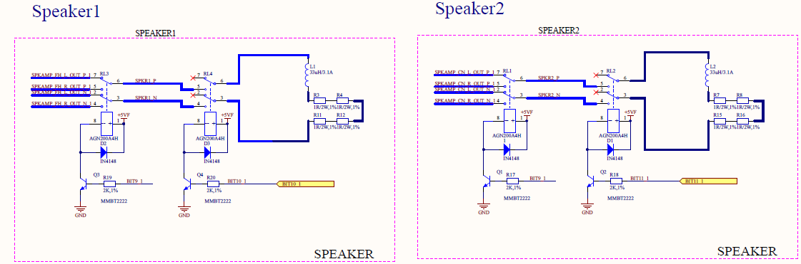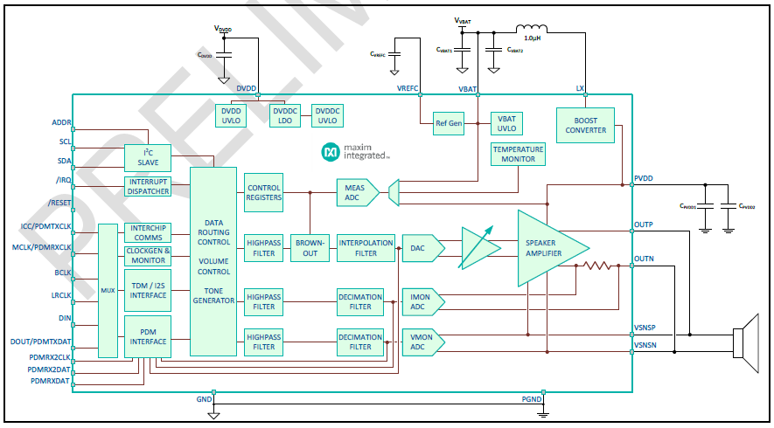

Set VBAT to 4.0V

SPK_L_CN_LEFT

Add 4ohm load_CN_LEFT

SPK_R_FH_RIGHT

Add 4ohm load_FH_RIGHT

CN&FH_L

CN LIFT boost-voltage

audioparam -b spkl1 -n boost-voltage -g

spkl1: boost-voltage = 6.500000

CN LIFT battery-voltage

audioparam -b spkl1 -n battery-voltage -g

spkl1: battery-voltage = 4.000000

CN LIFT temperature

audioparam -b spkl1 -n temperature -g

spkl1:temperature = 28.215999

Rdc_CN_Left_FCT

=VMON_RMS / IMON_RMS

THDN_VMON_CN_Left

THDN_IMON_CN_Left

CN_Left_VMON_Frequency

CN_Left_IMON_Frequency

CN_Left_VMON_FFT PeakMagnitude

=11* Channel 0 PeakM/(2^31-1)

CN_Left_IMON_FFT PeakMagnitude

=3* Channel 1 PeakM/(2^31-1)

audioreg -b spkl2 -w -a 0x0082 -d 0x1C

-->Envelope Tracker Vout Headroom 11100 = 3.500 V

audioreg -b spkl2 -w -a 0x0083 -d 0x10

-->Envelope Tracker Boost Vout Delay 10000 = Delay 16 base rate sample

audioreg -b spkl2 -w -a 0x0084 -d 0x02

-->Envelope Tracker Release Rate 010 = 100 ms/V

audioreg -b spkl2 -w -a 0x0085 -d 0x07

-->Envelope Tracker Hold Rate 111 = 1500 ms

audioreg -b spkl2 -w -a 0x0086 -d 0x01

-->Envelope Tracker Control 1 = Enable boost envelope tracker

audioparam -b spkl1 -s -n ch-location -v 0

audioparam --set --block spkl1 --param enable-mon --value true

audioparam --set --block spkl1 --param ch-vmon --value 0

audioparam --set --block spkl1 --param ch-imon --value 1

routeaudio -b spkl1 -i spk-i2s -o spk-out -r

-->设置音频信号路径:从i2s输入,out pin输出

audioparam -b socmca -p ap-mca2 -s -n master-lrclk-enable -v false

loopaudio -b socmca --txport ap-mca2 --rxport ap-mca2 --bitdepth 32 --rate 48000 --len 1500 --freq 2400 -c 8

-->设置输入音频play/record 48Khz, 32-bit, 8 channels of packed audio data for 1500mS

processaudio -p crop -i looprx0 -o "--start 5000"

processaudio -p fft -i process0 -o "--normalize false --peakBinWidth 3"

-->进行FFT运算得到THDN等数值

log show:

2017/03/20 15:35:30.356 : Channel 0:

2017/03/20 15:35:30.371 : Using 65536 bins, Peak Bin=3277; Peak Magnitude=97210606.163785; Frequency: 2400.146484 +/- 1.098632 Hz

2017/03/20 15:35:30.403 : DC Magnitude=457123.718267

2017/03/20 15:35:30.419 : Signal Bins=7

2017/03/20 15:35:30.419 : SINAD=55.263072 dB

2017/03/20 15:35:30.419 : Peak Power: 159.754273 dB

2017/03/20 15:35:30.419 : Signal Power: 159.895409 dB

2017/03/20 15:35:30.419 : Noise Power: 104.632336 dB

2017/03/20 15:35:30.419 : Average Noise PSD: 63.281328 dB

2017/03/20 15:35:30.419 : Noise Margin: 96.472944 dB

2017/03/20 15:35:30.435 : THD+N: -60.493620 dB

2017/03/20 15:35:30.451 : Channel 1:

2017/03/20 15:35:30.451 : Using 65536 bins, Peak Bin=3277; Peak Magnitude=74531242.324404; Frequency: 2400.146484 +/- 1.098632 Hz

2017/03/20 15:35:30.483 : DC Magnitude=1551888.001181

2017/03/20 15:35:30.483 : Signal Bins=7

2017/03/20 15:35:30.483 : SINAD=43.701998 dB

2017/03/20 15:35:30.483 : Peak Power: 157.446767 dB

2017/03/20 15:35:30.499 : Signal Power: 157.587903 dB

2017/03/20 15:35:30.499 : Noise Power: 113.885905 dB

2017/03/20 15:35:30.499 : Average Noise PSD: 72.534896 dB

2017/03/20 15:35:30.499 : Noise Margin: 84.911870 dB

2017/03/20 15:35:30.501 : THD+N: -50.232539 dB

VMON_RMS_CN_Left

IMON_RMS_CN_Left

VMON_PP_CN_Left

IMON_PP_CN_Left

processaudio -p rms -i process0

-->进行rms运算等得到dbfs等测值

VMON_RMS = 11 * <Channel 0, RMS (Root-Mean-Square) value> / ( 2^31-1 )

IMON_RMS = 3 * <Channel 1, RMS (Root-Mean-Square) value> / ( 2^31-1 )

VMON_PP = 11 * [ 10^( <Channel 0, Positive dBFS value> / 20 ) + 10^( <Channel 0, Negative dBFS value> / 20 ) ]

IMON_PP = 3 * [ 10^( <Channel 1, Positive dBFS value> / 20 ) + 10^( <Channel 1, Negative dBFS value> / 20 ) ]

log show:

2017/03/20 15:35:30.995 : Channel 0:

2017/03/20 15:35:31.011 : Mean: -1254251.443582

2017/03/20 15:35:31.011 : Mean of Square: 37844723826012528.000000

2017/03/20 15:35:31.011 : RMS (Root - Mean - Square): 194537204.220715

2017/03/20 15:35:31.011 : Variance (Mean of Square - Mean Squared): 37843150679328800.000000

2017/03/20 15:35:31.027 : Positive dBFS: -17.881318

2017/03/20 15:35:31.027 : Negative dBFS: -17.802749

2017/03/20 15:35:31.027 : Channel 1:

2017/03/20 15:35:31.027 : Mean: -4349443.362388

2017/03/20 15:35:31.027 : Mean of Square: 22264672091883240.000000

2017/03/20 15:35:31.043 : RMS (Root-Mean-Square): 149213511.760440

2017/03/20 15:35:31.043 : Variance (Mean of Square - Mean Squared): 22245754434320620.000000

2017/03/20 15:35:31.045 : Positive dBFS: -20.323507

2017/03/20 15:35:31.045 : Negative dBFS: -19.949254

CN Left boost-voltage_Track

processaudio --freebufs all

setvol -b spkl2 -n amp-vol -v -5

setvol -b spkl2 -n spk-pcm-gain -v 15

setvol -b spkl1 -n amp-vol -v -5

setvol -b spkl1 -n spk-pcm-gain -v 15

audioparam -b socmca -p ap-mca2 -s -n master-lrclk-enable -v false

loopaudio -b socmca --txport ap-mca2 --rxport ap-mca2 --bitdepth 32 --rate 48000 --len 50 --freq 2400 -c 8

audioparam -b socmca -p ap-mca2 -s -n master-bclk-enable -v true

audioparam -b socmca -p ap-mca2 -s -n master-lrclk-enable -v true

audioparam -b spkl1 -n boost-voltage -g

2017/03/20 15:35:31.422 : script: audioparam -b spkl1 -n boost-voltage -g

2017/03/20 15:35:31.485 : block specific:

2017/03/20 15:35:31.485 : spkl1:

2017/03/20 15:35:31.485 : boost-voltage = 9.969999

audio --turnoff spkl1

audio --turnoff spkl2

audio --turnoff socmca

## 43.Throttle Test

**Open VBUS, check SOC Throttle voltage when VBATT raise down and up.**

Open VBUS

Ramp down VBATT slowly from 4.3V to 3.2V(step by 0.2v), observe VCCMAIN_DROOP_PMU_TO_SOC_L transition.

Set VBATT to 4.3V

Set VBATT to 3.9V

PPVCC_MAIN VBAT 3.9V VBUS open

PPVCC_HIGH VBAT 3.9V VBUS open

socgpio --pin 199 –get SoC GPIO[0,199] = 1

Set VBATT to 3.6V

PPVCC_MAIN VBAT 3.6V VBUS open

PPVCC_HIGH VBAT 3.6V VBUS open

socgpio --pin 199 –get SoC GPIO[0,199] = 1

Set VBATT to 3.4V

Set VBATT to 3.2V

PPVCC_MAIN VBAT 3.2V VBUS open

PPVCC_HIGH VBAT 3.2V VBUS open

socgpio --pin 199 –get SoC GPIO[0,199] = 1

Set VBATT to 2.90~2.76V (0.006v by every step)

SOCHOT0_H2L VBATT

Read SOCHOT0 pin

socgpio --pin 199 –get SoC GPIO[0,199] = 0

SOCHOT0_LOW

Raise VBATT from 2.76 to 2.9V, step by 0.006v,observe SOCHOC0_L transition

Read SOCHOT0 pin

SOCHOT0_L2H VBATT

SOCHOT0_HIGH

2017/03/20 15:35:55.985 : [00155901:1013A93A] :-) socgpio --pin 199 --get

2017/03/20 15:35:56.257 : SoC GPIO[0,199] = 1

SOCHOT_HYSTERISIS_VOL

-->H2L与L2H之间的差值

Reconnect VBUS

Increase VBATT back to 4.3V (slow ramp up)

Set VBATT to 3.2V

PPVCC_MAIN VBAT 3.2V VBUS 5V NTC OFF

PPVCC_HIGH VBAT 3.2V VBUS 5V NTC OFF

Set VBATT to 3.4V

delay 0.1s

Set VBATT to 3.6V

delay 0.1s

PPVCC_MAIN VBAT 3.6V VBUS 5V NTC OFF

PPVCC_HIGH VBAT 3.6V VBUS 5V NTC OFF

Set VBATT to 3.9V

delay 0.1s

PPVCC_MAIN VBAT 3.9V VBUS 5V NTC OFF

PPVCC_HIGH VBAT 3.9V VBUS 5V NTC OFF

Reconnect VBUS

## 44.CONN_IO TO PMU

**Check battery connect status**

UART Tx Buffer Test ???

2017/03/20 15:35:56.257 : [00155901:1013A93A] :-) memrw --32 0x20a0d4010 0x178

2017/03/20 15:36:00.049 : 0x20A0D4010: 0x00000206

2017/03/20 15:36:00.049 : OK

2017/03/20 15:36:00.049 : [00155901:1013A93A] :-) memrw --32 0x20a0d4020 0xc0

2017/03/20 15:36:00.065 : 0x20A0D4020: 0x00000000

2017/03/20 15:36:00.065 : OK

2017/03/20 15:36:00.065 : [00155901:1013A93A] :-) memrw --32 0x20a0d4010

2017/03/20 15:36:00.081 : 0x20A0D4010: 0x00000006

2017/03/20 15:36:00.081 : OK

SoC UART5 Output 0

-->socgpio --pin 163 --output 0

UART_BATT_HDQ Low

2017/03/20 15:36:00.113 : [00155901:1013A93A] :-) pmugpio --pin 6 --input --get

2017/03/20 15:36:00.145 : PMU GPIO[6] = 0

BATT_SWI_CONN Low

SOC UART5 Output 1

-->socgpio --pin 163 --output 1

UART_BATT_HDQ High

2017/03/20 15:36:00.353 : [00155901:1013A93A] :-) pmugpio --pin 6 --input --get

2017/03/20 15:36:00.369 : PMU GPIO[6] = 1

BATT_SWI_CONN High

## 45.Performance State Test

SoC have 8 states 0~7; These test items are check the every state if setting correct the CPU voltage and frequency.

Disconnect USB Power,vbus=0v

Vbatt=4.3v

State 0

PPVDD_CPU State 0_B0

PPVDD_S1_FIXED_SOC State 0_B0

PPVDD_CPU_SRAM State 0_B0

PPVDD_CPU State 0 Percentage

-->由公式100*(ADC_CPU*1000 - V_CPU)/V_CPU计算

PPVDD_S1_FIXED_SOC State 0 Percentage

--> 100*(ADC_SOC*1000 - V_SOC)/V_SOC

System Current with WiFi/BT Off State 0

State 1

PPVDD_CPU State 1_B0

PPVDD_S1_FIXED_SOC State 1_B0

PPVDD_CPU_SRAM State 1_B0

PPVDD_CPU State 1 Percentage

PPVDD_S1_FIXED_SOC State 1 Percentage

[00155901:1013A93A] :-) soc -s "perfstate 0"

2017/03/20 15:36:00.705 : OK

2017/03/20 15:36:00.705 : [00155901:1013A93A] :-) soc -p get-perf-state

2017/03/20 15:36:00.721 : Cpu State :0

2017/03/20 15:36:00.721 : Cpu Frequency :396MHz

2017/03/20 15:36:00.721 : Cpu Voltage :628mV

2017/03/20 15:36:00.721 : SoC State :13

2017/03/20 15:36:00.721 : SoC Voltage :850mV

2017/03/20 15:36:00.721 : Gpu State :0

2017/03/20 15:36:00.737 : DDR Frequency :1600MHz

2017/03/20 15:36:00.737 : Sram Voltage :738mV

2017/03/20 15:36:00.737 : [00155901:1013A93A] :-) soc -s "perfstate 1"

2017/03/20 15:36:01.985 : OK

2017/03/20 15:36:02.001 : [00155901:1013A93A] :-) soc -p get-perf-state

2017/03/20 15:36:02.017 : Cpu State :1

2017/03/20 15:36:02.017 : Cpu Frequency :768MHz

2017/03/20 15:36:02.017 : Cpu Voltage :638mV

2017/03/20 15:36:02.017 : SoC State :13

2017/03/20 15:36:02.017 : SoC Voltage :850mV

2017/03/20 15:36:02.017 : Gpu State :0

2017/03/20 15:36:02.033 : DDR Frequency :1600MHz

2017/03/20 15:36:02.033 : Sram Voltage :738mV

2017/03/20 15:36:02.033 : [00155901:1013A93A] :-) soc -s "perfstate 2"

2017/03/20 15:36:02.593 : OK

2017/03/20 15:36:02.593 : [00155901:1013A93A] :-) soc -p get-perf-state

2017/03/20 15:36:02.609 : Cpu State :2

2017/03/20 15:36:02.609 : Cpu Frequency :1152MHz

2017/03/20 15:36:02.609 : Cpu Voltage :650mV

2017/03/20 15:36:02.609 : SoC State :13

2017/03/20 15:36:02.609 : SoC Voltage :850mV

2017/03/20 15:36:02.609 : Gpu State :0

2017/03/20 15:36:02.625 : DDR Frequency :1600MHz

2017/03/20 15:36:02.625 : Sram Voltage :753mV

State 2

PPVDD_CPU State 2_B0

PPVDD_S1_FIXED_SOC State 2_B0

PPVDD_CPU_SRAM State 2_B0

PPVDD_CPU State 2 Percentage

PPVDD_S1_FIXED_SOC State 2 Percentage

State 3

PPVDD_CPU State 3_B0

PPVDD_S1_FIXED_SOC State 3_B0

PPVDD_CPU_SRAM State 3_B0

PPVDD_CPU State 3 Percentage

PPVDD_S1_FIXED_SOC State 3 Percentage

State 4

PPVDD_CPU State 4_B0

PPVDD_S1_FIXED_SOC State 4_B0

PPVDD_CPU_SRAM State 4_B0

PPVDD_CPU State 4 Percentage

PPVDD_S1_FIXED_SOC State 4 Percentage

State 5

PPVDD_CPU State 5_B0

PPVDD_S1_FIXED_SOC State 5_B0

PPVDD_CPU_SRAM State 5_B0

PPVDD_CPU State 5 Percentage

PPVDD_S1_FIXED_SOC State 5 Percentage

System Current with WiFi/BT Off State 5

Delta System Current 0 and 5 //状态5和0 之间current的差值

State 6

PPVDD_CPU State 6_B0

PPVDD_S1_FIXED_SOC State 6_B0

PPVDD_CPU_SRAM State 6_B0

PPVDD_CPU State 6 Percentage

PPVDD_S1_FIXED_SOC State 6 Percentage

State 7

PPVDD_CPU State 7_B0

PPVDD_S1_FIXED_SOC State 7_B0

PPVDD_CPU_SRAM State 7_B0

PPVDD_CPU State 7 Percentage

PPVDD_S1_FIXED_SOC State 7 Percentage

System Current with WiFi/BT Off State 7

Delta System Current 0 and 7

State 7to5 //状态7跳到状态5

PPVDD_CPU State 7to5_B0

System Current with WiFi/BT Off State 7to5

Delta Performance Current 7to5 and 5

State 5to0 //状态5跳到状态0

PPVDD_CPU State 5to0_B0

System Current with WiFi/BT Off State 5to0

Delta Performance Current 5to0 and 0

## 46.Hibernate Current Test

**Measure Battery Current when system sleep**

Low battery voltage from 4.3V to 3.6V

VBUS=OPEN

Put device in to hibernate mode

--> sleep –t

Battery Current in Hibernation Gross

Battery Current in Hibernation

## 47.Hibernate Voltage Test

**Measure Power rail voltage when system sleep**

|  |
| --- |
| PPVCC_MAIN in Hibernation |
| PP1V8_ALWAYS in Hibernation |
| PP1V8_SW1 in Hibernation |
| PP1V8_S3_SW3 in Hibernation |
| PP3V0_S3_TRISTAR in Hibernation |
| PP1V2_SOC in Hibernation |
| PPVDD_CPU in Hibernation |
| PPVDD_GPU in Hibernation |
| PP1V8_S3 in Hibernation |
| PP1V8_S2_VA_VCP in Hibernation |
| PP1V8_SW1_CAMERA in hibernation |
| PP1V8_CAM_FRONT_CONN in Hibernation |
| PP1V8_CAM_REAR_CONN in Hibernation |
| PP1V8_S2_EXT_SW2 in Hibernation |
| PP1V19_CAM_REAR_CONN in Hibernation |
| PP1V5_CAMERA in Hibernation |
| PP2V85_AVDD_CAM_REAR_FILT inHibernation |
| PP2V9_AVDD_CAM_FRONT_FILT inHibernation |
| PP3V0_ALS in Hibernation |
| PP3V3_S2 in Hibernation |
| PP3V3_ACC in Hibernation |
| PPVDD_CPU_SRAM in Hibernation |
| PPVDD_GPU_SRAM in Hibernation |
| PP1V8_EXT_SW1 in Hibernation |
| PP1V8_PHOS_FILT in Hibernation |
| PPVDD_S1_FIXED_SOC in Hibernation |
| PP0V9_NAND in Hibernation |
| PP1V1_S1_EXT_SW in Hibernation |
| PP1V8_MAGNESIUM_FILT in Hibernation |
| PP1V8_GRAPE_EXT_SW in Hibernation |
| PP1V19_FRONT_CAM in Hibernation |
| PP3V0_UT_SVDD_FILT in Hibernation |
| PP3V3_EXT_SW in Hibernation |
| PP3V3_GRAPE in Hibernation |
| PP3V3 in Hibernation |
| PPVCC_MAIN_LCD_SW_CONN in Hibernation |

Set VUSB=5V

## 48.PMU Wakeup Test

**Connect VBUS, measure Power rail voltage**

FORCE_DFU

Set VUSB=5V

Vbatt=3.6v

|  |
| --- |
| PPVDD_CPU Wakeup_B0 |
| PPVDD_CPU_SRAM Wakeup_B0 |
| PP0V9_NAND Wakeup |
| PP1V1_S1_EXT_SW Wakeup |
| PP1V2_SOC Wakeup_B0 |
| PP1V8_SW1 Wakeup |
| PP1V8_EXT_SW1 Wakeup |
| PP1V8_SW1_CAM Wakeup |
| PP3V3_EXT_SW Wakeup |
| PP1V8_CAM_FRONT_FILTWakeup |
| PP1V8_CAM_REAR_FILT Wakeup |
| PP1V8_PHOS_FILT Wakeup |
| PP3V3 Wakeup  Turn off VUSB  Turn off VBAT |

## 49.BATT Reset Current End

Set vbatt from 0 to 4.3v,step by 0.5v

BATT RESET CURRENT

Turn off VBAT